


Deputy Headteacher
The Ladder School

Required for January 2027 but earlier start date negotiable.

Permanent, Full-Time.
Competitive Salary
(Leadership L14 to L18)

Candidate Pack

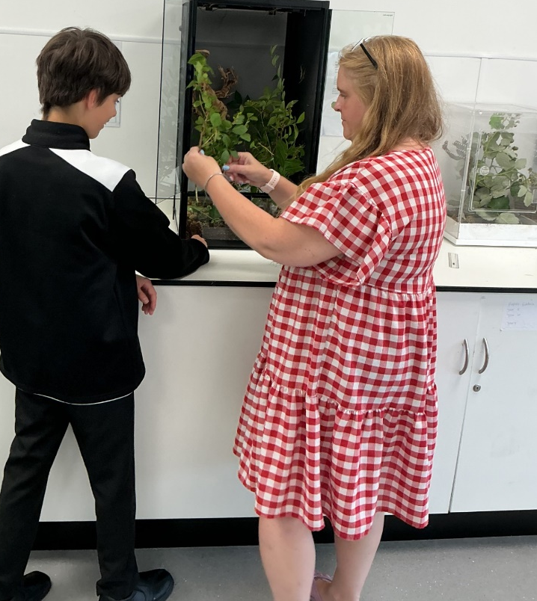

WELCOME TO THE LADDER SCHOOL

  - A specialist Alternative Provision where every child is seen, valued and prepared for their next step.
The Ladder School is a specialist Alternative Provision Free School in the heart of Walsall and part of The Mercian Trust. We provide a purposeful, nurturing and ambitious education for young people who need something different from mainstream provision. More than an alternative placement, The Ladder School offers students a fresh opportunity to reconnect, re-engage and prepare positively for their future.
At The Ladder School, every student is known as an individual. Our staff look beyond behaviour, barriers and previous experiences to understand the whole child. Through strong relationships, consistent routines and high expectations, students are supported to rebuild trust, develop confidence and re-engage with learning.
Our school has a warm, family feel. It is safe, respectful and inclusive, while remaining clear about standards, responsibility and ambition. Students experience care, structure and challenge in equal measure, and are encouraged to recognise their strengths, overcome obstacles and believe in what they can become.
Our provision is carefully designed around each young person. The Ladder School combines high-quality teaching with therapeutic thinking, safeguarding, personal development, careers education and meaningful partnerships with families, schools, the Local Authority and wider agencies. This joined-up approach ensures that students receive targeted support that meets their academic, social and emotional needs.
Success at The Ladder School is measured through readiness: readiness to learn, readiness to engage, readiness to build positive relationships, readiness to transition and readiness for adulthood. We prepare students for their next step by helping them develop self-worth, resilience, independence and a clear sense of possibility.
The Ladder School is proudly relational in our practice. Our students know they belong. Families experience a school that works with them, not against them. Staff build bridges where relationships have broken down and help young people reconnect with learning, adults, peers, family and themselves.
We are a community where students are not defined by what has happened before. They are valued, capable and prepared for a future worth working towards. Above all, at The Ladder School, we believe in our students until they are ready to believe in themselves.
We are now seeking a visionary and compassionate leader to help guide The Ladder School into its next chapter. This is a rare opportunity to shape the future of a school that makes a meaningful difference every day, and to work alongside a team united by its commitment to young people, families and lasting transformation.

Hannah Shepherd
Head Teacher

Vacancy for the Role of Deputy Headteacher – The Ladder School

Dear Applicant,
Thank you for taking the time to find out more about The Ladder School and our Deputy Headteacher vacancy.
The Mercian Trust and Local Governing Body are looking to appoint an inspirational, compassionate and highly skilled leader for The Ladder School, with the expertise to strengthen inclusive practice, champion excellent behaviour and attitudes, and ensure that the highest educational, pastoral and safeguarding standards are met for every student. The successful candidate will share our belief in belonging and mattering, strong relationships, care with high expectations, and the importance of helping every young person develop resilience, self-worth and readiness for the future.
We are looking for a Deputy Headteacher who combines relational warmth with calm authority; someone who understands the complexities of ‘atypical education’ such as Alternative Provision or Specialist Settings and can lead with clarity, compassion and courage. The successful candidate will bring the relational credibility to build trust quickly and authentically with students, families, staff and external partners, recognising that strong relationships are central to behaviour, attendance, safeguarding, learning and lasting change. They will bring emotional resilience, sound judgement and a steady presence in complex situations, balancing strategic school improvement with visible, hands-on operational leadership. Above all, they will share our belief in possibility: that every young person can grow, change and succeed when they are known, supported and challenged in the right way. They will uphold high expectations and help create a culture where students feel they belong, know they matter, and are supported to become ready for their next step.
The Mercian Trust is dedicated to equipping our students to live life to the full by realising their potential, thriving in the world of work and making a positive contribution to their community. At The Ladder School, we support this vision by providing a purposeful, nurturing and ambitious Alternative Provision for young people who need something different from mainstream education. Our mission is to ensure that every student is known, valued and supported to feel that they belong and matter. Through strong relationships, inclusive practice, consistent routines, high expectations and carefully planned support, we help students reconnect with learning, rebuild confidence, develop resilience and prepare positively for their next step.
We strongly encourage interested candidates to visit The Ladder School to gain a fuller understanding of our provision, ethos and the young people we serve. To arrange a visit or find out more about the vacancy, please contact Elaine Woodward at The Ladder School on 01922 285848 or email info@tls.merciantrust.org.uk .
We hope that the information provided in this pack will inspire you to apply for the role of Deputy Headteacher at The Ladder School.

Hannah Shepherd
Head Teacher

ABOUT YOU
You will:
- Align with our Trust’s Blueprint for Leadership and culture, demonstrating this through your values, professional behaviours and commitment to The Ladder School’s ethos of belonging, mattering, inclusion and high expectations.
- Be committed to our mission of social mobility and social justice, with an unwavering commitment to those students who are disadvantaged, have SEND or are more likely to face discrimination.
- Work with all stakeholders to create a school culture of safeguarding, belonging, inclusion and mattering, where students are known, valued and supported to engage positively with learning.
- Be able to confidently and effectively safeguard your own wellbeing and that of your colleagues.
- Share our belief in possibility: that every young person can grow, change and succeed when they are known, supported and challenged in the right way.
- Bring relational credibility and authenticity of character, building trust quickly and consistently with students, families, staff, external partners and wider agencies.
- Lead with care, courage and candidness and demonstrate accountability through your leadership values.
- Lead by example and be passionate about constantly driving improvement with innovation and a pioneering spirit.
- Bring emotional resilience, sound judgement and a steady presence in complex, fast-moving or challenging situations.
- Have an acute understanding of curriculum and how to develop it.
- Have experience of leading curriculum, teaching and learning practices that have delivered an impressive impact on securing exceptional student outcomes.
- Work with accuracy and precision to deliver effective strategic business planning and budget management.
- Be committed to a distributed leadership model and make your leadership style responsive to those being led, demonstrating a commitment to your own professional development and that of others.
- Balance strategic school improvement with visible, hands-on operational leadership, leading from the front with strong communication, clarity and team-building skills.
- Be keen to work collaboratively with peers within and outside of our Trust.




STRATEGIC PLAN 2025-2030
The Mercian Trust’s Strategic Plan for 2025–2030 marks an important transition from our pioneering chapter to a confident, maturing stage of development. Rooted in our commitment to social mobility and social justice, the strategic plan sets out a bold and innovative vision for the next five years—one that builds on our distinctive identity and shared values across a diverse family of schools.

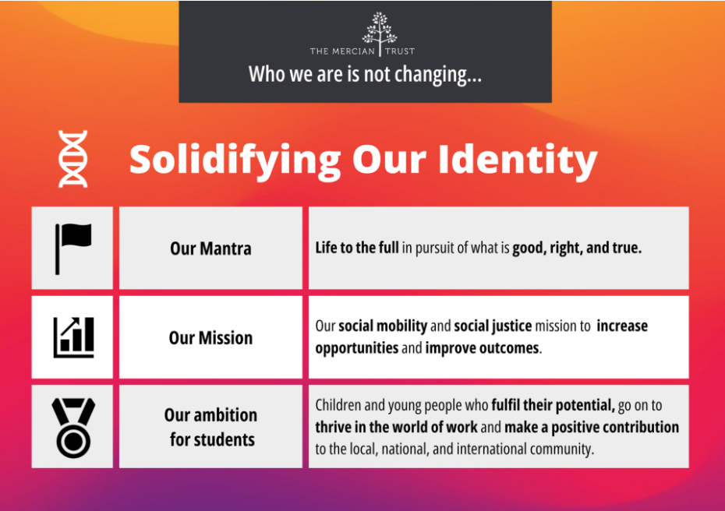
Our strategy is anchored in three long-term priorities: purpose, people, and place. We aim to increase opportunities and improve outcomes for all students, recruit and retain exceptional staff, and deepen our engagement with communities and external partners. This is underpinned by a culture of inclusive leadership, continuous improvement, and purposeful innovation—ensuring every school flourishes and every learner experiences “life to the full.” As we move forward, we are thinking in decades, not just academic years, and we are excited for innovative and aspirational leaders to join us in shaping the future of education across Walsall, Sandwell and the Black Country.


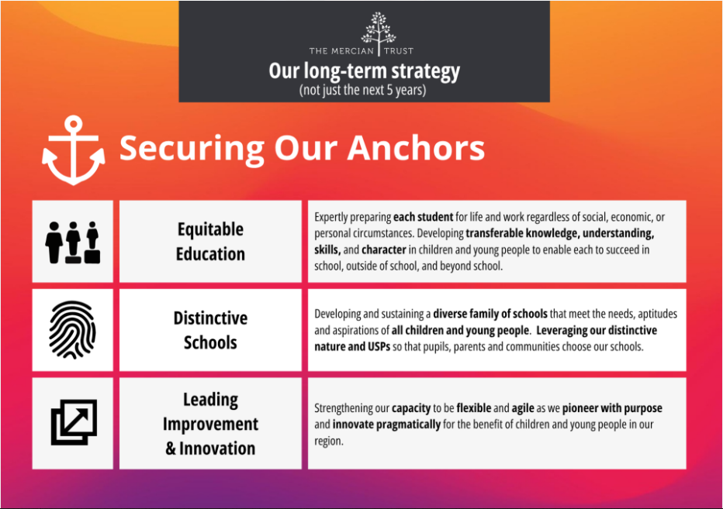
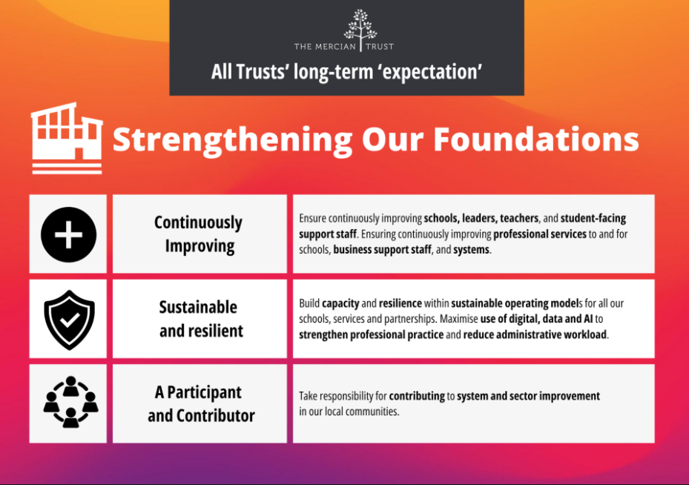
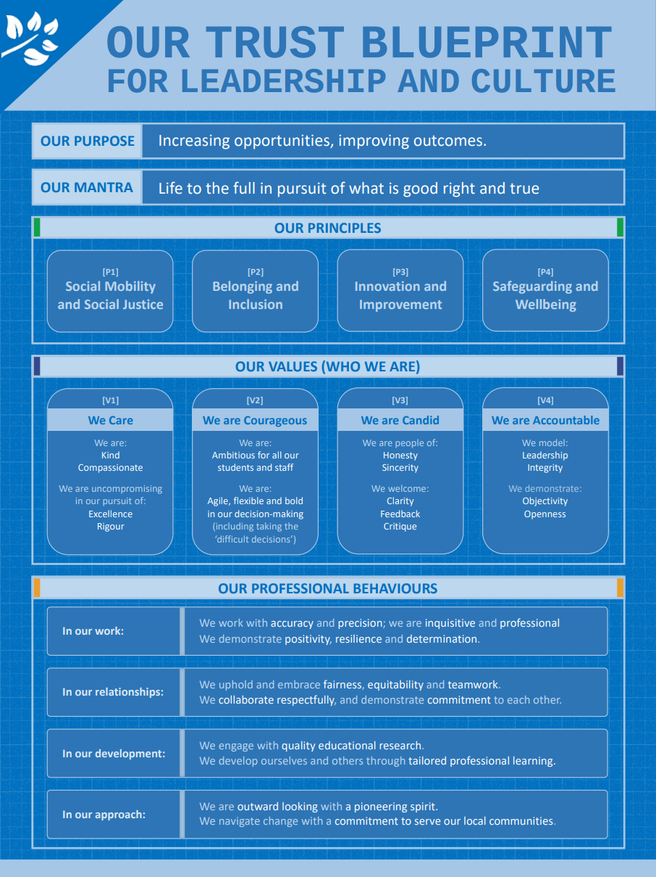

THE MERCIAN TRUST

The Mercian Trust is one of the largest and leading regional Trusts in the West Midlands with 12 schools and over 10,000 students. We are making strategic investments of time, focus, and resources into realising our Vivid Vision for 2030, alongside the development of our strategic foundations and anchors. This is all set alongside our identity and mission to increase opportunities and improve outcomes for children and young people. Our Vivid Vision for Purpose, People and Place articulates our ambitious plans for our students, our staff and our local communities.

The Mercian Trust was incorporated in January 2018 and currently governs nine secondary schools, comprising selective grammar schools, large comprehensive schools, an alternative provision free school and a 14-19 specialist studio school. In 2021, the Regional Schools Commissioner approved the merger between The Mercian Trust and Q3 Academies Trust. The formal merger transfer was completed on 1st May 2022 when all nine academies of the two Trusts became part of the same family of schools governed by The Mercian Trust. In summer 2025, our first Primary School and our first Special School joined our Trust, along with a Pupil Referral Unit bringing our family of schools to twelve.
- Aldridge School (11-18)
- Rushall School (Primary School)
- Oakwood School (Special School)
- New Leaf School (Pupil Referral Unit)
- Q3 Academy Great Barr (11-18)
- Q3 Academy Langley (11-16)
- Queen Mary’s High School (11-18, selective)
- Queen Mary’s Grammar School (11-18, selective)
- Shire Oak Academy (11-18)
- The Ladder School (Alternative Provision)
- Q3 Academy Tipton (11-18)
- Walsall Studio School (14-19)

The Members of The Mercian Trust include The Vine Trust and the Queen Mary’s Foundation. Both are charitable organisations focussed on improving the futures of local young people.

Trust ethos & values
Our name is rooted in history and expresses a geographical identity and ambition. The ancient kingdom of Mercia encompassed much of what we now recognise as the West Midlands – and crucially for us it included what we now call the Black Country. It was in Mercia that St Chad established an association of small monasteries which fostered unity through bonds of kinship. Now, a thousand years later, we look to demonstrate the same spirit in our approach. We are a family of schools committed to each other – diverse in nature, proud custodians of our history and success, but together, one charitable trust with a common purpose.

Our Trust exists to equip our students to:
- Realise their potential
- Thrive in the world of work
- Make a positive contribution to the local, national and international community.

Our mission is increasing opportunities and improving outcomes. Our mantra is Life to the full in pursuit of what is good, right and true.

JOB DESCRIPTION
Purpose
In conjunction with the Headteacher, develop the school’s overall vision, values and ethos so that The Ladder School provides a purposeful, nurturing and ambitious specialist Alternative Provision in the heart of Walsall.

The Deputy Headteacher will help increase opportunities, improve outcomes and prepare students positively for their next step, particularly those who are disadvantaged, have SEND, are vulnerable, have experienced disruption to their education, or are more likely to face discrimination, while ensuring the school’s vision aligns with the wider Trust vision and mission.

Lead in accordance with the Trust’s Blueprint for Leadership and Culture, ensuring that Trust principles underpin decision-making and that The Ladder School’s culture reflects its core values of belonging and mattering, relationships, inclusion, care with high expectations, readiness for the future, resilience and self-worth, partnership and joined-up support, and belief in possibility.

Our Principles
- To ensure that the school reflects our Trust’s mission of social mobility and social justice for staff and students.
- To embed a school culture of belonging and mattering for all staff and students, ensuring that everyone who works or studies at The Ladder School is known, valued, safe and able to flourish.
- To seek out opportunities to be innovative in strategy and delivery to ensure that the school continues to improve and develop.
- Uphold and embed a culture of safeguarding, wellbeing and emotional resilience for staff and students, recognising the complex needs, lived experiences and barriers faced by young people in Alternative Provision.

School Leadership
- Articulate, develop and embed a relational, inclusive and ambitious school culture where students are known, valued and supported to feel that they belong, matter and can reconnect with learning.
- Provide strategic leadership, with others, to develop school improvement and quality assurance plans that deliver the school’s vision, values and priorities, while remaining visible, responsive and operationally effective in the day-to-day life of a busy Alternative Provision.
- Promote a school culture that prioritises The Ladder School’s core values of belonging and mattering, relationships, inclusion, care with high expectations, readiness for the future, resilience and self-worth, partnership and joined-up support, and belief in possibility.
- Ensure all teachers set high expectations which inspire, motivate and challenge all students.
- Ensure a school environment in which commonalities are identified and celebrated, difference is valued and nurtured, and bullying, harassment and violence are never tolerated.
- Model calm authority, relational credibility and trusting relationships with students, families, staff, external partners and wider agencies, recognising that strong relationships are central to behaviour, attendance, safeguarding, learning and lasting change.

Safeguarding
- Contribute to the school’s safeguarding culture, ensuring that arrangements, expectations and daily practice support the safety and wellbeing of students and staff.

- Work with the designated safeguarding lead and wider colleagues to support effective safeguarding practice, including appropriate communication with families, schools, the Local Authority and relevant agencies where needed.

- Support appropriate responses to safeguarding matters in line with school and Trust expectations, working collaboratively with colleagues as required.

Education and Standards
In order to increase opportunities, improve outcomes and prepare students for their next step in KS4, KS5, further education, training or employment, especially vulnerable groups, disadvantaged students, students with SEND, children in care or formerly in care, and those more likely to face discrimination, you will ensure that students experience:

- a broad, balanced and adaptive curriculum that supports re-engagement, prepares students for ambitious destinations, is strengthened by high quality CEIAG, and includes personal development, employability, independence and preparation for adulthood.

- consistently strong teaching practice across the school, underpinned by high expectations, adaptive support, trauma-informed thinking and a belief that every student can grow, change and succeed when they are known, supported and challenged in the right way.

- assessment practices that are appropriate to their age and used meaningfully by teachers to help them improve.

- learning that takes place in a positive, respectful and relational environment where students feel safe, belong, know they matter, and are supported to develop resilience, self-worth, confidence and readiness for their next step.

- Deliver the school’s strategy for supporting disadvantaged students, including the effective use of pupil premium funding, monitoring impact on student outcomes, attendance, engagement and readiness, and evaluating progress towards the Trust’s social mobility measures.

- Articulate, develop and deliver the school’s approach to maintaining the highest standards and expectations for students, ensuring clear expectations of behaviour, consistent routines, restorative and relational practice, and effective transitions are understood by all and embedded within the school’s culture.

People Development
- Line manage key staff within school so that all staff are developed in line with the Trust Blueprint, The Ladder School’s values, and the specialist knowledge required to work effectively in Alternative Provision.

- Ensure that the school conducts professional growth for all staff in line with our Trust’s policy, ethos and approach.
- Manage your own and others’ workload to maintain appropriate work-life balance and wellbeing for all staff, recognising the emotional demands of AP work and ensuring clear delegation, support, supervision and accountability.

Operational Leadership
- Balance strategic school improvement with visible, hands-on operational leadership, ensuring that daily routines, transitions, behaviour systems, safeguarding responses and communication processes are calm, consistent and effective.

- Work closely with the Headteacher, Trust colleagues, families, placing schools, Walsall Local Authority and wider agencies to secure coordinated support, effective communication, successful reintegration or transition planning, and positive outcomes for students.

Miscellaneous
- Any other duties as directed by the Headteacher.

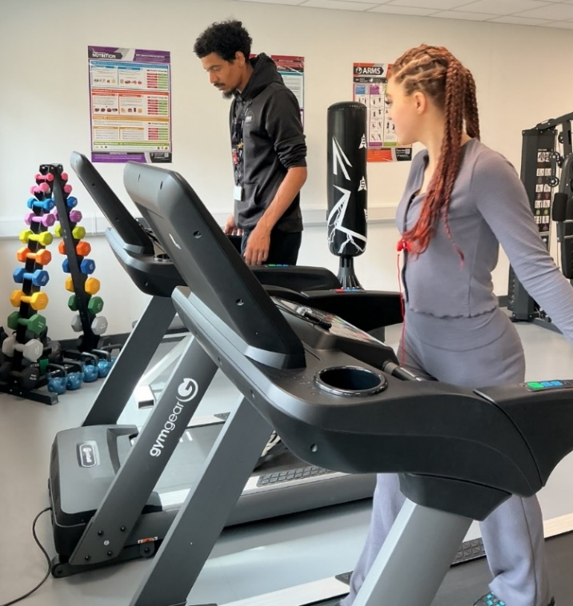
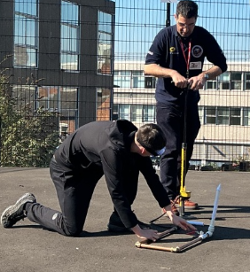

PERSON SPECIFICATION

QUALIFICATIONS | ESSENTIAL | DESIRABLE | EVIDENCE
QTS. | X |  | Application/  Cert
Honours Degree or Equivalent. | X |  | Application/  Cert
Postgraduate Qualification in Leadership / Management. |  | X | Application/  Cert
Recent Relevant Professional Development. | X |  | Application/  Cert

KNOWLEDGE AND UNDERSTANDING | ESSENTIAL | DESIRABLE | EVIDENCE
Understanding of inclusion, belonging and mattering in an Alternative Provision setting, including how relational practice supports best practice. | X |  | Interview
Knowledge of and commitment to a whole-school safeguarding culture that supports the safety, wellbeing and readiness of students and staff. | X |  | Application/  Interview
Update your own knowledge and expertise of evidence-based research relating to all areas of school practice and culture. | X |  | Interview
Ofsted framework and associated publications. | X |  | Interview
Understanding of pastoral, safeguarding and multi-agency support for vulnerable students, including those with SEND, disadvantage, disrupted education or complex barriers to learning. | X |  | Interview
Ability to articulate excellence in a specialist Alternative Provision and provide the vision, ambition and belief in possibility needed to deliver it. | X |  | Interview

SKILLS AND ATTRIBUTES | ESSENTIAL | DESIRABLE | EVIDENCE
Commitment to the Trust’s Blueprint for Leadership and Culture and to The Ladder School’s values of belonging and mattering, relationships, inclusion, care with high expectations, readiness, resilience, partnership and belief in possibility. | X |  | Application / Interview
Intellectually rigorous and values-led approach to leadership, with a detailed understanding of what excellence looks like across school . | X |  | Application / Interview
Able to see the big picture and translate strategic priorities into visible, practical and consistent day-to-day leadership. | X |  | Interview
Able to balance strategic school improvement with visible, hands-on operational leadership in a busy and complex AP environment. | X |  | Interview
Able to demonstrate successful change leadership (across the whole organisation). | X |  | Application / Interview
Ability to inspire, challenge, motivate and develop teams with relational credibility, emotional resilience, clarity, care and high expectations. | X |  | Interview
Ability to understand and analyse student, school and staff data / management information and insights to effectively raise school standards. | X |  | Interview
Presence, calm authority and the ability to provide strong, visible and relational leadership throughout the school day. | X |  | Interview
Ability to set high and clear expectations, hold others to account, and model care with high expectations for students and staff. | X |  | Interview
Excellent interpersonal skills, with the ability to build trust quickly and authentically with students, families, staff, external partners and wider agencies. | X |  | Interview

EXPERIENCE WITH IMPACT | ESSENTIAL | DESIRABLE | EVIDENCE
Substantial school senior leadership experience with impact over time. | X |  | Application
Experience of working or leading within an Alternative Provision, specialist setting, PRU, SEMH provision or other atypical education context. |  | X | Application
Work within a Multi Academy Trust or multi-site environment. |  | X | Application
Leading whole school improvements in a range of areas including teaching and learning. | X |  | Application / Interview
Composing, implementing and evaluating strategic improvement and development plans. | X |  | Application
Experience of leading CPD training/mentoring/ coaching, and staff appraisal. | X |  | Application / Interview
Effective work with executive leaders or governors including Self Evaluation and Improvement plans |  | X | Application / Interview
Experience of working with families, placing schools, Local Authorities, external agencies, employers, voluntary groups and wider partners to secure joined-up support and positive student outcomes. |  | X | Application / Interview
Commitment to research and contribution to body of knowledge (e.g. through published work) |  | X | Application / Interview

OUR OFFER TO YOU
- A superb staff team committed to doing their absolute best for all in our school community.
- Support from our Trust central teams and other schools in our Trust to ensure you have the tools to deliver success (our schools are all located close to one another, and we work better when we are working together).
- A wealth of support for your ongoing continuing professional development, including a Trust-wide programme for leaders drawing on expertise from across the Mercian Trust and external professional coaches.
- A comprehensive employee assistance and staff benefits package including UK Healthcare (cash-back health plan and 24:7 video call and telephone access to GP and counselling) and a discounts portal (ranging from gym membership to discount cards and vouchers for online and high street retailers).
- There will never be a dull moment; we never stand still, every day offers new challenges and opportunities within an ambitious, forward-thinking team.

SAFEGUARDING AND SAFER RECRUITMENT
- The Mercian Trust is committed to equal opportunities, safeguarding, and promoting the welfare of children and young adults. We expect all staff to share this commitment. As this post involves working in regulated activity unsupervised with children all post-holders are subject to satisfactory pre-employment checks including an online search check, Enhanced Disclosure and Barring Service check.

- You are required to uphold all relevant policies in respect of child protection and safeguarding, which are based on KCSIE (2026) and Working Together to Safeguard Children (2018).
- You are required to demonstrate and model the Nolan Principles (The Seven Principles of Public Life): Selflessness, Integrity, Objectivity, Accountability, Openness, Honesty, and Leadership. https://www.gov.uk/government/publications/the-7-principles-of-public-life
- You should demonstrate your commitment to our equality policy and all our related work to promote diversity, inclusion and belonging.


KEY INFORMATION – HOW TO APPLY

Post | Deputy Headteacher
Responsible to | Headteacher
Contract and Salary | Full time, permanent  Leadership L14 – L18
Closing Date | Monday 21st September 2026, 9.00am
Interview Dates | 30th September and 1st October 2026
Start Date | January 2027 but earlier start date negotiable
Informal Confidential Conversations and Visit of School | To speak to someone about this post and/or to arrange a school visit, please contact Miss E Woodward, Executive PA and Office Manager: e.woodward@tls.merciantrust.org.uk or 01922 285848 ext. 3101
How to apply | Please complete our Online Application Form via MyNewTerm website.  Please ensure your supporting statement outlines the following:  - How your recent and relevant leadership experience has prepared you to be successful as Deputy Headteacher at The Ladder School.  - How your vision, values and leadership style align with The Ladder School’s ethos and the Trust’s Blueprint for Leadership and Culture.  - The impact you have had in your career to date, particularly in improving outcomes, strengthening culture, developing staff, leading change and creating the conditions for students to feel safe, known, valued and ready for their next step.  - How you would contribute to an inclusive, relational and ambitious Alternative Provision in the heart of Walsall.  Please note – your ability to communicate a wide range of information with appropriate examples and evidence clearly and concisely in your supporting statement will be assessed as part of the shortlisting process.

