
Woods Avenue, Hatfield, Hertfordshire, AL10 8NN
Telephone: 01707 276 504

Woods Avenue, Hatfield, Hertfordshire, AL10 8NN
Telephone: 01707 276 504


Southfield School
Candidate Information Pack
Vacancy:
Teaching Assistant

Introduction
We are seeking to appoint a highly motivated Teaching Assistant, preferably with SEN experience, (but not essential), who would love the opportunity to make an impact on the teaching and learning at Southfield School.

The successful candidate will work in small classes of children who are not yet working at age related expectations. All pupils have an EHCP, which often states a diagnosis of Autism and associated Speech, Language and Communication needs. Children may demonstrate challenging behaviours.

Southfield School is ambitious and committed to the personal development of all staff. There are excellent opportunities for high-quality CPD and we are keen to support you in your development.

Contract Type
This is a permanent role, working term time only.

Start Date
We are looking to appoint as soon as possible.

This job may close earlier than the expected if we receive a high volume of applications. Southfield School reserves the right to interview and appoint candidates on receipt of applications before the closing date.

Salary
£ 25,583 FTE (Grade TBC)

About the School
Southfield is a primary school for over 100 pupils with Learning Difficulties, which include, Autism, Speech Language and Communication Needs, Global Developmental Delay, and other conditions.


Admissions are via the Local Authority, and the present criteria is that children are accessing learning approximately 50% below their chronological age. We follow the EYFS and Key Stage 1 National Curriculum and adapt these to meet the individual interests and needs of our pupils. We do this through a 3 Phase curriculum that is presently being developed. Priority is given to communication, self-regulation, independence and functional Literacy and Maths. We use a wide range of approaches and strategies to support learning, including multi-sensory communication, social stories, TEACCH and Hertfordshire Steps. We also work with a range of professionals, from advisers in the Local Authority to Therapists and social care colleagues. Access to sporting and creative arts organisations, provide a range of enhanced learning opportunities, both in school and the local area.

Southfield is going through a period of rapid and exciting change, that you could be part of. It is a journey of challenge, in the pursuit of excellence, but one that provides huge rewards both personally, in your professional development and when you see the difference you make to the lives of our young people and their families.

About the Role
Our Teaching Assistant will work under the direction of the Class Teacher in whole class, group, or individual situations. They will have some basic knowledge of specialist communication skills e.g., Makaton and PECS. There will be a need to interpret information or situations and to solve them according to school policy and to refer more complex problems to the class teacher. All tasks will be carried out within recognised procedures or guidelines and the teacher will be available for support or guidance.

Support for pupils:
- Work with pupils on specific tasks in small group or individual situations as required by the teacher
- Ensure that all personal equipment for pupils is up to date and inform the teacher of any requirements
- Support pupils according to the school policy, pupils’ needs and their risk assessments.
- Follow approved strategies outlined in Behaviour Support Plans and report any significant changes in behaviour to the teacher
- Complete accurate records on pupils’ progress and achievement in accordance with agreed procedures
Support for the teacher:
- Assist the teacher to ensure that the aims and objectives of the school are achieved
- Prepare materials, set out equipment, keep equipment sorted and tidy. Report any broken items
- Supervise individual and small groups of pupils
- Supervise pupils on playground/ lunch break as part of a team
- Undertake any photocopying or other administrative tasks that may be required
- Put up wall displays etc. as directed by the class teacher
- Produce teaching aids and materials as required by the class teacher
- Support for the curriculum:
- Use computer programs and other ICT equipment to support student’s learning as appropriate.
- Use basic Makaton signs and PECS
- Undertake tasks to support the curriculum and assist with events connected to the curriculum e.g., Sports Day, Multicultural events, Swimming etc.
- Support the implementation of Government and school initiatives under the direction of the class teachers.
Support for School:
- Assist in general cleaning duties to maintain a safe and caring learning environment.
- Where these duties and responsibilities are carried out effectively the Headteacher and Governors feel that the following outcomes will be apparent:
- Within the school there will be a positive ethos that reflects its commitment to continuing achievement.
- Effective teaching and learning will take place with pupils making at least good progress.
- The post holder will feel valued and will have a clear knowledge and understanding of what they need to do to contribute to pupils’ learning.
- The post holder will appreciate how their role relates to, and is different from, that of teaching staff.
- Effective and efficient use will be made of resources and the skills and talents of the post holder.
- Policies will be consistently applied to secure effective pupil management and the achievement of pupil targets.
- The class teacher will have confidence in the post holder who has demonstrated the ability to work in effective partnership focusing on the individual needs of pupils in the class.
- The duties and responsibilities of any post may change from time to time. Post holders may be expected to carry out other work not explicitly mentioned above, appropriate to the level of responsibility is vested in the post.

This job description is not a comprehensive definition of the post. Discussions will take place on a regular basis to clarify individual responsibilities within the general framework and character of the post as identified below.
The duties may be varied to meet changed circumstances in a manner compatible with the post held, at the reasonable direction of the Headteacher. This job description does not form part of the contract of employment. It describes the way in which the member of staff is expected and required to perform and complete the duties as set out above.
A word from our Headteacher

Are you bored with life? Looking for a new challenge? Have a desire to work in an environment where you can make a ‘real’ difference to the lives of young people? If so, Southfield School is the right environment for you.
We are a family with over 100 pupils. No two students are alike, and no two members of staff are alike. Our pupils all have challenging ASD and associated conditions.
Our school vision is to support all children, so they thrive during their time at Southfield School and are prepared socially, emotionally, and academically for their next steps in education. Collaboration with parents and carers and the entire multi-disciplinary team who support our students is vital and key to our success.
Everyone plays a part in the future of our students with staff skills being used in order that we have a huge range of skill set and expertise. Everyone makes a difference to the lives of our students and families.
We are looking for like-minded, resilient staff who are passionate and who can work in a team.
If you have yet to find what it is that you were meant to do with your life – Southfield School may be what you have been searching for.

Come and join us and make a difference to the lives of children every day.

Angela O’Rourke
Headteacher

Our Vision and Values

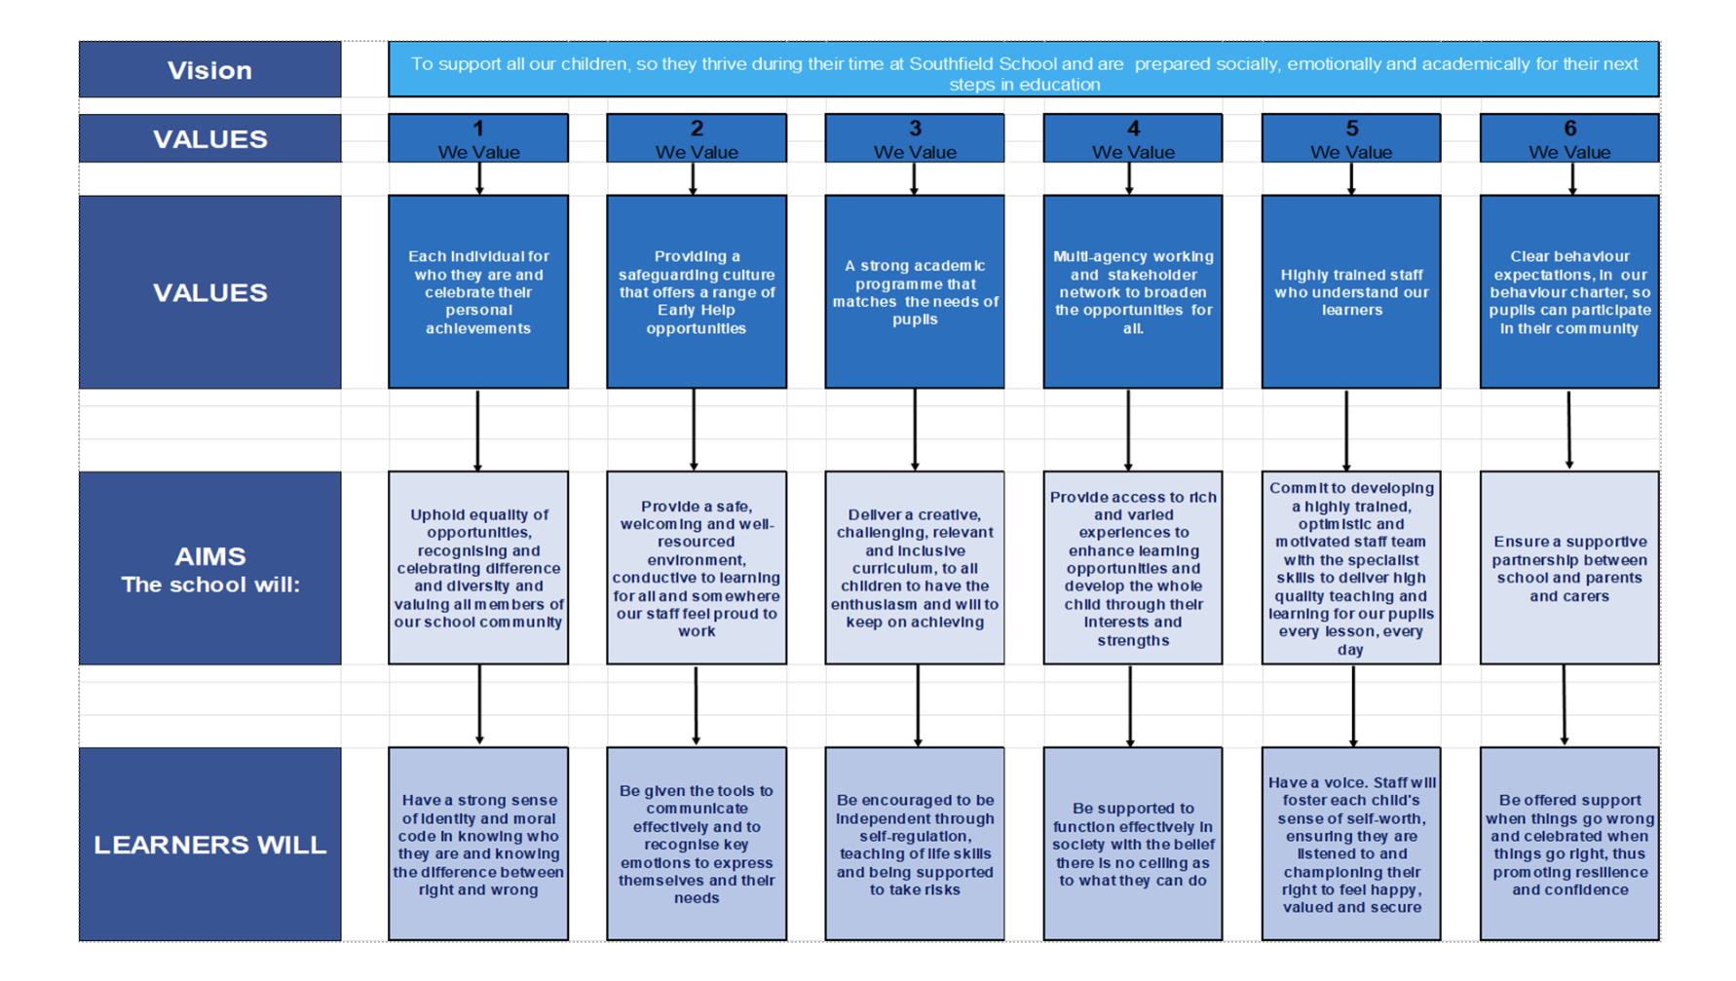
A Bright Future for ALL
What We Offer
Working at Southfield School is more than just a job – it’s a career with meaning, and whether you are working directly with our young people or in a supporting role, the work you do ultimately helps to change lives.

We recognise that our employees are the key to helping us achieve our ambitions and deserve to be valued and supported.

Our rewards and benefits include:
- 24 hour employee assistance programme (EAP) for advice, information and support
- Access to the Local Authority Employee Benefits and Discount Platform.
- Local Authority Cycle to Work Scheme.
- Long Service Awards.
- High quality training offered through face to face, virtual and through various providers free of charge.
- Free care parking on site.
- Contribution towards staff uniform.
- Free refreshments and staffroom area.
- Tax relief may be available on staff uniform.
- Staff recognition scheme.
- Termly staff raffles.
- Highly supportive team environment.
- Support with career progression.
- Pension Scheme – Please follow the link for further information regarding Teacher Pensions and rates of contributions: http://www.teacherspension.co.uk/

Post Application Information
Equal Opportunities Monitoring Form
At Southfield School, we want our workforce to reflect the diversity of the community we
serve. It is our policy to ensure that job applicants and employees are treated justly, and are
recruited, selected, trained, and promoted on the basis of the job requirements, skills and
abilities. We will ensure that people are not disadvantaged by conditions or requirements, which cannot be shown to be justified as being necessary for the effective performance of
the job. You are under no obligation to complete this form, however if you do you are agreeing, under the Data Protection Act 2018 that Southfield School may hold and use personal information about you for monitoring purposes.

Safeguarding
Southfield School has a responsibility for and is committed to safeguarding and promoting
the welfare of children, young people, and vulnerable adults to ensure that they are
protected from harm. All conditional offers of employment are subject to the following pre-employment clearances:

Satisfactory Medical Clearance
All successful candidates complete a medical questionnaire and may be required to pass a
medical examination by the Southfield School.

Satisfactory References
It is the school’s practice to take up 2 references from your last two job references. Referees must not be a member of your family, or spouse/partner and the reference must be provided on letter headed paper or come from a work email address. If you are a recent school or further education leaver, one of your references must be from your school or college. Occasionally more than two references may be required, if this is the case, we will inform you before we contact former employers.
In line with our safer recruitment policy, we will take up references ahead of interview. Once we have received your references, we will call your referees to verify that the reference
is from them as part of the keeping children safe in education requirement. No employment
will be offered until 2 satisfactory references are received.

Rehabilitation of Offenders Act 1974
The Rehabilitation of Offenders Act 1974 makes it unlawful for prospective employers to
consider offences in relation to which the person concerned is deemed to be rehabilitated. This means that after a certain period (dependent on the seriousness of the offence
and length and severity of the punishment), the person concerned is to be assessed as if the conviction has been ‘spent’ (i.e. treated as if it had never occurred). Rehabilitation periods vary according to the type and length of conviction originally incurred. All posts within the school are covered by the Rehabilitation of Offenders Act (Exemptions)
Order 1975 and DBS clearance is required and therefore detail must be given about all
convictions, whether spent or not.

Disclosure and Barring Service (DBS) (Previously CRB) Clearance
As all posts require a DBS check, the successful candidate will be required to complete the
appropriate DBS documentation. The successful candidate will be unable to take up the
appointment until the clearance is received from the DBS. The timescale for these checks is
outside the Southfield School’s control.

Prohibition from Teaching
All teaching appointments are subject to a check with the Department for Education to
ensure that you are not subject to a prohibition order or an interim prohibition order.

Evidence of Qualifications
We will need evidence of the qualifications (original certificates) you specify in your
application form. Originals must be brought to the interview for candidates who have been
short-listed. Copies will not be accepted.

Eligibility to work in the UK
To comply with the Asylum and Immigration Act 1996 (As AMENDED) (Immigration, Asylum
and Nationality Act 2006), all employers in the United Kingdom are required to make basic
documentation checks on every person they intend to employ. We ask all short-listed applicants to provide proof that they can be legally employed. We must see satisfactory proof in the form of original documentation before we can confirm any
offer of employment. If we do not see satisfactory proof, an offer of employment can be
withdrawn.
The complete list of documents that may be accepted as proof of your identity, along with
information on the number and types required can be found below. There are three routes as outlined, however where possible, we encourage short listed applicants to produce
documents which adhere to Route 1 of the ID Checking process to avoid delays in the ID
checking process.

