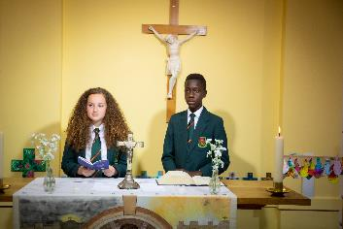
About the role:
An exciting opportunity is available to join our well-established, fully staffed, and high-performing Maths department. We are looking for a dedicated and enthusiastic Maths teacher who is eager to make a meaningful contribution to our school community. Our department is reflective, supportive and highly collaborative. We use research-informed practice to guide our approach to teaching and learning, and we are
committed to managing staff workload thoughtfully—particularly in relation to shared planning
and marking expectations. September or earlier start.
The Ideal Candidate Will:
- Demonstrate a strong commitment to delivering outstanding teaching and learning.
- Inspire, motivate, and challenge students to excel and reach their full potential.
- Build and sustain excellent relationships with both students and colleagues.
- Contribute to maintaining and further improving our strong Maths outcomes.
- Embrace and uphold the core vision and values of our Catholic school.
- Contribute to our core vision and values as a Catholic school.

APPLICATION DEADLINE – Friday 20 March 2026 at 8am

Why Blessed William Howard?

- A Christian community with a caring, secure and
disciplined environment.
- A wide range of extra-curricular activities.
- High academic standards.
- A commitment to success for all.
- Ongoing CPD for all staff.

“There is a warm atmosphere and the quality of relationships between all members of the school community are a particular strength. Pupils and staff are friendly, helpful, polite and welcoming to visitors.” Diocesan Section 48 Report

Further details and application forms can be accessed via My New Term https://mynewterm.com/ This school is committed to safeguarding and promoting the welfare of children and young people/vulnerable adults and expects all staff and volunteers to share this commitment. This position is subject to appropriate vetting procedures including a criminal record check from the Disclosure and Barring Service (formerly CRB), which will require you to disclose details of all unspent and unfiltered spent reprimands, formal warnings, cautions and convictions as part of the recruitment process.

Blessed William Howard is proud to part of the St Gabriel the Archangel Catholic MAT, A company limited by guarantee registered in England & Wales with company number 08146661. Registered Office Address: Station Road, Cheadle, Staffordshire ST10 1LH. Telephone: 01538 493777 Web: www.bwh.staffs.sch.uk
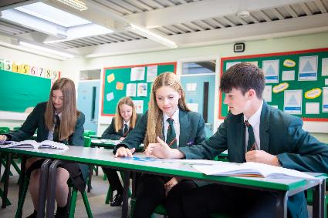
Teacher of Mathematics
Pay grade – MS/UPS
Permanent, full-time position

Blessed William Howard
Catholic High School, Stafford ST17 9AB
Part of the St Gabriel the Archangel Catholic
Multi – Academy Trust

Are you looking for a new opportunity in an innovative and supportive 11-18 Catholic school? Now part of the St Gabriel the Archangel Catholic Multi – Academy Trust, the largest multi-academy in the Archdiocese of Birmingham. Blessed William Howard is looking to recruit dynamic, forward-thinking and inspirational staff to join us on our journey to success. With a strong Catholic ethos that puts ‘love’ at the heart of its community, the school provides a haven where all can flourish. Situated just outside the town centre and easily accessed by train, bus or the M6, Blessed William Howard is proud of its strong community links and its beautiful grounds.

