Job description: SENCO
Location | Gladstone Park Primary School
Contract term | Permanent
Full time/term time | Full Time
Pay range | Salary dependant on experience (MPS - UPS) with SEND allowance
Reporting to | Headteacher

Job purpose
To lead, manage, develop and maintain high-quality special educational needs provision which enables quality teaching, excellent learning outcomes and success for all pupils.

Inclusion at Anthem
As a trust, we have an ambitious Inclusion Strategy which sets out our vision for Inclusion further. One exciting element of this is our commitment to developing our relational approach across our schools. This year all of our schools are undertaking training with the Thrive Approach which will further embed our practice in trauma-informed, developmentally based provision.

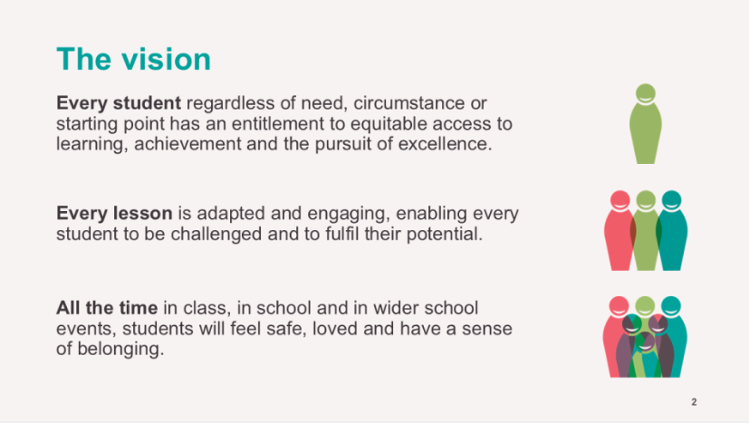



Overall responsibilities
The SENCO, under the direction of the Headteacher, will:
- Determine the strategic development of special educational needs (SEN) policy and provision in the school
- Be responsible for day-to-day operation of the SEN policy and co-ordination of specific provision to support individual pupils with SEN or a disability (SEND)
- Provide professional guidance to colleagues, working closely with staff, parents and other agencies

Main duties
Strategic direction and development of SEND provision in the school
With the support of, and working with, the Headteacher / Senior Leadership Team (SLT) the SENCO will:
- Contribute to a positive and inclusive whole school ethos that promotes excellent outcomes for pupils with SEND
- Ensure the school meets its responsibilities under the Equality Act 2010, Children’s Act 2014 and the SEND Code of Practice 2015
- Develop a strategic overview of provision for pupils with SEND across the school, monitoring and reviewing the quality of provision
- Ensure the Anthem Trust SEND policy is implemented effectively within the school
- Develop, implement and monitor strategic SEND plans that are reflected in the Academy Improvement Plan
- Support all staff in understanding the needs of SEN pupils
- Liaise with staff, parents, external agencies and other schools or settings to co-ordinate their contribution, provide maximum support and ensure continuity of educational provision for pupils with SEND
- Evaluate whether funding is being used effectively, and advise the Headteacher on making effective use of resources to ensure value for money
- Maintain an up-to-date knowledge of national and local initiatives which may affect the school’s policy and practice
- Contribute to school self-evaluation, particularly with respect to provision for pupils with SEND
- Provide regular information to SLT and governors on the effectiveness of SEN provision and outcomes
Operation of the SEN policy and co-ordination of provision
- Support early and accurate identification and assessment of special educational needs
- Maintain an accurate SEN register
- Work in partnership with parents and families who have a child with SEN
- Advise on the graduated approach to SEN support
- Ensure the cycle of Assess, Plan Do review is used to inform provision and meet individual needs
- Co-ordinate additional provision that meets the pupils’ needs, and monitor its effectiveness
- Coordinate the use of a Provision Map (Edukey or equivalent) and ensure it is being used effectively to develop individual learning plans and record, track and monitor the effectiveness of interventions
- Support person-centred approaches, involving pupils and parents in all aspects of SEN provision
- Be aware of the provision in the Local Authorities local offer
- Work with early years/feeder primary providers, other schools, educational psychologists, health and social care professionals, and other external agencies and be a key point of contact for external agencies
- Work in partnership with the pupil, parents and other professionals to ensure the needs of pupils with Education, Health and Care (EHC) Plans are fully met and meet statutory requirements
- Support transition at all stages for pupils with SEN
- Ensure records of pupils with SEN are kept up to date
Leading and managing staff
- Advise and contribute to all aspects of effective SEND continuing professional development for staff (including leading training and coaching)
- Establish opportunities for staff to review the needs, progress and targets of pupils with SEN

Where the role involves line management:
- Lead and manage teaching assistants working with pupils with SEND (delete if not appropriate)
- Lead staff appraisals and review staff performance on an ongoing basis (delete if not appropriate)
Teaching and learning
- Support staff to implement inclusive Quality First Teaching (QFT) for all pupils with SEN
- Collect and analyse assessment data on SEN to demonstrate progress and inform practice
- Implement intervention groups for pupils with SEN, and evaluate their effectiveness
- Support subject leaders to implement a broad, balanced and relevant curriculum in line with Anthem’s curriculum vision for SEND
- Promote the pupil’s inclusion in the school community and access to extra-curricular activities
- Ensure appropriate Access Arrangements are in place, to support pupil need in public examinations, and all paperwork submitted correctly

Additional responsibilities and general requirements
- Safeguard and promote the welfare of children and young people, and follow school policies and the staff code of conduct
- Show commitment to the school, promote an inclusive ethos and equal opportunities for all in the school community, opposing strongly any form of discrimination
- Attend and participate in relevant training sharing the knowledge and ideas gained with colleagues
- Participate in the school’s appraisal and professional development scheme, ensuring that objectives are set and met within the agreed time-scale
- Undertake any professional duties commensurate with the grade of the post, reasonably delegated to him/her by the Headteacher
- Network and share good practice with other Anthe Trust SENCos
This job description will be supported by the school improvement plan which will identify key distinct tasks and responsibilities for this role in the school year. These will be derived from ongoing school self-evaluation and other local/national priorities. The postholder’s duties must be carried out in compliance with the school’s policies and procedures including child protection and safeguarding procedures.
These duties and responsibilities should be regarded as neither exhaustive nor exclusive as the post holder may be required to undertake other reasonably determined duties and responsibilities commensurate with the grading of the post.
The school is committed to safeguarding and promoting the welfare of children and young people and expects all staff to share this commitment.

Person specification: SENCO
Qualifications and training  Evidenced through: Application | Essential | Desirable
- Relevant good degree
- Qualified Teacher Status
- Commitment to undertake NASENCo training
- Commitment to undertake Level 3 Safeguarding training
- Recent and relevant professional development
- Further professional qualification
- Accredited qualification for assessing and teaching students with specific learning difficulties or Access Arrangements

Experience/employment record  Evidenced through: Application/Interview/References | Essential | Desirable
- Teaching experience in secondary/primary sector
- Working knowledge of the SEND Code of Practice
- Working successfully with SEND students in mainstream setting
- Use of assessment and attainment data and information
- Target setting and assessment techniques
- Knowledge of up to date developments in SEND
- Coaching/mentoring young people
- Success identifying and delivering appropriate interventions
- Experience of working with parents to support student progress
- Experience of deploying staff effectively
- Supporting and training staff to support student progress
- Awareness of Health and Safety issues
- Maintaining SEND register
- Experience of leading annual reviews for students with EHCPs
- Experience of managing a budget
- Experience of middle leadership
- First Aid qualification or experience

Personal qualities  Evidenced through: Application/Interview/References | Essential | Desirable
- The ability to converse at ease with members of the public and provide advice and information in accurate spoken English
- Excellent communication skills
- A positive role model
- Ability to motivate, inspire and challenge students
- Confident ICT user
- Ability to plan, prioritise and organise self and others
- An enthusiastic and committed teacher
- Commitment to raising standards
- Calm, adaptable, dependable, resilient and reliable
- A good team player
- Collaborative
- Commitment to further own professional development
- Drive and enthusiasm
- A commitment to promoting and safeguarding the welfare of young people
- A commitment to inclusive, comprehensive education

