
ROLE PROFILE
*Red Kite Learning Trust is committed to supporting work–life balance and recognise the benefits of flexible working. We welcome requests for flexible working arrangements as part of the recruitment process. While flexibility may be possible for many roles, each request will be considered on an individual basis.
Job Title: | Trust Compliance Officer | School: | Central Trust
Salary Grade: | Band 10 SCP 22 - 25 | Working Hours: | 30–37 hours per week (negotiable)
Contract Type: | Permanent, Full Year or Term Time Only + 3 additional weeks | Location: | Harrogate (with regular visits to Trust Schools in Leeds and Harrogate)
Responsible to: Director of Estates
Role summary: The Trust Compliance Officer will support the Director of Estates in ensuring all Trust schools achieve and maintain full compliance with statutory and Trust estates requirements.
The postholder will lead the implementation and management of the Trust’s compliance system (Risk Manager), ensuring tasks are accurately allocated, completed on time, and supported by auditable evidence.
The role will monitor compliance performance, deliver audits and reporting, and lead the annual Paperwork Evaluation and Premises Inspection processes to ensure all schools remain inspection-ready
Special conditions of service: No smoking policy, including e-cigarettes/vaping. Occasional requirement to work outside of school hours and off school premises.
Role specific responsibilities:
Compliance System Management (Risk Manager)
- Take ownership of the implementation and ongoing management of the Trust’s compliance system (Risk Manager).
- Ensure all statutory and Trust compliance tasks are:
    - Correctly configured
    - Allocated to appropriate responsible staff
    - Completed in line with required frequencies
- Develop and maintain Trust-wide templates within the system to ensure consistency and auditability.
- Work with school staff to develop school-specific formats based on Trust templates.
- Provide training and guidance to staff on effective use of the system and any other training which may be appropriate to the role.

Compliance Monitoring, Audit and Reporting
- Undertake regular and structured compliance audits across all schools.
- Review:
    - Completion of compliance tasks against required schedules
    - Quality and validity of uploaded documentation
    - Accuracy and completeness of compliance records
- Identify and challenge instances of non-compliance, agreeing corrective actions and timeframes with schools.
- Escalate risks to the Director of Estates as necessary.
- Track completion of remedial actions through to closure.
- Produce monthly compliance reports for the Director of Estates, including:
    - RAG-rated compliance position
    - Emerging trends and risks
    - Schools requiring additional support or intervention

Inspection Readiness & Paperwork Assurance
- Lead and complete the annual Paperwork Evaluation and Premises Inspection processes across all Trust schools, ensuring consistency, accuracy and compliance with Trust expectations.
- Produce clear reports and action plans following each evaluation.
- Track and verify completion of all identified actions.
- Support and coordinate school preparation for:
    - Fire Risk Assessments (FRAs)
    - External audits and inspections
- Maintain a Trust-wide overview of inspection readiness.
- Work with schools to create action plans following receipt of FRA’s/ external audit reports and track and verify completion of identified actions.

Support to Schools
- Provide guidance and practical support to school-based staff in completing compliance tasks.
- Act as a central point of assurance and challenge, ensuring compliance standards are met.
- Deliver training and support sessions on:
    - Compliance requirements
    - Evidence standards
    - Use of compliance systems
- Intervene where required to ensure critical compliance risks are addressed.

Compliance Scheduling & Contractor Oversight
- Maintain oversight of the Trust-wide compliance schedule, ensuring all statutory inspections are completed within required timeframes.
- Monitor contractor delivery of compliance services, ensuring outputs meet contractual and statutory requirements, ensuring value for money
- Escalate performance concerns and support resolution where required.

Projects and Contracts
- Assist the Director of Estates in establishing shared service contracts for compliance and maintenance.
- Manage contracts for compliance service providers, including collating feedback from schools and ensuring this is communicated effectively to contractors and addressed appropriately.
- Ensure all works are delivered in line with statutory compliance and Trust standards.

Data, Assurance & Continuous Improvement
- Maintain accurate, consistent and audit-ready compliance records.
- Identify opportunities to improve compliance processes and reporting.
- Contribute to Trust-wide estates strategies, compliance frameworks and governance reporting.

All colleagues, regardless of career stage, will make a positive contribution to the wider life and community of our school, for example through sport, music, hobbies etc.

RK People responsibilities:
- Contribute to the overall aims and values of our Trust, appreciate and support the roles of other members of the wider team and attend and participate in relevant meetings as required
- Comply with all Trust policies and procedures including child protection, health, safety, welfare, security, confidentiality and data protection etc., reporting any concerns to the appropriate person
- Contribute to ensuring safeguarding procedures are in place and always used effectively.
The role holder must demonstrate a flexible approach to the delivery of the role. Consequently, the role holder may be required to perform work not specifically identified in the role profile, but which is in line with the general scope, grade and responsibilities of the role.
The postholder is also expected to contribute to a collaborative, Trust wide site team culture, supporting colleagues, sharing responsibilities, and working flexibly to ensure that all schools receive consistent, safe and effective site support at all times.

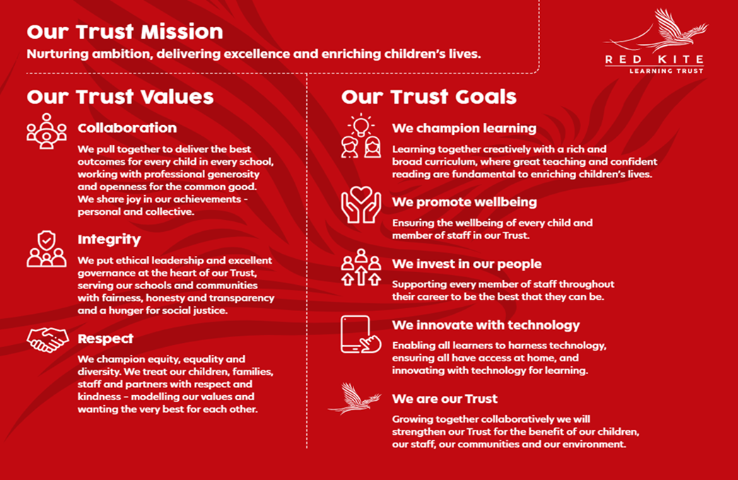
PEOPLE PROFILE
Aptitudes and Characteristics |  |  | Essential | Desirable
Ability to work flexibly across multiple sites |  |  | *
Strong attention to detail with the ability to maintain accurate, auditable records |  |  | *
Ability to analyse data and identify compliance risks and trends |  |  | *
Ability to challenge and influence others to achieve compliance outcomes |  |  | *
Confident in delivering training and guidance to staff |  |  | *
Strong teamwork skills within a centrally managed service |  |  | *
Able to communicate effectively with staff at all levels within the school and across the MAT. |  |  | *
Able to identify and report risks and maintenance concerns |  |  | *
Able to relate positively to young people. |  |  | *
Able to work effectively as part of a team. |  |  | *
Able to take initiative and work independently. |  |  | *
Ability to work under pressure. |  |  | *
Able to prioritise and plan to ensure completion of tasks. |  |  | *
Demonstrates a sense of pride in work, the school and wider environment. |  |  | *
Demonstrates a positive attitude and a solution-based focus. |  |  | *
Able to be discreet at all times in the disclosure of information about the school and MAT and has a clear awareness of confidentiality. |  |  | *
Demonstrates a full commitment to safeguarding and promoting the welfare of children and young people. |  |  | *
An inclusive, optimistic mindset with a natural ability to uplift others. |  |  | *
Self-motivated and hard working. |  |  | *
Open and honest. |  |  | *
Flexible and willing to comply with requests to ensure site services are delivered to an outstanding standard for all school pupils, staff, parents, and visitors. |  |  | *
Willingness to undertake additional training and develop personal skills. |  |  | *
Willingness to be flexible and work to meet the best interests of the school and MAT. |  |  | *
Willing to carry out any other duties commensurate with the grade of the post, as directed by the Director of Estates. |  |  | *
Qualifications, Knowledge and Experience |  |  | Essential | Desirable
Experience of using compliance management systems (e.g. CAFM / Risk Manager or similar) |  |  |  | *
Relevant Health & Safety qualification (e.g. IOSH Managing Safely or equivalent) |  |  |  | *
Experience of undertaking compliance audits and producing reports |  |  | *
Knowledge of statutory estates compliance requirements including (but not limited to): Fire safety, Asbestos management, Water hygiene (Legionella)and Electrical safety. |  |  | *
Prior experience in an estates or premises maintenance environment. |  |  | *
Knowledge / prior training of Health and Safety legislation. |  |  | *
Demonstratable problem solving skills within a work environment. |  |  | *
Good numeracy and literacy skills |  |  | *
Competency when using IT software and systems |  |  | *
Driving Licence - be willing to drive and undertake tasks as required |  |  | *
Experience in an educational setting. |  |  |  | *
Safeguarding and Promoting the Welfare of Students |  |  | Essential | Desirable
Has appropriate motivation to work with, and at times alongside, children. |  |  | *
Ability to maintain appropriate relationships and personal boundaries with children. |  |  | *
Has emotional resilience in working with challenging behaviours; and appropriate attitudes to the use of authority and maintaining discipline. |  |  | *

