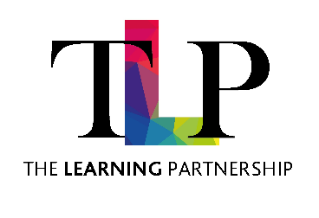
CENTRAL SERVICES

JOB DESCRIPTION

JOB TITLE | Administrator | GRADE | 4

BASIC JOB PURPOSE

To support the Central HR team in a variety of administration functions. As part of the Admin Team, you will be required to support in the completion of a range of tasks including those outlined in the main responsibilities below.

Main Responsibilities
- Provide administrative support to the People Team and assist with ad hoc administrative projects as directed by the People Business Partners.
- Monitor and triage the HR inbox, ensuring queries are responded to or forwarded appropriately.
- Support the People Business Partners with the preparation of letters, reports and other HR documentation.
- Attend meetings and provide note-taking support, producing accurate records and action notes.
- Support the Payroll team with filing, record management and general administrative tasks.
- Maintain accurate employee records, ensuring data is handled confidentially and in line with data protection requirements.
- Undertake general administrative duties including filing, scanning, data entry, document management and correspondence.
- Arrange meetings, book rooms and support the coordination of People Team activities.
- Carry out other duties commensurate with the responsibilities and grade of the role.

The Trust is committed to safeguarding and promoting the welfare of children and young people and expects all staff and volunteers to share this commitment.
Notwithstanding the detail in this job description, the jobholder will undertake such work as may be determined as necessary by the Trust.

