
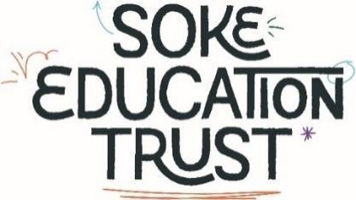
Alderman Jacobs Primary School
Class Teacher Person Specification
Attributes | E=essential  D=desirable | A=application  I=interview
Qualifications and experience  Qualified to degree level including Qualified Teacher Status  Successful teaching experience across the primary age phase  A commitment to own further professional development  Experience of leading a subject | E  E  E  D | A  A  A  A
Professional Knowledge and Experience  A thorough understanding of the National Curriculum requirements for Primary Phases  Clear understanding of how children learn and the ability to plan for effective teaching and learning  Understanding of assessment practices, including assessment for learning  Experience of planning and organising a highly effective learning environment  Thorough knowledge and experience of teaching Read Write Inc  Knowledge of CUSP curriculum/ Ark Maths Framework | E  E  E  E  D  D | A/I  A/I  A/I  A/I  A/I  A/I
Professional Skills  Ability to work effectively as part of team  Ability to form good relationships with children and parents  Good communicator – orally and in writing  Able to use IT to enhance learning  Able to create an effective, calm classroom learning environment  Able to collaborate with a range of professionals within the Trust and with external partners | E  E  E  D  E  D | A/I  I  A/I  I  A/I  A
Personal characteristics  Reliable  Able to take initiative and responsibility  Well organised  Enthusiastic and energetic! | E  E  E  E | A/I  A/I  A/I  A/I
Other  A commitment to the health, safety, welfare and safeguarding of all children  A commitment to equality, diversity and to inclusion for all  A commitment to the highest standards of learning and teaching  A commitment to following the school’s behaviour policy and holding high expectations for learning behaviours in the classroom.  A commitment to take part in all aspects of the life of the school, including meetings, training, special events and other extra curricular activities as required | E  E  E  E  E | A/I  A/I  A/I  A/I  A/I

All experience should be relevant and recent.

Soke Education Trust is committed to safeguarding and promoting the welfare of children and young people and
expects all staff and volunteers to share this commitment. The successful candidate will be required to undergo
an Enhanced Disclosure and Barring Service Check from the Disclosure and Barring Service (DBS). The appointment and interview process will thoroughly explore issues relating to safeguarding and promoting the welfare of all children.

