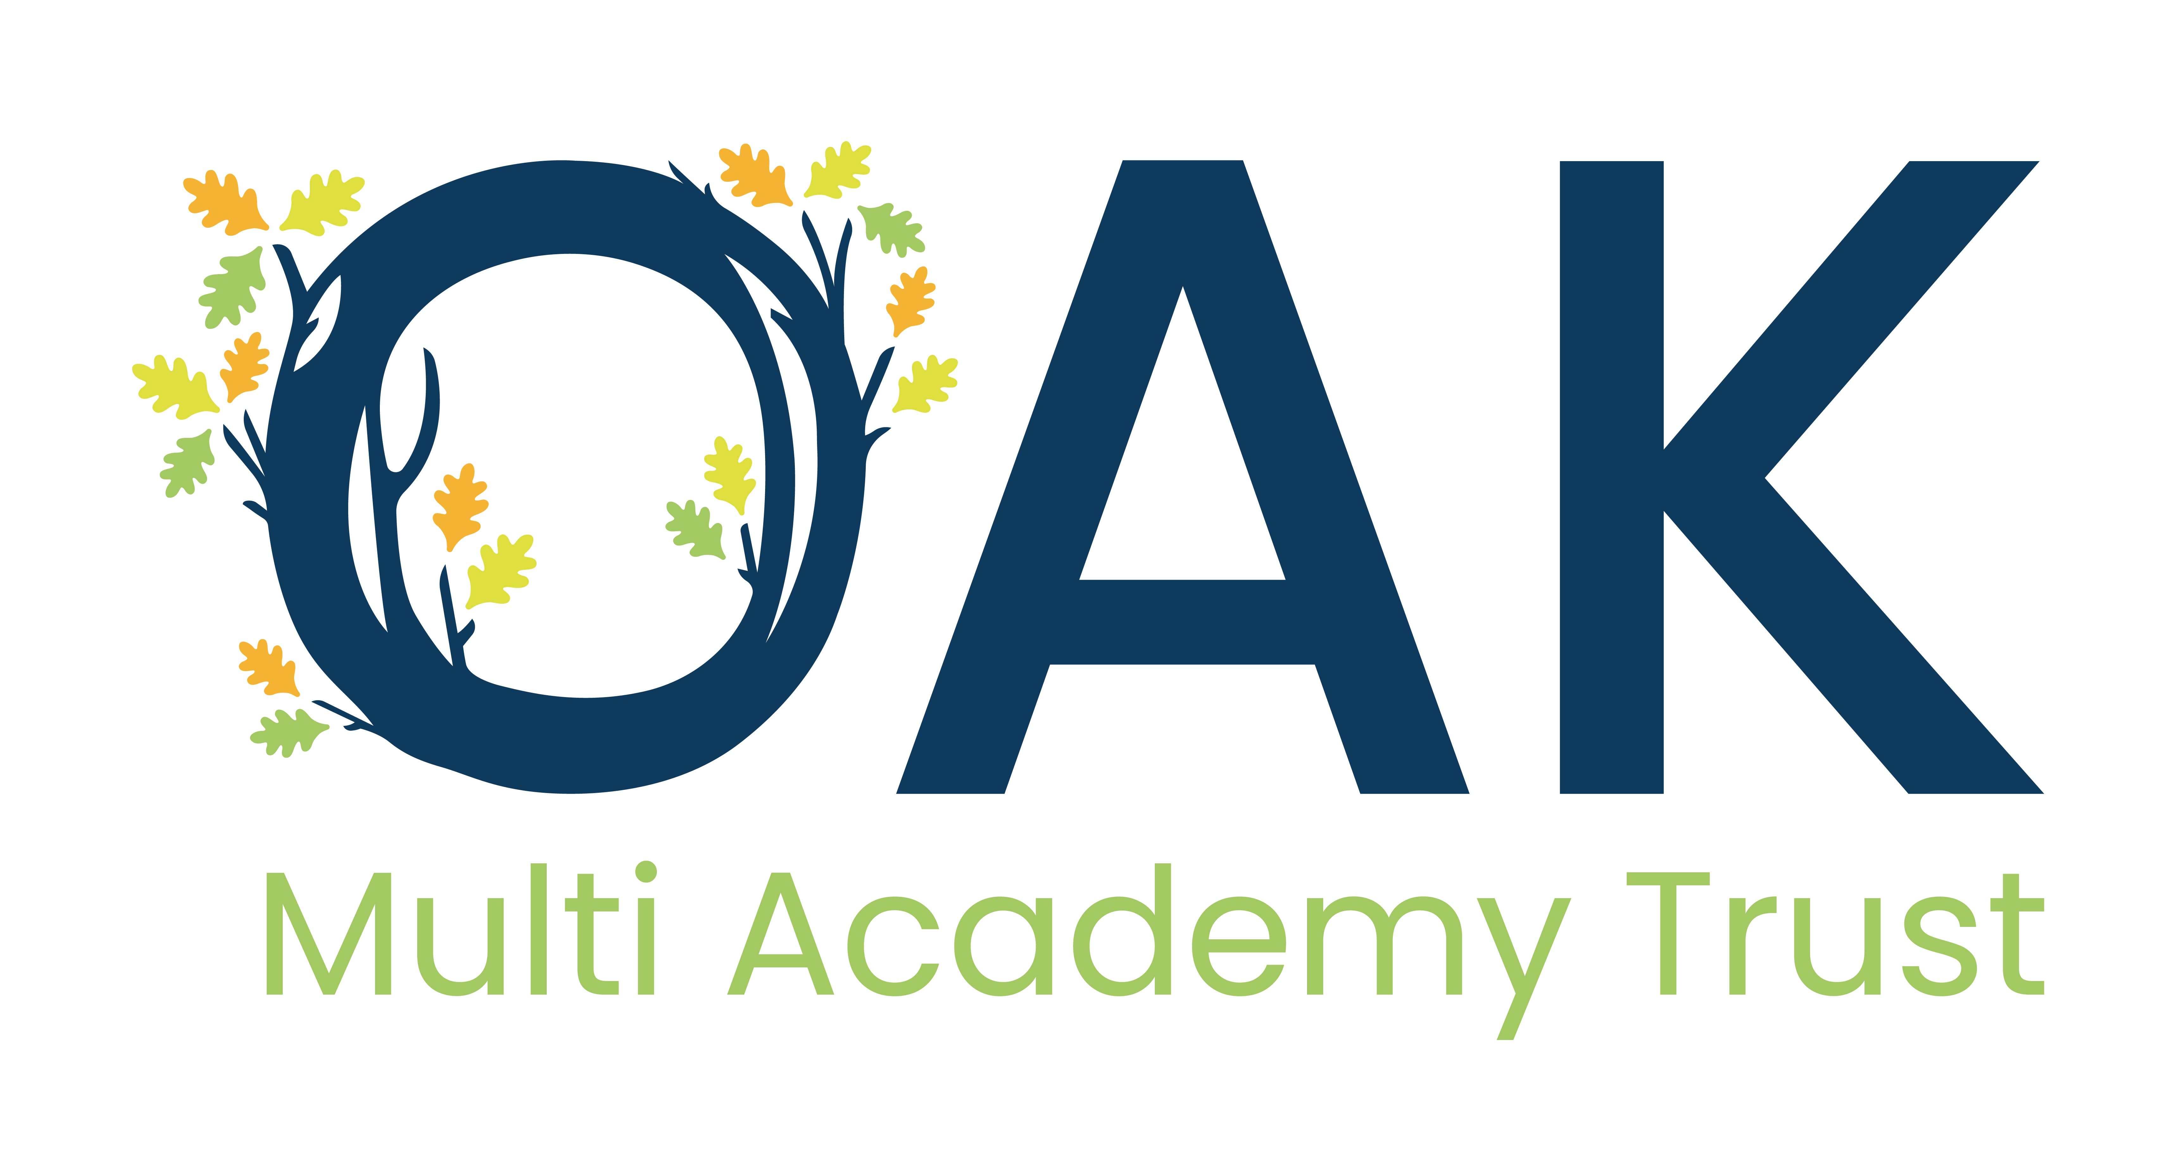
This post is eligible for a DBS check under the Rehabilitation of Offenders Act 1974 (Exceptions) Order 1975 (i.e. it involves certain activities in relation to children and/ or adults) and is defined as regulated activity under Part 1 of the Safeguarding Vulnerable Groups Act 2006.
Job Title: | Before / After School Assistant
Grade: | 2 (Point 3 – 4)
Full time salary: | £24,796 - £25,185 per annum
Responsible to: | Headteacher, Before / After School Leader
Responsible for:
Key Relationships/ Liaison with: | SENDCo, teaching staff, other Teaching Assistants, external agencies
Job Purpose: | To assist in the provision of the care, safety and learning of the children.
Occupational Standards: | Teaching Assistant Professional Standards
Main Duties and Responsibilities
Children’s Care
- Ensuring the well-being, safety and security of the children.
- Helping in setting up and clearing away.
- Maintaining records as directed.

Children’s Learning
- Assisting in the planning and implementing a multi-cultural play curriculum to stimulate children’s interest in learning.
- Assisting the monitoring the quality of learning.
- Assisting in the monitoring and recording of children’s development.
- Assisting in planning in relation to Ofsted early learning goals (the desirable learning outcomes).

Management, Organisation and Administration
- Working as a member of the team.
- Assisting in administration and organisation as required, including fee collection.
- Ensuring the Children Act and Ofsted requirements are complied with.
- Operating within the group’s policy framework, particularly in relation to health and safety, child protection and equal opportunities.
- Liaison with parents/carers and other staff to ensure children are welcomed and supported.
- Participation in appropriate professional staff development and training.
- Other such duties in relation to the job purpose that are from time to time required.

Other duties:
- To actively engage in own professional development and participate in the Trust’s performance management arrangements.
- To undertake additional duties as required, commensurate with the level of the job

Before / After School Assistant
Personal Specification
 | Essential | Desirable
Qualifications | - Level 1 or 2 qualification or equivalent in Childcare  - Good numeracy and literacy skills  - IT literate
Experience | - Experience of working within a school setting  - Understanding of religious and cultural diversity | - Experience of working within a school setting
Knowledge/Skills | - Ability to create a stimulating and enthusiastic working environment  - Excellent organisational skills  - Ability to work collaboratively in a team  - Ability to encourage high standards of effort, care and presentation
Personal Competencies and Qualities | - Enthusiastic and positive  - Ability to communicate succinctly and effectively both orally and in writing  - Friendly and approachable with a can-do attitude  - High degree of personal motivation, initiative, energy, creativity and drive  - Ability to build good relationships with parents and colleagues, including working well within a team and ability to take direction  - Punctual and flexible
Other Requirements | - Willing to receive further training  - Understanding of safeguarding issues and ability to follow all Trust procedures relating to this  - A commitment to the Trust’s aims and values  - Hold positive values and attitudes and adopt high standards of behaviour in a professional role  - Demonstrate commitment to teamwork and whole Trust improvement  - Integrity  - Self-motivated

