
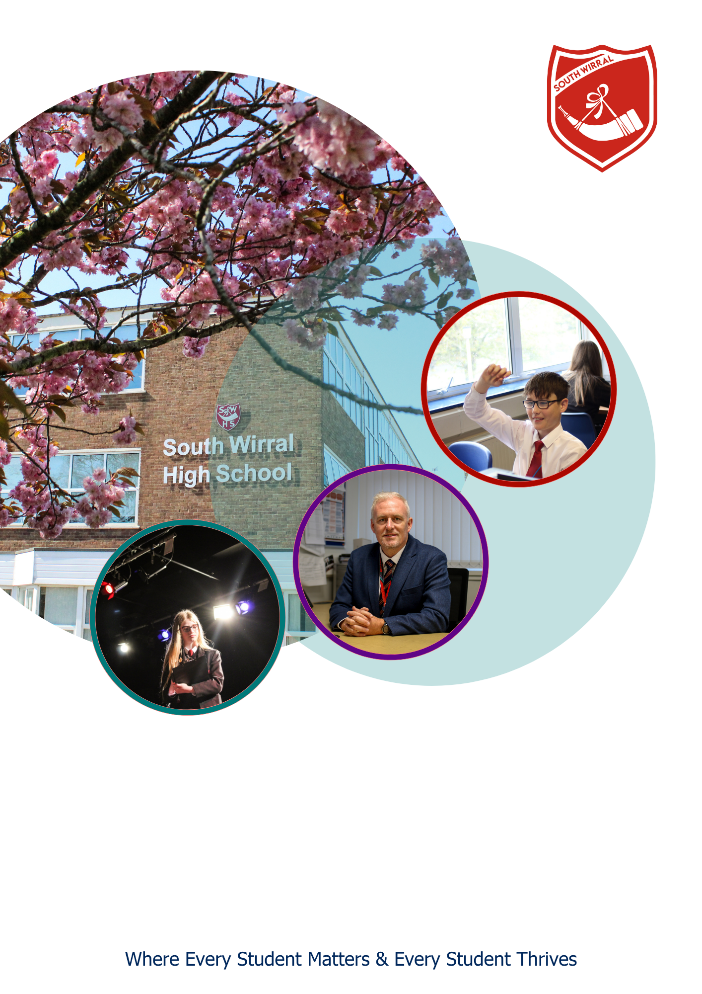

MARKETING & COMMUNICATIONS OFFICER
Job Description and Person Specification

POST OVERVIEW
Marketing & Communications Officer

37 hours per week / Term Time Only Plus 2 Weeks
Band G - NJC scp 19 (£30,295) to scp 24 (£33,462)

Location: South Wirral High School, Eastham, Wirral, CH62 8EH
Are you a creative communicator with a passion for digital marketing, design and storytelling? Are you ready to help shape the future of a forward-thinking school through powerful branding, community engagement and innovative campaigns?

South Wirral High School is seeking a Marketing & Communications Officer to take the lead in promoting our school’s values, achievements and ambitions. You will play a vital role in strengthening our profile in the local community, supporting student recruitment, and helping generate alternative income through grant bids and partnerships.

About the Role
You’ll be involved in a wide range of creative and strategic activities, including:
- Developing and delivering the school’s marketing and communications strategy
- Creating engaging content for social media, newsletters, print and web
- Managing and updating the school website with SEO-friendly content
- Promoting and managing school lettings, events, and opportunities for partnership working
- Designing visual materials and managing brand identity across platforms
- Supporting student recruitment through open evenings, tours and feeder school engagement
- Building relationships with the local press and community partners

You’ll work closely with the School Business Manager and Leadership Team to ensure that our marketing approach supports school improvement and generates positive engagement.

About You
We’re looking for someone who is:
- Experienced in marketing, digital communications or design
- Creative, with strong copywriting and visual storytelling skills
- Proficient in tools such as Canva, Adobe Creative Suite and website CMS platforms
- Organised and self-motivated, with the ability to manage multiple projects independently
- Confident in using social media, analytics and digital marketing tools
- A strong communicator, capable of engaging with a wide range of stakeholders

Experience working in a school or education setting is desirable but not essential. A passion for education and a desire to make a difference is an essential.

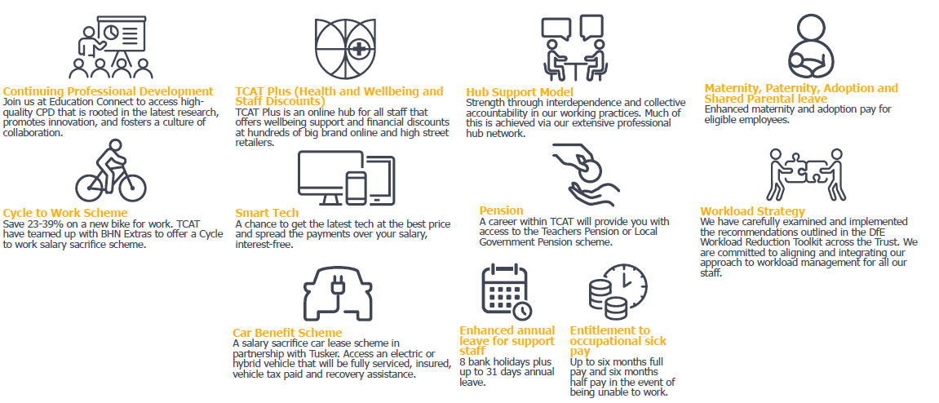
What we offer:

We are part of The Challenge Academy Trust, to learn more about the trust please visit www.tcat.uk.com.

For more information on this role, please contact Jenny Long – HR Manager – recruitment@southwirral.wirral.sch.uk

The Challenge Academy Trust is committed to promoting the safeguarding and welfare of children and young people and expects all staff and volunteers to share this commitment. All appointments are made subject to an Enhanced DBS check. We are an Equal Opportunities Employer, and our employment policies, procedures and practices are regularly reviewed to ensure compliance with legislation. We are committed to creating a workplace culture that is inclusive, positive, and fair with opportunity for all.

Closing Date – 18th September 2026

Successful Applicants will be notified by 21st September 2026

Interviews
Interviews will take place week commencing 21st September 2026

Method of Application
Please apply via MyNewTerm

JOB DESCRIPTION

NAME:
JOB TITLE: | Marketing Officer
HOURS: | 37
SALARY BAND: | Band G
CONTRACT TYPE: | 40 weeks
REPORTS TO: | School Business Manager
RESPONSIBLE FOR: | N/A

MAIN PURPOSE
The Marketing & Communications Officer plays a central role in promoting South Wirral High School’s vision, values and successes through strategic marketing, communication, and digital content creation. The postholder will be responsible for raising the school’s profile, increasing student recruitment, building community engagement, and supporting the development of alternative income streams including lettings, grant funding and partnership working.

DUTIES & RESPONSIBILITIES
Strategic Marketing & Branding
- Lead on the development and implementation of the school’s marketing and communications strategy.
- Promote a consistent brand and key messages across all platforms and events.
- Develop marketing campaigns to support student recruitment and enhance the school's public image.

Digital Marketing & Content Creation
- Plan, produce and manage engaging content across digital platforms (social media, website, email newsletters, etc.).
- Maintain the school website ensuring up-to-date, accessible and high-quality content optimised for search engines (SEO).
- Design promotional materials including prospectuses, newsletters, event signage, and digital graphics using tools such as Canva or Adobe Creative Suite.

Media Relations & Storytelling
- Build relationships with local and national media to generate coverage of school achievements and activities.
- Create press releases and manage media enquiries.
- Identify and capture compelling stories about students, staff and the school community for use across marketing channels.

Event Promotion & Communications
- Plan, promote and support key events such as Open Evenings, Welcome Days and community showcases including attendance and distribution of promotional materials.
- Capture and share photography, video and testimonials from events to build social media presence and reputation.
- Support the production and delivery of internal communications including parent bulletins and staff newsletters.

Community Engagement & Income Generation
- Proactively support and manage the development and promotion of lettings of school facilities, liaising with the Lettings Officers and customers to maximise occupancy and revenue. Managing the SchoolHire lettings site and responding to queries from customers.
- Lead marketing campaigns targeting local businesses, housing developments, and community networks to drive interest in school services.
- Support the identification and promotion of grant funding opportunities and partnerships to enhance school resources and community links.

Partnerships & Admissions
- Maintain relationships with feeder schools, community groups and parents to support Year 7/12 recruitment and transition.
- Administer marketing aspects of admissions including managing enquiries, tours and follow-up communications.
- Coordinate print and digital content for transition packs, admissions events, and welcome communications.

The job description is not necessarily a comprehensive description of the duties required but outlines the main responsibilities of the post and you may be asked to undertake any duties commensurate with the grade of the post.
The Headteacher or postholder may seek a modification of the job description at any time.
An Enhanced DBS check will be required for this post.
PERSON SPECIFICATION – MARKETING & COMMUNICATIONS OFFICER

Criteria |  | Essential | Desirable | Assessment Method
Relevant experience / qualifications
1 | Relevant qualification in marketing, communications, digital media, or a related field | X |  | A/I/T
2 | Proven experience creating digital content and running marketing campaigns | X |  | A/I/T
3 | Experience managing websites and social media accounts for an organisation | X |  | A/I
4 | Experience in event promotion, community engagement, or partnership working |  | X | A/I
5 | Experience using tools like Canva, Adobe Creative Suite, or similar design platforms | X |  | A/I
6 | Experience working in an education, charity or public sector setting |  | X | A
Knowledge & understanding
7 | Understanding of marketing best practice, including branding and visual identity | X |  | A/I/T
8 | Awareness of SEO, web accessibility and content optimisation | X |  | A/I
9 | Knowledge of analytics tools (e.g. Google Analytics, Meta Business Suite) |  | X | A/I
10 | Understanding of safeguarding, GDPR and responsible communication standards | X |  | A/I/T
Competencies
11 | Strong written and verbal communication skills, including copywriting and editing | X |  | A/I/T
12 | Excellent attention to detail in written and visual content | X |  | A/I/T
13 | Ability to manage multiple projects and meet deadlines independently | X |  | A/I/T
14 | Confident using digital platforms, CMS, and social media schedulers | X |  | A/I/T
15 | Creative thinker with the ability to develop new ideas and approaches | X |  | A/I/T
16 | Able to work flexibly, respond to emerging priorities, and attend occasional events outside of normal hours | X |  | A/I
17 | Committed to the vision, values, and ethos of South Wirral High School | X |  | A/I
Commitment to Equal Opportunities

18 | Understanding of and commitment to the principles and practice of equality, diversity, and inclusion, both in relation to employment issues and to service delivery | X |  | A/I

Key: A = Application I = Interview T = Task

NOTE TO APPLICANTS: Whilst all points on the specification are important, those marked as ‘essential’ are the key requirements for the role. You should pay particular attention to these points and provide evidence of meeting them. Failure to do so may mean that you will not be invited for interview.

