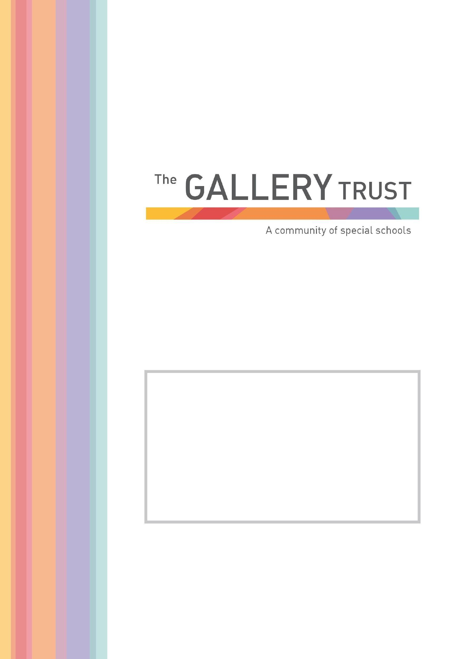

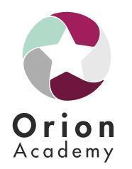

Teacher of SEND
Candidate Information Pack
Summer 2026

Welcome

Thank you for your interest in the role of Teacher of SEND, at Orion Academy.

Orion Academy currently offers places to 74 students; the roll of the school will rise steadily over the next two years to cater for 108 students, aged from 10 to 18 years: the teacher roles are advertised due to a planned increase in student numbers for September 2026. Students attend from throughout the county, and transfer from our SEND feeder school, Northern House Academy, and from mainstream primary and secondary schools. The Academy moved into new, state of the art buildings in September 2021. Our facilities offer a wide range of exciting curriculum and vocational opportunities to learners, and a fantastic working environment.

All students who attend Orion Academy have an Education, Health and Care Plan, which describes their special needs and drives their educational provision.

Students are taught through a differentiated and bespoke curriculum designed to enhance their personal and social development and academic achievement. We have a strong intent to ensure our students leave with the personal characteristics to thrive in their communities. Classes are taught in stages, not necessarily age, allowing innovation and creative approaches to teaching and learning. The Academy provides support for our students with social and emotional needs through our Academy Community Learning Team, which consists of youth workers, therapeutic and pastoral workers.

Thank you for your interest in Orion Academy. This is an exciting time to join our school and we look forward to receiving your application.

Jessie Shakespeare Hannah Shuker
Co. Headteacher Co. Headteacher

Teacher of SEND
Location: Orion Academy, Oxford
Contract Type: Full time
Salary: TMS/UPS plus SEN allowance

If you are committed to enriching and improving the lives of young people with Special Educational Needs and Disabilities, would like to join a team which delivers an exciting and diverse curriculum, and want to work in a vibrant and dynamic Special Academy – we want to hear from you!

Students are taught through a differentiated and bespoke curriculum designed to enhance their personal development through the lens of our six characteristics: self-awareness, commitment, being resilient, team player, problem solver, showing empathy.

The curriculum delivery is through a hybrid model with KS3 students using a primary model and KS4 students having several teachers. The academy provides support for the social, emotional and mental health needs of the students through a qualified and skilled Community Learning Team. This team underpins the pastoral support and wellbeing of our students.

Our focus is to recruit teachers who are keen to grasp the possibilities offered by the Academy where practice is based on SEN pedagogy and evidence informed practice: who would relish getting involved in developing themselves as teachers of excellence. You will want to work as part of a multi-disciplinary and specialist team.

Orion is at an exciting stage of its development where we are looking to develop our curriculum and offer to be innovative and driven by the future needs of our society so that our neurodiverse community thrive in their communities and employment.

Teaching and support staff actively inform the developments of the school and collectively we identify the best ways of working through our developing professional learning community.

Our unique features include:

- Curriculum innovation and design for the future is happening now
- Individual learning pathways which teach the way our students learn and moves away from ‘one-size fits all’ approach
- An ethos of restorative approaches, mutual respect and social responsibility which creates an inclusive and nurturing community.
- A flexible, innovative student-centred approach, which supports not only excellent teaching and learning, but also emotional and mental wellbeing of students and individual needs.

Benefits of working at Orion Academy, part of The Gallery Trust

Career Progression

- Be a key member of a friendly and supportive staff team who are dedicated to achieving the best for every one of our pupils
- Participate in high quality professional development opportunities which are tailored to your needs and to your career aspirations
- Develop your career in The Gallery Trust, an expanding and successful organisation which offers opportunities for progression, secondments and collaborative working with colleagues across our schools

Financial
- Competitive salaries for teaching and support staff based on School Teacher Pay and Conditions Document and the NJC Green Book
- Perkbox membership
- Access to LGPS pension linked to salary life assurance
- Contribution towards glasses and eye tests for DSE use
- Salary sacrifice schemes, including childcare vouchers and cycle to work

Wellbeing
- 24/7 access to a free Employee Assistance Programme to provide confidential advice and guidance
- Excellent induction processes, and strong line management structures to promote your wellbeing at work
- A culture which is open to employee ideas and encourages open dialogue
- Regular staff surveys to gain feedback on wellbeing and to drive improvements
- The opportunity to join colleagues for social events
- Family friendly policies, which promote your wellbeing
- The opportunity to work in a new, purpose-built school building, which offers an exciting environment in which to teach and learn, located just a short drive from Oxford’s ring road
- Free car parking and cycle storage
- On-site catering

Application Process

To apply for this post please submit an application form via the MyNewTerm portal. The deadline for applications is Friday 12th June 2026 at Midnight. Interviews are provisionally scheduled to take place on Thursday 18th June 2026.

Please ensure you detail any gaps in employment and use the selection criteria which is contained in the job pack when you prepare your application, as shortlisting for interview will be based on how closely you demonstrate your ability to fulfil the essential criteria. We are committed to ensuring that everyone feels welcome, respected, and supported throughout our recruitment process. If you have a disability, are neurodivergent, or have any additional needs that may require adjustments at any stage of your application or interview, please let us know via recruitment@orionacademy.co.uk
Visits to the academy are encouraged. Please contact Jessie Shakespeare or Hannah Shuker at Orion Academy, to arrange an informal visit and conversation. We look forward to hearing from you. We do not accept CVs. If you are shortlisted, we will take up written references before your interview so please provide permission for this and provide accurate phone and email contact details for your referees. One of your referees must be your current or last employer, and if you are employed in a school, must include your current Head Teacher. If you have previously worked in a school, your referees must include your most recent Head Teacher.

The Gallery Trust is committed to safeguarding and promoting the welfare of all children and expects all staff to share this commitment. Any offer of employment with The Gallery Trust is subject to verification of ID and qualifications, satisfactory evidence of the right to work in the UK, health clearance, and Enhanced Disclosure and Barring Check. The Gallery Trust is an equal opportunities employer, and we welcome applications from candidates from all ethnic and community backgrounds.

The Gallery Trust is a Special Multi Academy Trust which is dedicated to improving outcomes for SEND learners in Oxfordshire. We strive to provide the best possible specialist learning experience for all pupils.

Our Strategic Aims

- Places where innovation drives learning – our schools have a clear purpose, they educate the whole child and prepare them for adulthood. Everything we do, from our curriculum offer to our pastoral care, is meaningful and driven by the needs of learners.

- Places where relationships drive engagement and achievement – our schools are built around exceptional relationships. We provide excellent experiences, growth, and opportunities for pupils and staff, and specialist working environments and resources.

- Places which provide exceptional knowledge and support – our schools are supported by a skilled and experienced central team which provides high quality school improvement and central support services.

- Places which inspire and influence – our schools are committed to collaborating with our local and national partners and communities to ensure that children and young people with SEND receive the education and opportunities they deserve.

As we enter the next phase of our development and build on our many successes, we want to embrace future challenges and opportunities. The Trust is on a continuing journey of expansion, growing from a Multi Academy Trust based on a single academy in 2013, to its position as the largest Special Trust in Oxfordshire. There are currently six special academies in the Trust located throughout Oxfordshire, with an additional academy opening in January 2024, and a further academy scheduled to open in 2026. The Trust’s vision is to continue to expand over the next five years, supporting a community of converter academies, free schools and sponsored academies, and providing outreach and other opportunities. All academies collaborate to share SEND expertise and best practice, and work in partnership with peers who are committed to common aims and goals.

The Board of Trustees believes that by providing the support of highly experienced and specialised school improvement and business teams, school leaders are empowered to focus on the standards of teaching and learning, and in meeting the operational and strategic demands of running their schools.

Teacher of SEND
Job Description

Responsible to: Co-Head Teachers and Line Manager

Introduction

This job description describes in general terms the normal duties which the postholder will be expected to undertake. However, the job or duties described may vary or be amended from time to time without changing the level of responsibility associated with the post.

The performance of all the duties and responsibilities shown below will be under the reasonable direction of the Co-Headteachers or other Senior Manager if appropriate, will be mindful of her/his duty to ensure that the employee has a reasonable workload and sufficient support to carry out the duties of the post.

The job description will be reviewed at least annually and any changes will be subject to consultation. The academy’s grievance procedure will be used to resolve any disagreement arising out of the job description. Other relevant policies may be the Stress at work policy and Dignity at work policy.

Job Purpose
To assist and support the leadership in providing high standards of teaching and learning across the curriculum and to promote the school’s vision and ethos.

Key Tasks
Teaching and Learning
- Ensure all pupils in their care within the academy receive an exciting, effective and appropriate education as outlined in their Educational Health Care Plan (EHCP) and in accordance with the academy’s curriculum framework.
- The provision of suitably differentiated work to meet the individual needs of the students
- The curriculum planning and review cycle is maintained in accordance with the school’s planning framework and policy
- On-going assessment of students’ work and abilities through comprehensive record keeping based on the academy’s agreed format
- Maintenance of good discipline in line with the academy’s Restorative Approaches policy
- Contribution, wherever appropriate, to the display, presentation and celebration of students’ work across the school, building a culture of learning
- Safeguarding and promoting the welfare of all students
- Set high expectations which inspire, motivate and challenge students ensuring progress and outcomes
- Demonstrate and promote high standards of literacy and numeracy and within the school curriculum areas
- Manage behaviour effectively to ensure positive and safe learning behaviours and environments
(Teacher Standards, DfE)
Wider Responsibilities Relating to Whole Academy Issues and Procedures
- Working for the positive development of the academy, in line with the Raising Achievement Plan and your area of curriculum specialism
- Attending staff meetings, curriculum forums or any other relevant meetings within the stipulated 1265 directed hours
- Taking a share of supervisory duties as part of the weekly routine as necessary
- Taking appropriate responsibility for one’s own health, safety and welfare and the health and safety of pupils, visitor and colleagues in accordance with the requirements and locally adopted policies: including taking responsibility for raising concerns with a manager
Specific Responsibilities

In addition to the duties outline in the School Teachers Pay and Conditions document currently in operation, or any subsequent legislation, you will be responsible for the following:

- Teaching across a range of curriculum areas, including the role of tutor
- Staff development and support
- Delivering INSET training throughout the academy, as appropriate

Links with Parents, Local Authority and The Wider Community

- Encouraging full parental participation in the work, life and development of the school and making sure they are fully informed of their child’s progress. To be available to deal with parental concerns and provide support where possible or refer to other professionals or agencies
- Working co-operatively with the Governing Body and Trustees
- Liaising and co-ordinating with external agencies and other professionals
Other Responsibilities
In addition to the duties outlined, you may be responsible for the following:
- Driving and supporting pupils in school vehicles
- Supporting pupils on a range of offsite educational visits
- Undertake tasks and duties as requested by the Headteacher
General Responsibilities
- Taking appropriate responsibility for one’s own health, safety and welfare and the health, safety and welfare of pupils, visitors and work colleagues in accordance with the requirements of legislations and local-adopted policies; including taking responsibility for raising any concerns with an appropriate manager and for reporting accidents and incidents appropriately
- To carry out other duties as may be reasonably assigned by the Co-Headteachers
- Be aware of and support difference, ensuring equal opportunities for all
- Be aware of and comply with the school’s policies and procedures

Selection Criteria
Teacher of SEND

 | Essential | Desirable
Professional Qualifications | - Qualified to work and teach in the UK  - Qualified Teacher Status (QTS)
Experience | - Successful teaching experience  - Planning for and teaching pupils  - Effective involvement in school improvement planning and monitoring  - Evidence of strategies developed for target setting and monitoring performance, in order to raise pupil achievement  - Experience of interactive teaching methods  - Evidence of differentiation of the curriculum  - Evidence of demonstrating an impact in your area of curriculum | - Planning for and teaching pupils with SEND (SEMH in particular)  - Leading a subject area  - Leading a subject area in your chosen specialism
Professional Knowledge & Skills | - Awareness of current initiatives, issues and legislation  - Knowledge and experience of developing a purposeful learning environment and using a range of strategies to promote good behaviour  - Respect for pupils’ social, cultural, linguistic, religious and ethnic backgrounds, with an understanding of how these may affect their learning  - Understanding the role of teaching assistants in maximising pupils’ learning  - Knowledge and experience of applying a framework of curriculum planning which: includes long and short-term plans; requires learning objectives to be identified for classes, group and individuals; enables monitoring, assessment and recording of pupils’ progress | - Knowledge of integrating therapeutic interventions (SaLT programmes, Physio programmes)  - Delivery of whole-school curriculum in your subject specialism
Personal Skills and Qualities | - Strong commitment to raising standards  - High expectations of self and others  - Ability to establish and maintain positive relationships, including with parents  - Ability to remain positive and enthusiastic, including when under pressure  - Ability to work flexibly and adapt according to the situation  - Highly effective communication skills  - Effective computing skills

Your application should clearly demonstrate how well you meet the above key criteria

Aims

At Orion Academy we believe our children and young people are unique individuals and as such we have designed our school curriculum with their learning and Social, Emotional and Mental Health needs at the heart of all we do.

Our nurturing approach seeks to extend our work out into the community; actively supporting, listening and engaging with our families and carers to deliver the best possible environment for our children and young people, thus enabling them to learn effectively, become active and responsible citizens who are well prepared for life after school.

We are committed to delivering this through:-

Our nurturing approach that will provide an environment to thrive –

- Where every child or young person is treated as an individual in a safe and nurturing environment that understands that all students can achieve but will require differentiated approaches based on their individual needs.
- With a school-wide family ethos demonstrating our values of empathy, acceptance and mutual respect, so each member of the school community feels valued and supported.

Our focus on personal development is designed to –

- Enable our children and young people to become more socially aware and of their responsibilities with a focus on trust and choice.
- Ensure we support our children and young people to make better decisions, coach them how to regulate frustrations, and reflect on their experiences through our restorative practices.
- Help our children and young people to make sense of the changing world and of the importance of diversity and equality of opportunity.
- Enable them to make informed choices and develop the confidence to be successful in their adult lives through our embedded personal, social and health education programme.

Our focus on celebration and recognition of success is designed to –

- Encourage and celebrate each student’s talents, skills and attributes.
- Develop the confidence and self-belief of the individual – a culture of ‘I can’ or ‘I can’t… yet’ is ingrained across our school.
- Provide opportunities for our children and young people to be successful and support them in both developing and promoting their individual resilience as well as celebrating the achievements of others.

Our ambitious curriculum offer that is designed to –

- Create the capacity to learn and enjoy learning by broadening our students’ horizons and extending learning beyond the classroom.
- Use real-world examples and first-hand experience; develop curiosity and a desire to challenge their understanding and deepen learning.
- Prepare our children and young people for their future through our broad and balanced curriculum, providing them with knowledge, core literacy and numeracy skills and experiences as well as a range of qualification pathways.
- Embed key learning and understanding through careful and thoughtful revisiting and reinforcing, whilst increasing student independence.

Our personalised provision that –

- Is responsive to the needs of each student but is uncompromising in expectation. We will be relentless in our support for our children and young people to achieve beyond their expectations.
- Understands that whilst a student’s needs are recognized and met, they are not confined by them; we do not define a future based on a child or young person’s past and we are unapologetic in our approach in wanting our students to continue to push the boundaries of their potential.

Our commitment to working in partnerships with our parents and carers which demonstrates that –

- We believe our children and young people will achieve their best when families and our school work together in a partnership.
- Effective working relationships are characterized by open and honest communication in order to achieve the best possible outcomes.

Our specialist and expert workforce who –

- Are passionate and committed to working in special education and will know each student as an individual, recognising their unique talents, skills and interests.
- Have developed strong and positive relationships with our children and young people in order to support them effectively.
- Have expertise, specialist knowledge and an understanding of a child or young person’s needs that embraces the most recent and evidence-based research will result in the best possible outcomes for students
- Are committed to working with therapeutic specialists and external agencies to enhance our provision for our students and their families.
- Support children and young people to recognise and value their own learning journey.

May 2026

