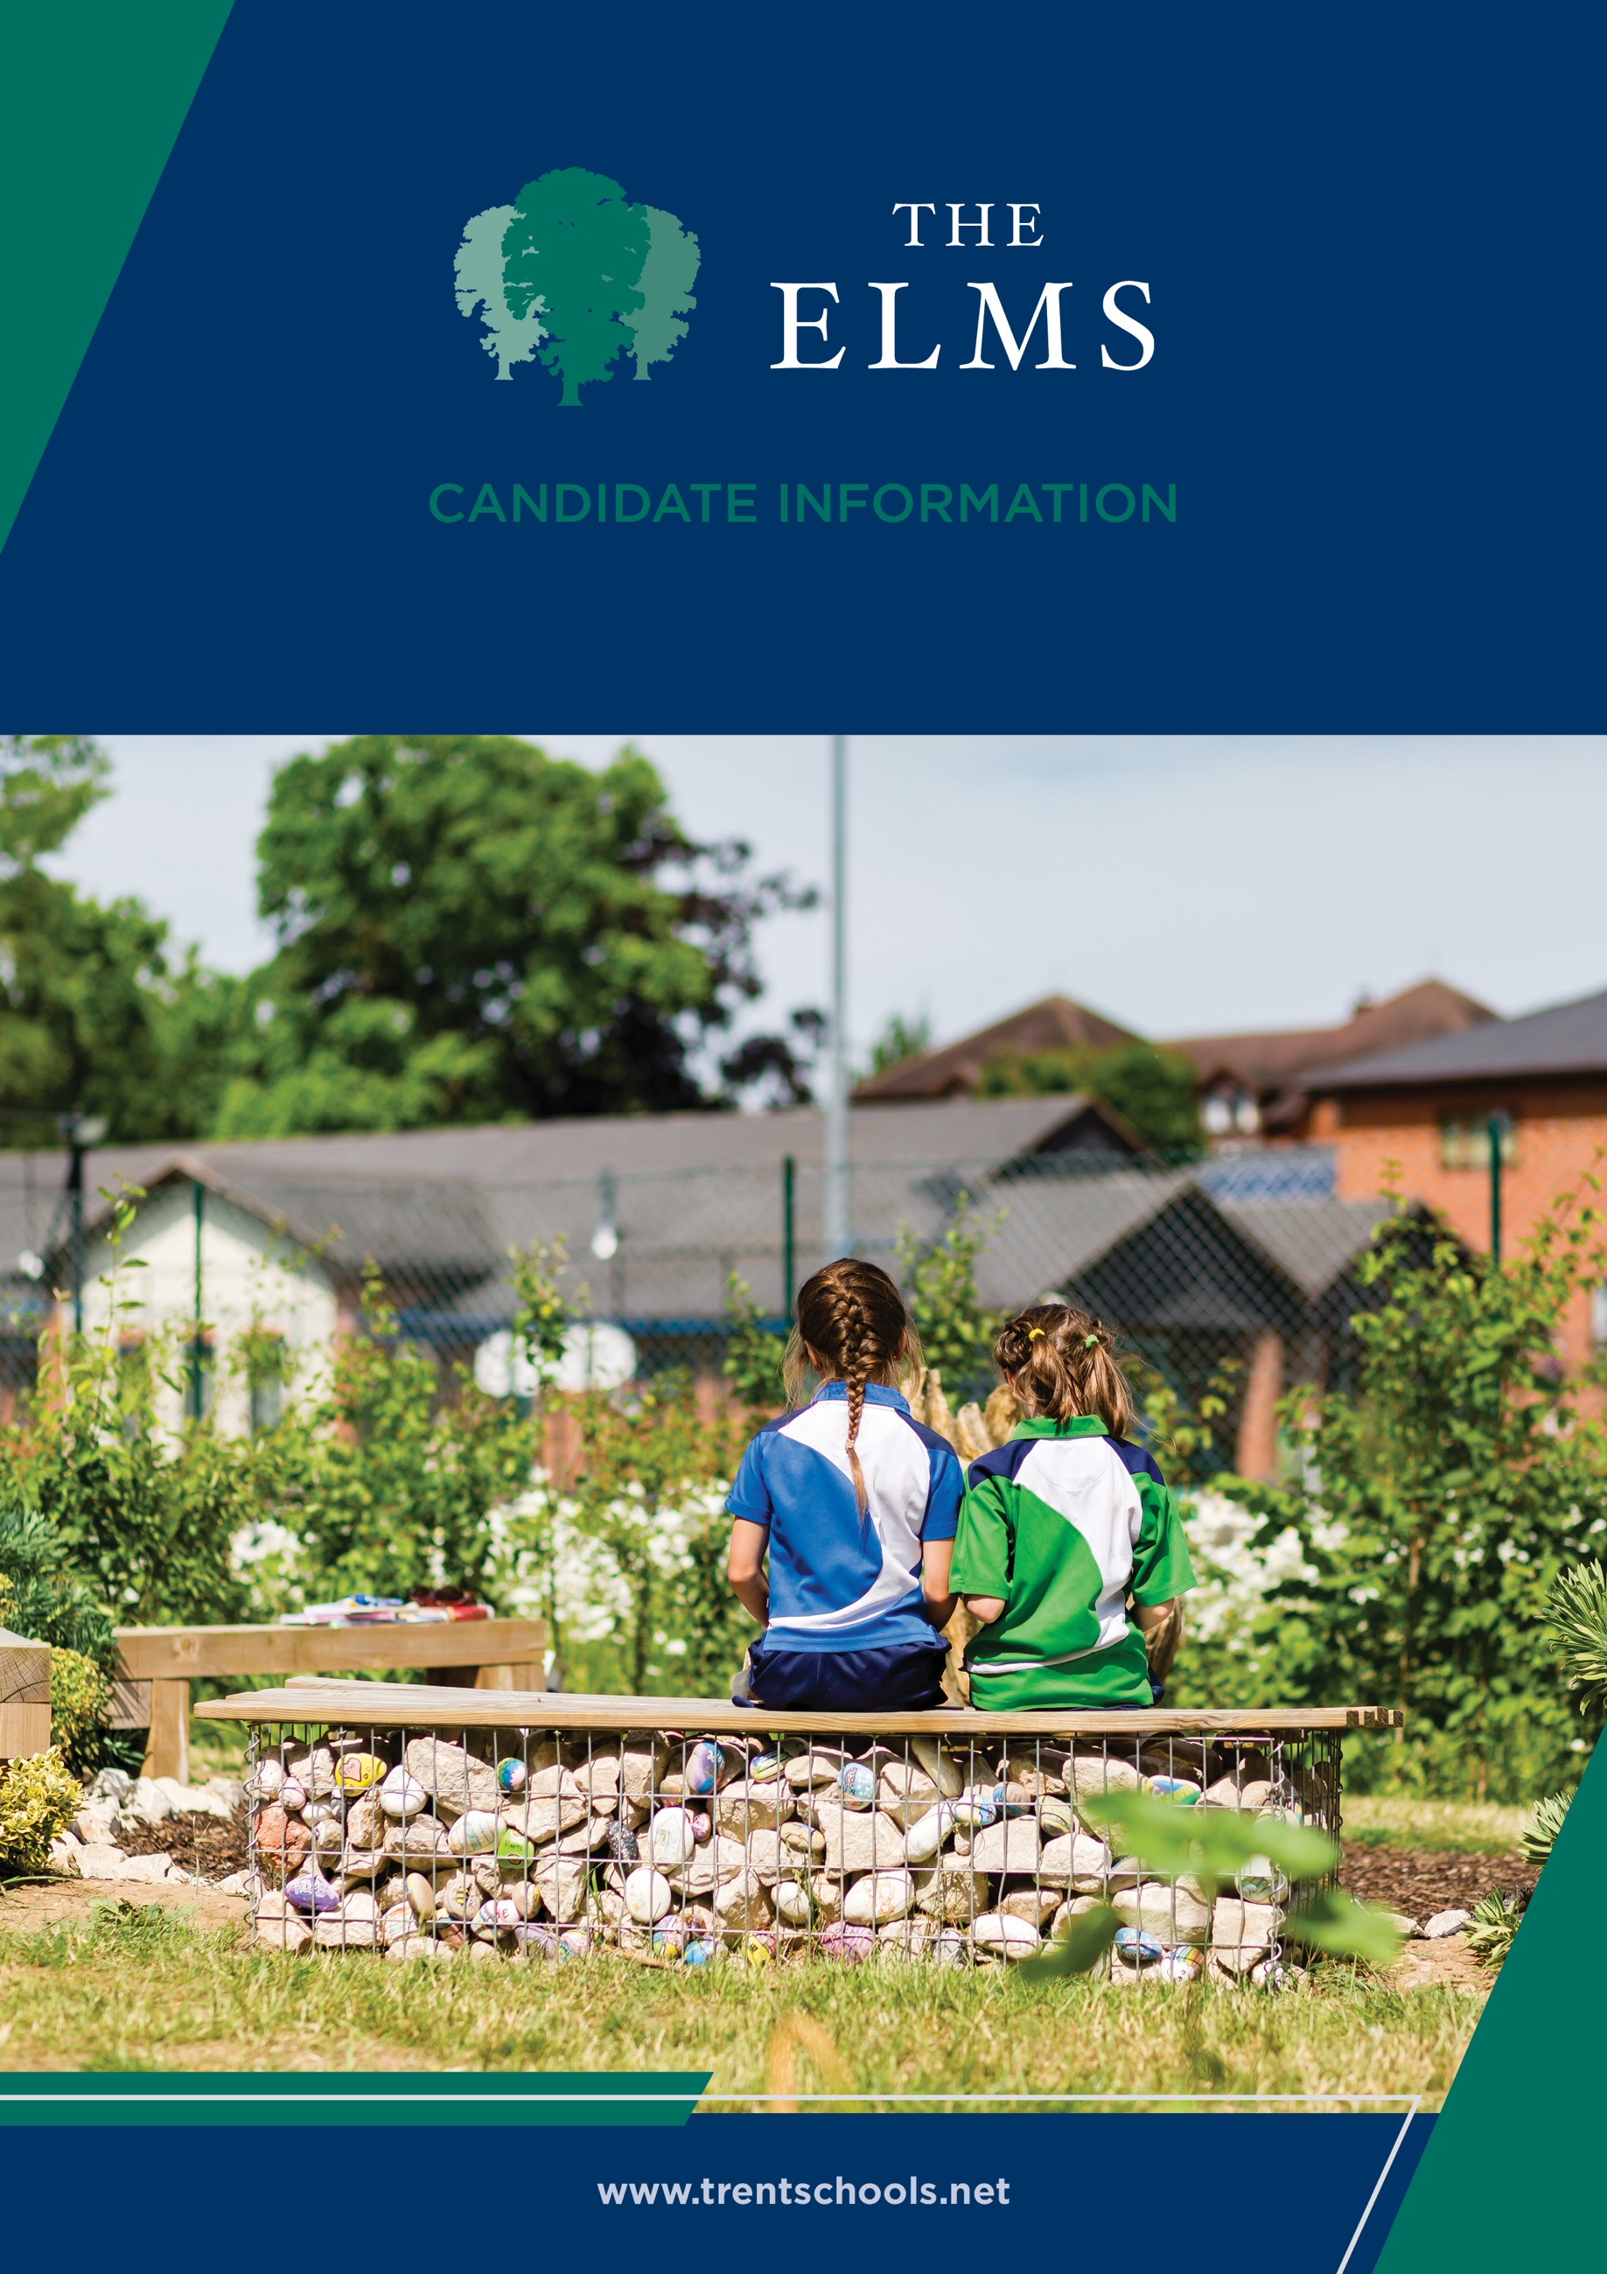


Welcome
The Elms is an independent co-educational school for children aged from 6 weeks to 11 years old. Located in Long Eaton, Nottinghamshire, The Elms is part of Trent College, and enjoys a beautiful, shared 45-acre campus with state-of-the-art facilities, including modern classrooms and sports facilities, as well as dedicated Nursery and Pre-School buildings, and wonderful outdoor learning facilities.
The Elms journey begins in the Nursery, which was recently rated ‘Outstanding’ in all areas. Here learning through play and exploration builds confidence and curiosity about the world around them.
As children progress through the school, the focus on exceptional pastoral care and inspirational teaching, along with a vast array of enrichment opportunities, ensure that our children leave us with the independence and resilience to embark successfully upon their senior school education.
Rated ‘Excellent’ across the whole school by the Independent Schools Inspectorate in 2021, we have highly qualified and experienced teaching staff who are committed to providing an excellent standard of education. We also have a large population of support staff, ensuring that our friendly school and beautiful campus operate to the very highest standards and our pupils are happy and flourish.
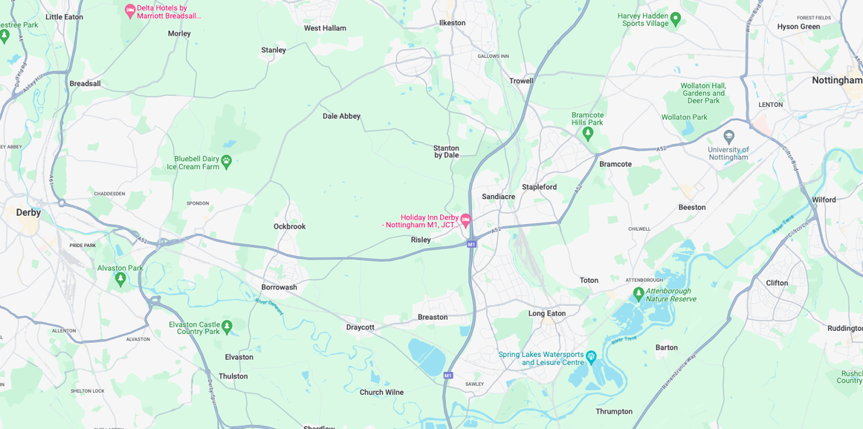


Our Location
Trent College and The Elms are conveniently situated on the border of Nottinghamshire and Derbyshire.
Ideally located at the heart of the UK’s motorway system, we are only 2 miles from junction 25 of the M1, which provides easy access to the M42 and A1.
Reaching Trent College by rail couldn’t be easier. Long Eaton boasts its own train station, located 1.5 miles from the schools. Rail routes through Long Eaton run along the Midlands Main
Line route, with direct routes to London, Loughborough, Leicester, Birmingham, Nottingham, Derby, Chesterfield and Sheffield.

Our Local Community
Working in partnership and serving the community are natural and very important values at Trent College and The Elms. We work with many local schools in Long Eaton and the wider Erewash borough to increase opportunities and aspirations, and to share the school’s excellent grounds, facilities and specialist staff.



Lunchtime Supervisor (Maternity Cover)

Job Description
• To supervise children eating their lunch in the dining hall (The Obolensky) followed by playground supervision or in inclement weather in the school building.
• To deal with unruly or unsafe behaviour in accordance with the school behaviour policy and where necessary report difficulties to the relevant member of the leadership team or teaching staff.
• To assist children with lunches in the school dining hall.
• To mop up or wipe spillages from the floor surfaces or meal tables as necessary.
• To ensure that the dining areas are left in a tidy condition.
• To ensure that any injury or sickness of pupils in the playground is dealt with immediately and to refer children to the medical centre for treatment if appropriate.
• To make sure that any accidents involving injury are written up on a accident form.
• To ensure that any health and safety hazards noted are reported.
• To monitor children on the playground/field during lunch breaks and to encourage play amongst the children.
• To ensure that every child has had a lunch.



- To ensure that no pupils remain in outside areas when afternoon lessons are due to begin and that no child is in the school building without a member of staff during the lunch break period.

- To be aware of the school’s safeguarding policy and to attend safeguarding training sessions as required
• Any other duties as may be reasonably requested to reflect the changing needs of the school and the requirement to provide a safe environment for the children.

This is not an exhaustive job description and may be subject to change according to the needs and development of the role. It is expected that the post holder may undertake such other duties as may be reasonably be requested.

Experience and Knowledge
- Experience of working with children or young people.
- Understanding of safeguarding and child welfare.
- Awareness of health and safety requirements.
Skills and Abilities
- Ability to supervise children safely and effectively during lunch breaks.
- Ability to encourage positive behaviour and play.
- Good communication and interpersonal skills.
- Ability to deal calmly and appropriately with accidents, incidents and challenging behaviour.
- Ability to follow school policies and procedures.
- Ability to work as part of a team.
Personal Qualities
- Reliable, punctual and responsible.
- Caring, patient and approachable.
- Able to remain calm under pressure.
- Commitment to safeguarding and promoting the welfare of children.

Person Specification



Benefits
- Free car parking is available on site and staff have access to a cycle to work scheme.
- Staff are able to make free use of the school gym and leisure facilities at designated times.
- A flexible retirement plan run by TPT Solutions (formerly The Pensions Trust), including Death in Service benefit.
- Enhanced sick pay and maternity pay is available to staff.
- Staff are entitled to a fee remission for children attending the school, in line with our policy.
- We provide a range of benefits to support staff, including counselling, an employee assistance programme and 24/7 online GP consultations.

Terms and Conditions
- The salary for this role is £3,882 per annum.
- This will be a fixed term contract to cover a period of maternity leave. You will work Monday to Friday, 11:50am to 13:20pm, term time only.


Making an Application
Candidates who wish to apply for this post should apply via our website.
If you have any questions about the role please email recruitment@trentcollege.net or telephone 0115 949 4949 (during term time).
The closing date for applications is included in the advert.
We reserve the right to close this advertisement early if we receive a volume of strong and suitable applications.

The school is committed to safeguarding and promoting the welfare of children and young people and expects all staff and volunteers to share this commitment.
Applicants will be required to undergo child protection screening appropriate to the post, including checks with past employers and the Disclosure and Barring Service (DBS). The school may carry out online searches on shortlisted applicants and all applicants will be required to provide details of their online profile, including social media account names/handles, as part of their application
The post is exempt from the Rehabilitation of Offenders Act 1974. The school is therefore permitted to ask job applicants to declare all convictions and cautions on a self-declaration form in advance of attending an interview (including those which are "spent" unless they are "protected" under the DBS filtering rules) in order to assess their suitability to work with children.



