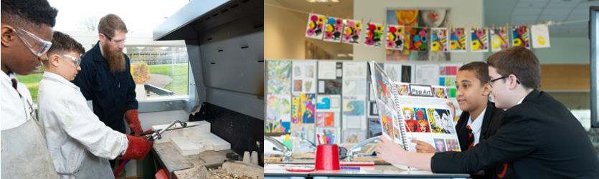


Design & Technology

At Northfleet Technology College, our Design and Technology Team stimulate creativity, curiosity and conscience to develop Technicians, Designers and Engineers who are passionate about problem solving and developing a better future.
Our faculty gives an exciting opportunity for staff to develop their subject knowledge and teaching pedagogy within a secure and supportive team. We want you to share with our students your skills and knowledge to create a secure and focused learning environment. At NTC, we focus on developing our learners to be independent, resourceful learners, and to develop their personal skills and attributes to be valued members of the local and wider community.
Design and Technology is taught at Key Stage 3, Key Stage 4 – BTEC Tech Award in Engineering and Key Stage 5 – BTEC Engineering. NTC students will develop their knowledge and skills within a selection of Design and Technology areas. Each component will cover a range of learning aims that will be assessed through the completion of several assignments. At Key Stage 4, theory is combined with learning about the vocational sector and the potential it can offer for careers or further study path. Key Stage 5 follows a variety of units addressing the fundamentals of working in an engineering workplace.
Design and Technology s is taught in mixed ability groups and work is differentiated to reflect the wide range of abilities and capabilities among our students. During lessons, students will gain subject knowledge and skills by investigating and responding to, an authentic, engaging, and complex question, problem, or practical challenge.
We have excellent Design and Technology and IT facilities and a wealth of resources that are available for use in lessons. We encourage debating activities and ‘learning outside the box’ to enable our students to follow our ethos of Curious, Creative and Caring learners.
Collaboration is a key part of the Design and Technology team and you would be joining a very dedicated and efficient group that teaches across all three key stages.
Our team is involved in delivering exciting after school activities to enhance learning and to support with improving interpersonal and social skills. These clubs are not limited to the national curriculum content, the aim is to broaden student experience. Creative initiatives and ideas are encouraged and very much welcomed.
This is an excellent opportunity for an individual, who is as passionate about Design and Tecnhology as we are, to join a supportive, friendly and committed team, dedicated to achieving the highest possible standards in both ourselves and our students.

