


JOB PROFILE
Job Title: | Subject Leader Religion Ethics Philosophy (REP) | School/Department: | Rossett School
Salary Grade: | MPS – UPS plus TLR 2b (£4,121) | Working Hours: | Full Time*
Contract Type: | Temporary Maternity Cover commencing September 2026 | Location: | Harrogate
* In our Trust we will consider requests for flexible working at the recruitment stage. For many roles some flexibility is possible, for example; flexible hours, part time, PPA time at home and in-year leave for special events. Please talk to us at interview about the flexibility you need. We can’t promise to give you exactly what you want, but we do promise to have an open discussion and give careful consideration to your preferences.
Responsible to: Senior Leadership Team
Role summary:
We are looking to appoint a highly motivated, talented, and enthusiastic leader of REP. The successful candidate will have the ability to excite and inspire young people and have a passion for REP, together with the skills, values, and behaviours to lead. This is an exciting time to join Rossett school.
We would warmly welcome applications from aspiring and experienced leaders.

Red Kite Learning Trust is committed to safeguarding and promoting the welfare of students and expects all colleagues and volunteers to share this commitment.
Special conditions of service:
No smoking policy, including e-cigarettes.
Role specific responsibilities:
Duties as a Teacher
- It is the duty as a teacher to maintain and build upon the standards achieved in the award for QTS (Secondary) as set out by the Secretary of State. In addition to the specific duties below as Programme Leader the post-holder will comply with the duties of a Main Scale Teacher.

Additional Duties as Subject Leader
- To be responsible for leading and developing the provision of an appropriately broad, balanced, relevant and differentiated curriculum for students studying REP at all Key Stages in accordance with the curriculum intent of the school.
- To ensure high standards of student attainment and achievement and to monitor and support the progress and development of students to ensure they fulfil their potential.
- To develop comprehensive schemes of work which include a range of teaching and learning styles providing a rich experience for students, and to incorporate a variety of assessment methods at key points to enable accurate judgements on student progress.
- To monitor and support the overall progress and development of students as a Teacher/Form Tutor
- To continuously develop and enhance the teaching practice of others in the department.
- To develop and enhance the teaching practice of others in the department.
- To inspire in students a love for learning by acting as a role model and showing enthusiasm for the subject
- To use positive management of behaviour in an environment of mutual respect which allows students to feel safe and secure and promotes their self-esteem.
- To meet (or exceed) the Professional Teachers’ Standards at a level consistent with what should reasonably be expected of a teacher in the relevant role and at the relevant stage of their career.
- To share and support the school’s responsibility to provide and monitor opportunities for personal and academic growth.
- To communicate effectively with members of the area & all other relevant members of the school
- To work with the SENCO to ensure Individual Provision Maps are used effectively within the area by setting subject-specific targets and matching the provision to individual student needs.
- To encourage staff to develop extra-curricular activities which may, or may not, be linked to the area.
- To manage the physical resources of the area and ensure best value is achieved.

RK People responsibilities:
- Contribute to the overall aims and values of our Trust, appreciate and support the roles of other members of the wider team and attend and participate in relevant meetings as required
- Comply with all Trust policies and procedures including child protection, health, safety, welfare, security, confidentiality and data protection, reporting any concerns to the appropriate person
- Contribute to ensuring safeguarding procedures are in place and used effectively at all times

The role holder must demonstrate a flexible approach to the delivery of the role. Consequently, the role holder may be required to perform work not specifically identified in the job profile but which is in line with the general scope, grade and responsibilities of the role.
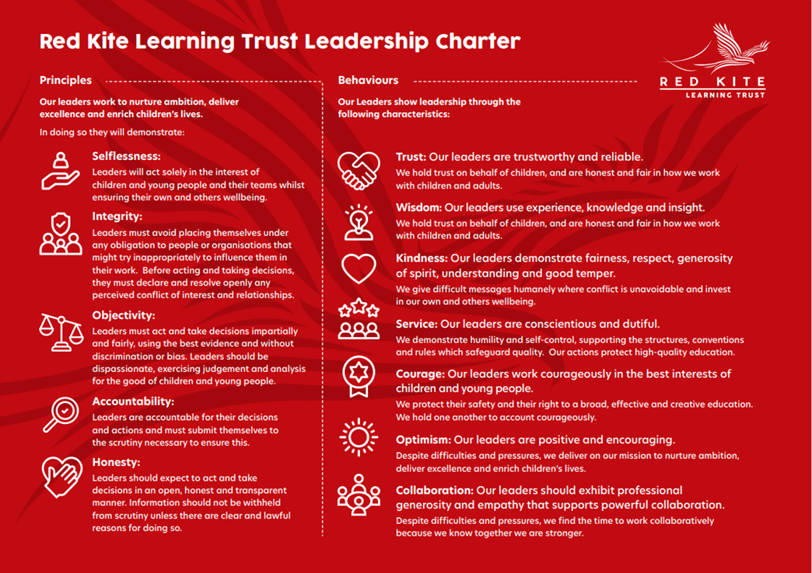

PEOPLE PROFILE
Aptitudes and Characteristics | Essential | Desirable
Skilled classroom practitioner | *
Highly effective communication skills | *
Capacity to evaluate and improve | *
Competent in IT/Software including knowledge & application of Management Info. Systems in school | *
High level of skill in dealing with issues relating to student behaviour | *
Ability to be able to forge and maintain educational partnerships | *
Ability to analyse performance data | *
Ability to contribute to wider school life. | *
Passionate belief in the ability of every student to achieve | *
A clear educational vision and sense of direction | *
Good organisational skills and high levels of self-motivation | *
Energy, self-confidence and the ability to ‘give more’ when the occasion demands it | *
Ability to work under pressure and to meet deadlines | *
Good sense of humour & ability to maintain a sense of perspective in all working conditions | *
Record of good attendance and punctuality | *
A desire for further promotion. | *
Qualifications, Knowledge and Experience | Essential | Desirable
Experience of more than one school/academy |  | *
Successful experience of raising standards at middle management level. |  | *
Successful experience of managing whole school/academy improvement in a secondary school/academy. |  | *
Successful experience of monitoring teaching and learning |  | *
Successful experience of leading, motivating and monitoring other members of staff | *
Successful experience of curriculum development |  | *
Experience of managing students with challenging behaviour. |  | *
Degree level qualification and qualified teacher status | *
Recent leadership training. |  | *
Up-to-date knowledge of curriculum related issues 11-19 | *
Detailed knowledge of pedagogical practice in relation to Teaching and Learning | *
Thorough understanding of best practice in raising student attainment | *
Thorough understanding of best practice in relation to assessment. | *
Safeguarding and Promoting the Welfare of Students | Essential | Desirable
An appropriate motivation to work with children and young people | *
Ability to maintain appropriate relationships and personal boundaries with children and young people | *
Emotional resilience in working with challenging behaviours and appropriate attitudes to the use of authority and maintaining discipline | *

