
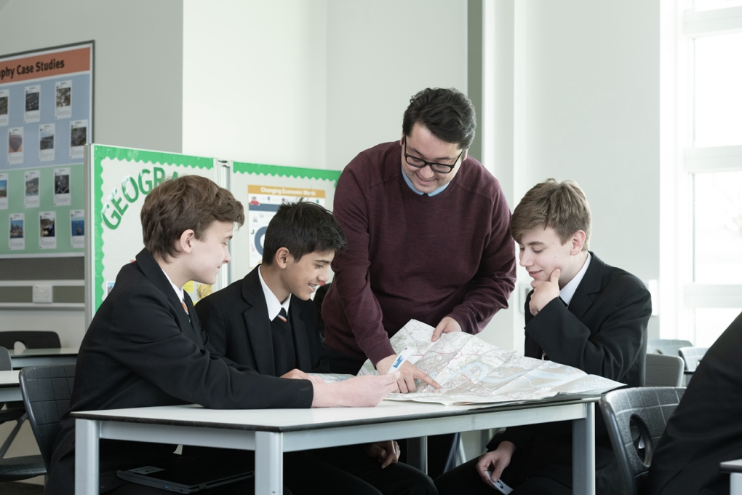



History

At Northfleet Technology College, Geography, History and Citizenship are some of the most popular subjects with our students. We also aim to introduce RE into broad Key Stage 4 offer from 2024.
Our faculty gives an exciting opportunity for staff to develop their subject knowledge and teaching pedagogy within a secure and supportive team. We want you to share with our students your skills and knowledge to create a secure and focused learning environment. At NTC, we focus on developing our learners to be independent, resourceful learners, and to develop their personal skills and attributes to be valued members of the local and wider community.
Through Humanities students will be exposed to a rich academic content, knowledge and skills such as critical thinking, problem solving, communication, collaboration, creativity and innovation. This is achieved by engaging in challenges and problem-solving activities which enable students to become principled leaders and aspiring risk takers.
Humanities is taught in mixed ability groups and work is differentiated to reflect the wide range of abilities and capabilities among our students. During lessons, students will gain subject knowledge and skills by investigating and responding to, an authentic, engaging, and complex question, problem, or challenge.
We have excellent IT facilities and a wealth of resources that are available for use in lessons. We encourage debating activities and ‘learning outside the box’ to enable our students to follow our ethos of Curious, Creative and Caring learners.
Collaboration is a key part of Humanities team and you would be joining a very dedicated and efficient team that teaches across all three key stages.
Our team is involved in delivering exciting after school activities to enhance learning and to support with improving interpersonal and social skills. These clubs are not limited to the national curriculum content, the aim is to broaden student experience. Creative initiatives and ideas are encouraged and very much welcomed.
This is an excellent opportunity for an individual, who is as passionate about Humanities as we are, to join a supportive, friendly and committed team, dedicated to achieving the highest possible standards in both ourselves and our students.

