

Catering Assistant
Recruitment Pack



Advert Opens: 22.07.2026
Advert Closes: 12.08.2026

Contents
Our School Vision | 2
Our School Values | 2
Welcome | 3
Job Description | 4
Person Specification | 6
Recruitment Process | 7
Safeguarding, Equal Opportunities & Data Protection | 8

Our School Vision
When pupils join our community of learners, they are at a critical stage in their development as young people. Each child brings with them a unique and complex web of skills and needs. As passionate educators, we seek to enhance these skills and respond to these needs so that they feel confident in aspiring to a positive future. We strongly believe that whilst in our care, every child deserves the opportunity to realise their fullest potential. By promoting an environment which seeks to remove barriers to learning and nurture individuals, we encourage the very best from our pupils. Wroughton Infant School is committed to helping children recognise and develop their many talents and, at all times, be ‘Proud to Belong’.
Our school values 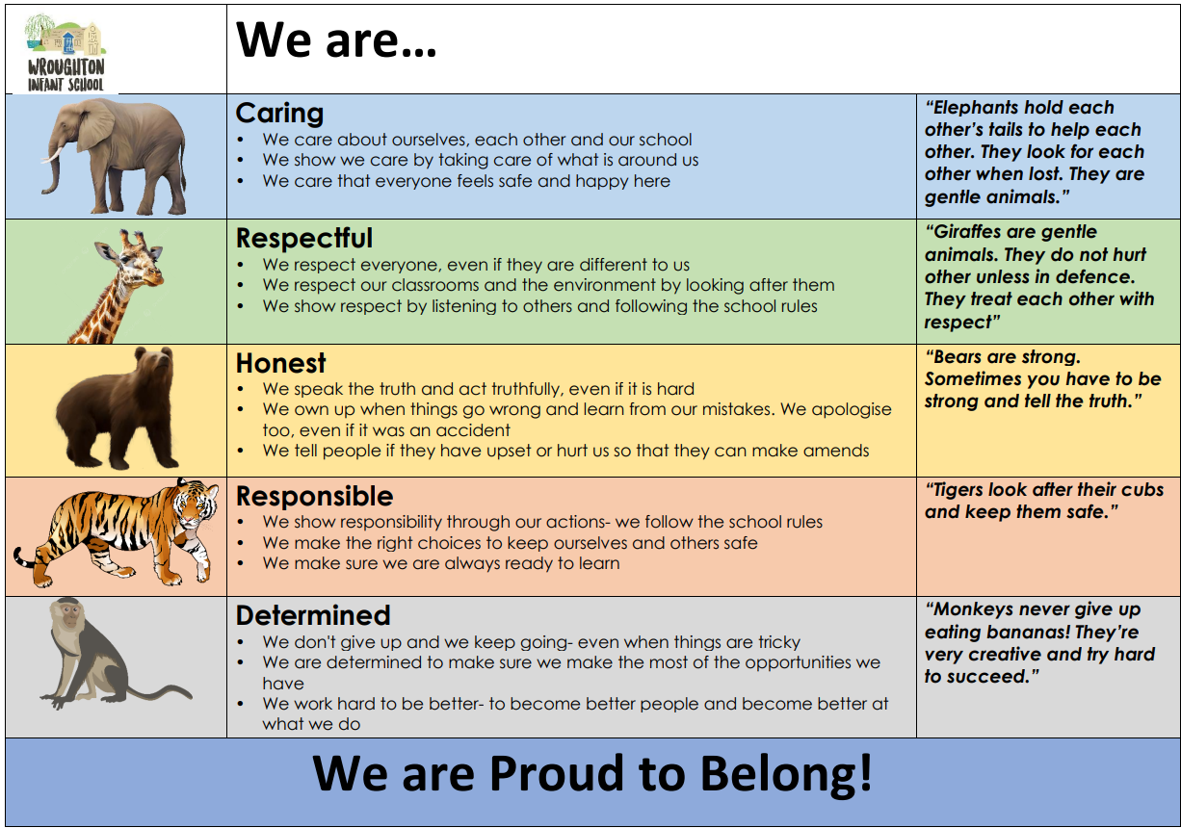

Welcome
Thank you for your interest in our Catering Assistant vacancy. Wroughton Infant School is a great place to work and I’m excited that you’re thinking about joining us. We are looking for an enthusiastic, dedicated and friendly Catering Assistant to join our team.
Wroughton Infant School is a two-form entry Infant School which is part of Grove Learning Trust. Since joining the trust, we have come together to share resources, expertise and our mutual vision and commitments for the children within our community. At Wroughton Infants, we are ‘Proud to Belong’ and this is shown through all aspects of the school. We work hard to ensure that no child is left behind and that the unique identity of the school is protected, celebrated and valued for the contribution they make to ensuring children have the best educational experiences. We passionately believe that by working together, the children will receive a higher quality of education.
We are proud of the learning environment we have created and strongly believe that prospective candidates will see that Wroughton Infants is a welcoming and inclusive school which benefits from a supportive staff team, families and governors.
I feel privileged to work with a team of open-minded and dedicated professionals who are resolutely focused on the children’s learning, wellbeing and development. We would welcome creative thinkers, inspirational team players, flexible leaders and people who are committed to making sure that the children who attend Wroughton Infant School get the very best, all-round experience which enables them to grow into talented young people.

What we can offer you
- Free breakfast club for any of your children who attend Wroughton Infants
- Access to free, high-quality professional development and training
- Free sight test plus a contribution towards the cost of glasses
- Free, confidential access to our employee assistance programme which includes legal and financial advice as well as wellbeing support
- Generous pension scheme
- Enhanced family-friendly policies, including maternity, paternity, adoption, and shared parental leave, and flexible working to allow staff to attend significant family/life events (weddings, children’s assemblies, hospital appointments etc.)
- Blue Light Discount & Discounts for Teachers
- Cycle to work scheme

If we sound like a good fit, we would welcome your application. Please do not hesitate to get in touch if you would like a tour of our school.

With best wishes,
M.A. James
M. James - Headteacher
Job Description
Job Title: | Catering Assistant
Location: | Wroughton Infant School
Reporting to: | Headteacher
Salary Range: | K1 (£13.35 per hour)
Working Hours: | 25 hrs per week. 9.30am to 2pm, Mon to Fri, term time only
Working Weeks: | Term time only, permanent
Start date: | Tuesday 1st September

Job Purpose:
We are looking for an enthusiastic individual to join our committed Catering Team. The successful candidate will assist in the planning, preparation, and cooking of meals for students at the school, as well as assisting with general kitchen tasks.
Key Responsibilities:
The precise nature of duties and responsibilities may vary to meet the needs of the school, but will include:
- Assist in the preparation and cooking of school food including preparation of vegetables, salads and sandwiches when required.
- To operate kitchen machinery such as mixers, slicers (when trained) dishwashers, sterilisers, steamers, ovens, etc as required.
- To carry out the washing up of all pots, pans, dishes, cutlery, working surfaces and floors as instructed.
- To maintain standards of hygiene and cleanliness and observe all requirements of the Health & Safety at Work Act.
- To prepare the dining room for service, dish up and serve meals to the children at the specified time, clearing away after service.
- Transporting and serving of meals including driving to the nearby Junior School to assist in the collection and delivery of hot food from our catering hub.
- To support in the maintenance of stock levels, including stock taking and stock rotation.
- To maintain and monitor records of daily fridge and freezer and food temperatures in accordance with Food Hygiene regulations and Health & Safety Policy
- To assist in the routine and in-depth cleaning of the kitchen, dining room and kitchen equipment on a regular basis using equipment and chemicals as recommended, in accordance with Health & Safety and CASHH requirements
- To assist in the completion of risk assessments as appropriate, to include the reporting of any hazardous or potentially hazardous situations.
- Attend training courses and meetings as required.
- Ensure hygiene and health and safety standards are met at all times.
- To play a full part in the life of the school community, supporting its distinctive mission and ethos, and encouraging and ensuring staff, pupils and students adhere to school expectations.
- Such other duties as may be reasonably allocated by the Headteacher.

Staff Development
- To engage actively in the Performance Management process.
- To take part in the staff development programme by participating in arrangements for further training and professional development.
- To actively promote school policies and procedures.
- To be responsible for own continued professional development.
- To be courteous to colleagues and visitors and provide a welcoming environment.

Safeguarding
- Be keenly aware of the responsibility for safeguarding children and to help in the application of the Safeguarding Policy within the school.
- Comply with the school’s Safeguarding Policy to ensure the welfare of children and young persons.

Grove Learning Trust is committed to safeguarding and promoting the welfare of children and young people and expects staff and volunteers to share this commitment. The duties and responsibilities in this job description are not restrictive, and you may be required to undertake any other duties that may be required from time to time. Any such duties should not however substantially change the general character of the post

Person Specification
The successful candidate will meet the following person specification. Please note that the listed criteria will form the basis of the selection process. Applicants should address all elements of the Person Specification, demonstrating experience and where appropriate citing supporting examples, within their application.
 |  | Essential | Desirable
Qualifications |  | - Good numeracy/literacy skills / GCSE (or equivalent) Maths and English.  - Willingness to undertake further CPD.  - Basic knowledge of Health & Safety guidelines.  - Full, clean UK driving license | - NVQ Level 1 in Food catering or equivalent  - A food hygiene qualification is preferable; training will be given if required.  - Willingness to acquire awareness of COSHH regulations  - Experience of compliance with requirements of regulatory bodies.
 | Experience | - Excellent interpersonal and teamwork skills.  - Excellent communicator – sensitive, compassionate and effective, able to resolve conflict.  - Good organisational skills and the ability to work well under pressure.  - Ability to work well as part of a team.  - Self-motivated and ability to use initiative.  - Commitment to high standards and expectations.  - Ability to work effectively with young people in a school-based setting. | - Experience of working with stock levels.  - Experience of working within a busy school kitchen environment.
 | Skills & Personal Attributes | - Able to establish good working relationships with a wide range of people - students, colleagues and parents.  - Demonstrable and consistent approach towards others in operating with confidence and integrity.  - Excellent time management.  - Hardworking and committed.  - Outstanding attendance record.  - Committed to the safeguarding of children. | - Commitment to continuous professional development and ongoing learning to enhance skills and knowledge.
 | School Specific Needs | - Fully committed to the vision and values of Wroughton Infant School as an inclusive school. | - Committed to developing the school at the heart of the community; strengthening links within the local area.

Recruitment Process

Applications and Visits

We’d really like to meet you, show you around and introduce you to the children and staff. Visits can be arranged by contacting our school office team on 01793 812340 or by e-mailing office@wroughton-infants.co.uk

School Website

Wroughton Infant School - Home

Key Dates:

Advert opens : 22.07.2026
Advert closes: 12.08.2026
Shortlisting: 13.07.2026 & 14.07.2026
Interviews: Week beginning 17th August 2026

Candidates who are successful at the shortlisting stage will be notified shortly after the closing date. Candidates who have not heard from us by this point should presume that their applications have not been successful on this occasion.

We reserve the right to interview prior to the closing date.

We will seek references for all shortlisted candidates prior to interview and, in line with guidance in ‘Keeping Children Safe in Education’, online checks will also be made of shortlisted candidates.

Safeguarding, Equal Opportunities and Data Protection

Safeguarding

We are committed to safeguarding and promoting the welfare of all children. We expect all candidates to share this commitment. The successful candidate will be expected to undertake an enhanced Disclosure & Barring Service (DBS) and relevant identity, qualification and disqualification by association checks before a formal offer is made, contracting is undertaken and induction commences within our school.

For further details about safeguarding, please visit our school website.

Equal Opportunities

We are an equal opportunities employer and welcome applications from all suitably qualified persons regardless of their race, sex, disability, religion/belief, sexual orientation or age.

Data Protection Privacy Notice

As part of the recruitment process, we collect and process personal data relating to job applicants. We are committed to being transparent about how we collect and use that data and to meeting data protection obligations. For further information on how we collect and process data, please refer to the Data Protection Policy & Privacy Notice found on www.grovelearningtrust.co.uk

