

Candidate Recruitment Pack

Admission Office & Hooper Lane Bespoke Package

UET Pathfinder Hooper Lane

Applications considered upon receipt

www.unityeducationtrust.uk rthornberry@unityeducationtrust.uk

A welcome from the CEO
Dear Applicant,

Thank you for your interest in our vacancy at Unity Education Trust (UET).
As Chief Executive of the UET, I am delighted to offer you a warm welcome to our Trust. These are exciting times for all those associated to Unity Education Trust a Multi-Academy built on developing like-minded schools to be outstanding education providers through collaborative working that develops a ‘unity of purpose’ in all that we do.
UET has expanded its family of schools and education professionals. Our collaborative work over the last 6 months has ensured a measured evolution into our new formal Trust arrangements. We’re welcoming outstanding teachers, subject specialists, tutors, support staff and experienced leaders with a record of transformation in education.

Teachers and support staff now number 795. All of our staff share the ethos of raising aspirations, unlocking potential and securing the best possible future for the 2700 young people attending our schools.

Our school’s range in size from 20 to 1200 students and effective collaboration across our schools is an important part of who we are.

I am proud that we are working in ‘Unity’ to meet the challenges in education head on and spearheading new developments for the benefit of all the children in our care.
We look forward to receiving your application.
Best wishes
Glyn Hambling
CEO


Our Story
Raising aspirations to fulfil potential

Raising Your text here
aspirations to fulfil potential

UET was established in March 2017. As of 2024, its family of schools have expanded providing education for 3 - 19 year olds across mainstream and alternative provision settings and now comprises the following:
Specialist
Pathfinder School –
Brooklands, Danby Wood, Douglas Bader, Hooper Lane, Brooklands, Rosebery

Compass –
Belton, Lingwood, West

- UET Earthsea
- Churchill Park Academy
- The Pinetree School
Mainstream
- Northgate High School and Dereham Sixth Form College
- Grove House Nursery and Infant School
- Kings Park Infant School
- Beeston Primary School
- Garvestone Primary School
- Great Dunham School
- Greyfriars Academy
- Highgate Infant School
- Kings Oak Academy
- Magdalen Academy
- St Germans Academy
- Wimbotsham & Stow Academy

The Trust sets high expectations in every aspect of our work, providing pupils with the best opportunities through outstanding teaching, the development of 21st century facilities, inspirational leadership and a growth mindset approach.
We will ensure that each of our academies maintains its unique identity at the heart of their community and engaging with all partners and stakeholders and other high performing educational organisations.

We have an unrelenting belief and focus that all students can achieve high standards, whatever their background and life experiences when given a positive climate of support, challenge and the development of Growth Mindset through outstanding teaching.
Furthermore we are committed to ‘raising aspirations to fulfil potential’ ensuring our learners are encouraged to build confidence, expand their leadership qualities and embrace British Values that enable all to thrive in an ever-changing society.

Our School – UET Pathfinder Hooper Lane

Hello, I’d like to welcome you to Hooper Lane School where our ethos is to create a warm and friendly atmosphere where children are happy, healthy, confident and above all safe. Hooper Lane is home to our assessment team who work with all new KS3 and KS4 pupils to build a full learner profile before they move onto one of our Short Stay bases and also our Pathway 4 Team providing bespoke learning experiences, our Transitions Team working to support our pupils back into mainstream education and Attendance Improvement Officer.

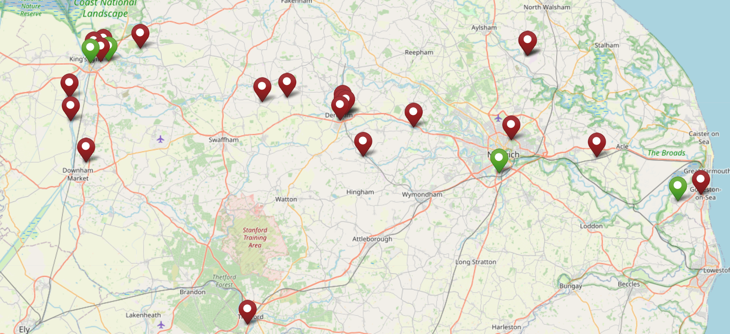

Underpinning principles




Supporting Our Staff

Unity Education Trust is committed to supporting all staff in their personal, professional and career aspirations by providing a range of development opportunities. We foster a culture which encourages you to develop your talent and strengths throughout your journey with us.

We are committed to providing the highest quality support to ensure our schools excel and give our students the education they deserve. Our Headteachers have a good deal of autonomy as school leaders within a framework developed collaboratively with our Director of Education and the Education Directorate.

Each Unity Education Trust school benefits from a comprehensive programme of support and challenge, including a strong emphasis on CPD and a regular programme of training events to improve performance across all sectors within our schools.

We believe it is very important that each of our academies plans in such a way that financial and human resources are deployed to support their educational strategies fully. This is supported by our experienced Central Service team, who are available to advise on financial planning, audit, HR, legal and property matters.



Job Description Admissions Officer & Hooper Lane Bespoke package worker
Job Title |  |  |  |  | Admissions Officer & HL Bespoke package worker
Location |  |  |  |  | Hooper Lane
Grade |  |  |  |  | G
Responsible to |  |  |  |  | Transitions Lead
Responsible for |  |  |  |  | The admission of pupils at UET Pathfinder Academy and support for the Hooper Lane bespoke package offer.(HLBPO)
Effective Date |  |  |  |  | July 2026
Job Purpose |  |  | To support transition into UETPA bases  To process the admission of pupils into UETPA bases.  To support pupils on an off site package  All staff will work with young people of all ages within an environment where the principles of SEAL and Restorative Justice are used to facilitate a holistic understanding of a young person's needs. They will advise and support schools, pupils and parents, promote an innovative approach, and be prepared to work in a variety of venues and with a wide age range if circumstances require. They will establish good behaviour for learning strategies and use these to raise attainment and reduce exclusions.  Work within the graduated framework of UETPA providing individual and group support for pupils in a variety of settings including mainstreams schools, UETPA bases, pupils' homes and specialist provision.  Work with schools, parents/carers and other agencies to support the successful educational reintegration and social inclusion of children and young people by providing interventions and devising programmes of work.
Context |  |  | The UETPA (Alternative Provision Academy) holds the commission from NCC for the establishment and operation of the Compass Provision.  It encompasses a wide range of curriculum pathways and is able to deliver personalised learning, based upon assessment of need for KSI , 2, 3 and 4 pupils, and transition into alternative provision and post 16 provision for KS4. Where longer term need is required is able to provided and identify the kind of provision recommending placements managing referral processes and supporting transition into placements.
Other Job Information |  |  | The post-holder is required to work with vulnerable pupils, staff, other professionals and parents in a range of settings including within the UETPA bases, schools and other alternative provision venues
1 To process referrals for incoming students taking responsibility for the liaison with previous schools (admissions meetings, file collection and the sharing of information with necessary staff). To do home visits and work with parents regarding transition into UETPA.
- Responsible for the collation of safeguarding information for new admissions, liaising with previous schools and outside agencies.
- To visit and support pupils reintegrating into new destinations
- To ensure safeguarding information relating to pupils admitted to UETPA and HLBPO is collated and passed on to the relevant DSL.
- To oversee bespoke packages
- To conduct panel welfare checks and initiate relevant referrals to other agencies.
- To support with setting up AP places and quality assure APs being used
- To work with outside agencies in order to ensure all necessary information is gathered and shared for pupils being admitted to UETPA and HLBPO
- Where necessary oversee applications for alternative provision and attend relevant admissions meetings.
 | 
 |  |  |  | Essential
 | Qualifications |  |  | Meet Higher Level Teaching Assistant standards or equivalent qualification or experience; Can work at NVQ level 4.  Excellent numeracy/literacy skills/GCSE (or equivalent NVQ 2) Maths and English;  Training in the literacy/numeracy strategy;  Specialist skills/training in curriculum or learning area, e.g. Social and emotional aspects of learning, bilingual, sign language, ICT.  Recent relevant professional development.
 | Experience |  |  | Experience of multi-agency working including safeguarding. Experience of working with children of relevant age  Experience of working with pupils with additional needs in a range of settings including with behavioural challenges  Ability to plan and implement effective actions for pupils at risk of underachieving
2
Able to demonstrate reflective practise
Experience of working in mainstream or special school classroom support
Experience of working with a range of support services/providers as part of multi-disciplinary and agency planning and interventions.
Skills/Knowledge | Understanding of principles of child development and learning processes and in particular, barriers to learning  Ability to use coaching skills to good effect when working with school staff as part of providing information, advice and guidance  Full working knowledge of relevant policies/codes of practice/legislation  Working knowledge of National Curriculum and other relevant learning programmes  Work constructively as part of a team.  Ability to relate well to children and adults  Range of ICT skills including use of PC for recording and monitoring data — Word/Excel etc Effective use of ICT to support learning  Meet Higher Level Teaching Assistant standards or equivalent Ability to manage own workload and prioritise workload.  Working knowledge of the NCC safeguarding guidance and the UETPA safeguarding policy.  Working knowledge of child protection procedures, health and safety procedures, Disability Equalities Scheme/Act, confidentiality and GDPR.  Higher Level Teaching Assistants or equivalent should have regard to the Standards and Regulations published by the DOE and the National Employers in carrying out their responsibilities.  Ability to support, motivate and inspire others. Knowledge of admissions procedures.

General Information

- The job descriptions detail the main outcomes required and should only be updated to reflect major changes that impact on the outcomes of the job

- Job holders must be aware of and comply with all current guidance, policies and procedures relating to safeguarding and ensure that they are in accordance with statutory and school safeguarding requirements at all times.

- All work performed/duties undertaken must be carried out in accordance with relevant Academy policies and procedures, within legislation, and with regard to the needs of our customers and the diverse community we serve.

- Job holders will be expected to be flexible in their duties and carry out any other duties commensurate with the grade and falling within the general scope of the job, as requested by management.



Joining Us

LOCATION
The post will be located at The Hooper Lane School. The Unity Education Trust reserves the right to transfer staff to alternative posts appropriate to the grade and/or alternative workplaces as is considered reasonable.
PROBATIONARY PERIOD
New employees of The Unity Education Trust will be required to serve a probationary period of 12 weeks.

REMUNERATION
The current salary for the post is within the range:
Salary – Grade G Point 19-22- £28,359 - £29,808 actual annual – (£33,119 -£34,811 fte)
This post is Scale G. Point 19 – Point 22. Subject to satisfactory service, salaries will rise within the scale by annual increments up to the maximum of the scale. Salary is paid in 12 equal instalments on or just before the 19th of each month. Payment is by credit transfer
HOURS OF WORK
The normal working week is one of 37 hours, Term Time + 1 week. This is a permanent position.

DRESS CODE
The post-holder will be expected to wear appropriate business attire and will be supplied with appropriate Staff ID. This must be worn at all times to ensure that students, staff and visitors are able to identify UET colleagues.
BENEFITS
- Comprehensive induction
- Commitment to your ongoing training and career progression
- Pension scheme
- Eye care vouchers (if criteria are met)
- Paid for enhanced DBS
- Wellbeing support
- FastTrack treatment service including physiotherapy

Terms and Conditions

PRE-EMPLOYMENT CHECKS
All staff must be prepared to undergo a number of checks to confirm their suitability to work with children and young people. The Trust reserves the right to withdraw offers of employment where checks or references are deemed to be unsatisfactory.

EQUAL OPPORTUNITIES
UET has a policy that seeks to ensure that all employees are selected, trained and promoted on the basis of ability, the requirements of the post and other similar and objective criteria. The gender, marital status, ethnic origin, age, religion or sexual orientation of an applicant or employee does not affect the employment opportunities made available except as permitted by legislation. UET also requires full and fair consideration to be given to people with disabilities in the recruitment process. Applicants declaring a disability who meet the minimum (essential) criteria for the vacancy will be invited for interview.

DISCLOSURE AND BARRING SERVICE CHECK

This post is subject to a Disclosure and Barring Service Check. Disclosure and Barring Service and Disclosure of Convictions Policy for employment of persons with criminal convictions – refer to our website www.unityeducationtrust.uk
Immigration, Asylum and Nationality Act Information – refer to our website www.unityeduationtrust.uk

How to apply
Click on the Apply Now button. You can save your application and return to it later. Please ensure you have completed your application before the end date.
No CVs accepted – please complete an application form if you wish to be considered for this role.
Candidates are advised that they may be subject to an online check from information in the public domain.
We aim to be an equal opportunities employer and welcome applications irrespective of race, gender, religion, disability, sexual orientation and/or age. We value the individuality and creativity that every worker potentially brings to the workforce.
This post will come under the requirements of the Childcare (Disqualification) 2009 Regulations and the successful applicant will be required to complete a declaration form to establish whether they are disqualified under these regulations.
​​​​​​​Unity Education Trust is committed to safeguarding and promoting the welfare of children. All applicants must be willing to undergo safeguarding screening appropriate to the post, including checks with Disclosure & Barring Service and at least 2 references which cover the last 3 years; for all our services we will request references from where you have worked with either children or vulnerable adults. Please be advised that references may be requested prior to interview for roles within our schools.
This post is covered by Part 7 of the Immigration Act (2016) and therefore the ability to speak fluent English is an essential requirement for this role.
We reserve the right to withdraw this vacancy at any time ahead of the closing date if there is a sufficient level of response. Therefore, we recommend you submit your application as early as possible.
We also reserve to right to interview shortlisted candidates ahead of the closing date.

Interview process

Applications will be considered upon receipt.

Interview process

- Candidates will be shortlisted
- References will be requested

If you would like an informal discussion. Please contact Rachel Thornberry, by emailing rthornberry@unityeducationtrust.uk.



Unity Education Trust
C/O Dereham Sixth Form College
Crown Road
Dereham
Norfolk
NR20 4AG

