AI Guidance for our Applicants
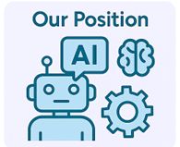
‍

At Kirklees Council, we recognise that AI tools (such as Chat GPT, Grammarly, Copilot, and others) are increasingly used to support job applications. These tools can help with spelling, grammar, structure, and even brainstorming ideas. We accept that candidates may choose to use AI, but we strongly encourage authenticity and personal reflection in all applications.

‍

You are not required to declare the use of AI tools in your application. However, if you choose to do so, please be honest and clear about how AI supported your application.

‍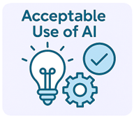

You may use AI tools to:
· Refine and clarify your idea sand structure your responses.
· Research Kirklees Council, our services, and the role you’re applying for.
· Check spelling and grammar to improve readabiliy.
· Prepare for interviews, including generating practice questions or summarising role requirements.
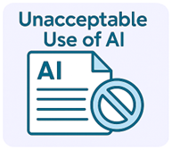

Please avoid using AI to:
· Copy and paste generic responses without personalizing them.
· Fabricate or exaggerate your skills, experience, or achievements.
· Complete assessments or tests on your behalf.
· Generate answers during live interviews, this is your opportunity to shine.
‍

‍

·

Make sure everything you write is true and personal to you.
· Be ready to talk about your application at interview.
· Ensure your supporting statements align with your actual experience.
· Avoid sounding like a generic applicant—let your personality and values come through.

AI Use for Disabled Applicants and GIS Candidates
If you are applying under the Guaranteed Interview Scheme (GIS) or require reasonable adjustments, you may use AI as an assistive tool.
This includes using AI to support spelling, grammar, structure, or to help organise your thoughts. This is considered an accessibility aid and will not count against you.
However, you must still ensure that:
- Your examples are real and based on your experience.
- Your supporting statement reflects your own achievements.
- You can discuss everything in your application at interview.
‍
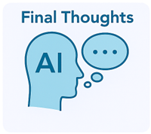
‍
AI can be a helpful tool, but it should never replace your own voice. We’re hiring people, not algorithms. The best applications are honest, personal, and reflective of who you are and what you can bring to Kirklees Council.
‍

