
Woods Avenue, Hatfield, Hertfordshire, AL10 8NN
Telephone: 01707 276 504

Woods Avenue, Hatfield, Hertfordshire, AL10 8NN
Telephone: 01707 276 504

SOUTHFIELD SCHOOL

Candidate Information Pack
Accounts Administrator

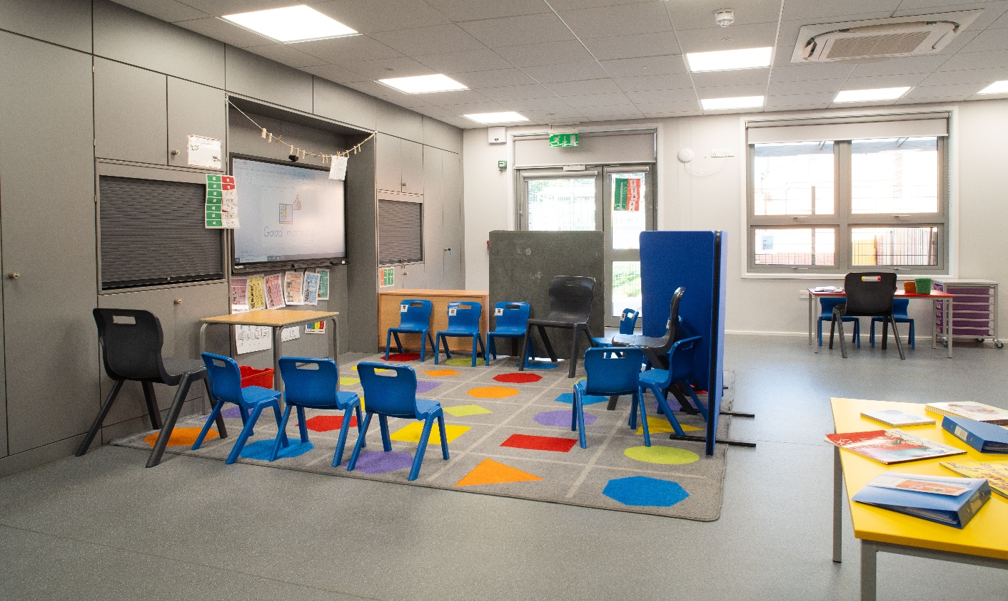

Introduction

Southfield School are looking to recruit an Accounts Administrator.

Contract Type

Term Time only plus

Start Date
As soon as possible

Closing Date
Sunday 4th January 2026

Southfield School reserves the right to interview and appoint candidates on receipt of applications before the closing date.

Interview Date
To be confirmed

Salary
£ 25,989 FTE

Grade
H4-6

Accounts Administrator - Recruitment Advertisement

Southfield is a primary school for over 100 pupils with Learning Difficulties, which include, Autism, Speech Language and Communication Needs, Global Developmental Delay, and other conditions.
Admissions are via the Local Authority, and the present criteria is that children are accessing learning approximately 50% below their chronological age. We follow the EYFS and Key Stage 1 National Curriculum and adapt these to meet the individual interests and needs of our pupils. We do this through a 3 Phase curriculum that is presently being developed. Priority is given to communication, self-regulation, independence and functional Literacy and Maths. We use a wide range of approaches and strategies to support learning, including multi-sensory communication, social stories, TEACCH and Hertfordshire Steps. We also work with a range of professionals, from advisers in the Local Authority to Therapists and social care colleagues. Access to sporting and creative arts organisations, provide a range of enhanced learning opportunities, both in school and the local area.

Southfield is going through a period of rapid and exciting change, that you could be part of. It is a journey of challenge, in the pursuit of excellence, but one that provides huge rewards both personally, in your professional development and when you see the difference you make to the lives of our young people and their families.

Recruitment will be in line with our Safer Recruitment Policy and online searches may be conducted.


Accounts Administrator - Job Specification

Purpose of the Role
To provide efficient, accurate and confidential financial and administrative support within the school office, ensuring that all accounting procedures comply with school and regulatory requirements. The postholder will assist in maintaining accurate financial records, processing payments, and supporting the smooth running of the school’s financial operations.
Key Responsibilities
Financial Administration
- Process purchase orders, invoices, and payments in line with school financial procedures.
- Reconcile supplier statements and resolve any discrepancies.
- Record income and bank receipts.
- Assist with the preparation and reconciliation of monthly accounts.
- Assist with payroll preparation.
- Maintain and update financial records using Arbor and the One Drive
Administrative Support
- Provide general administration within the school office when required.
- Maintain accurate and secure filing systems both electronically and paper based.
- Support period and year-end financial procedures and audit preparation.
- Liaise with suppliers, contactors, and parents regarding financial matters.
- Assist in the administration of school trips, clubs, and events.
Essential Skills and Experience
- Experience in financial administration or accounts work
- Strong numeracy and IT skills (particularly Excel and finance software)
- Excellent attention to detail and accuracy in data entry and record keeping.
- Good organisational and time management skills
- Ability to maintain confidentiality and manage sensitive information.
- Effective communication and interpersonal skills with all colleagues, parents and external partners.
Desirable Skills and Experience
- Experience in a school or educational setting
- Familiarity with school finance system – Arbor Finance
This job description is not a comprehensive definition of the post. Discussions will take place on a regular basis to clarify individual responsibilities within the general framework and character of the post as identified below.
The duties may be varied to meet changed circumstances in a manner compatible with the post held, at the reasonable direction of the Headteacher..This job description does not form part of the contract of employment. It describes the way in which the member of staff is expected and required to perform and complete the duties as set out above.
Letter from the Headteacher

Are you bored with life? Looking for a new challenge? Have a desire to work in an environment where you can make a ‘real’ difference to the lives of young people? If so, Southfield School is the right environment for you.
We are a family with 100 pupils. No two students are alike, and no two members of staff are alike. Our pupils all have challenging ASD and associated conditions.
Our school vision is to support all children, so they thrive during their time at Southfield School and are prepared socially, emotionally, and academically for their next steps in education. Collaboration with parents and carers and the entire multi-disciplinary team who support our students is vital and key to our success.
Everyone plays a part in the future of our students with staff skills being used in order that we have a huge range of skill set and expertise. Everyone makes a difference to the lives of our students and families.
We are looking for like-minded, resilient staff who are passionate and who can work in a team.
If you have yet to find what it is that you were meant to do with your life – Southfield School may be what you have been searching for.

Come and join us and make a difference to the lives of children every day.



Angela O’Rourke
Headteacher

OUR VISION AND VALUES

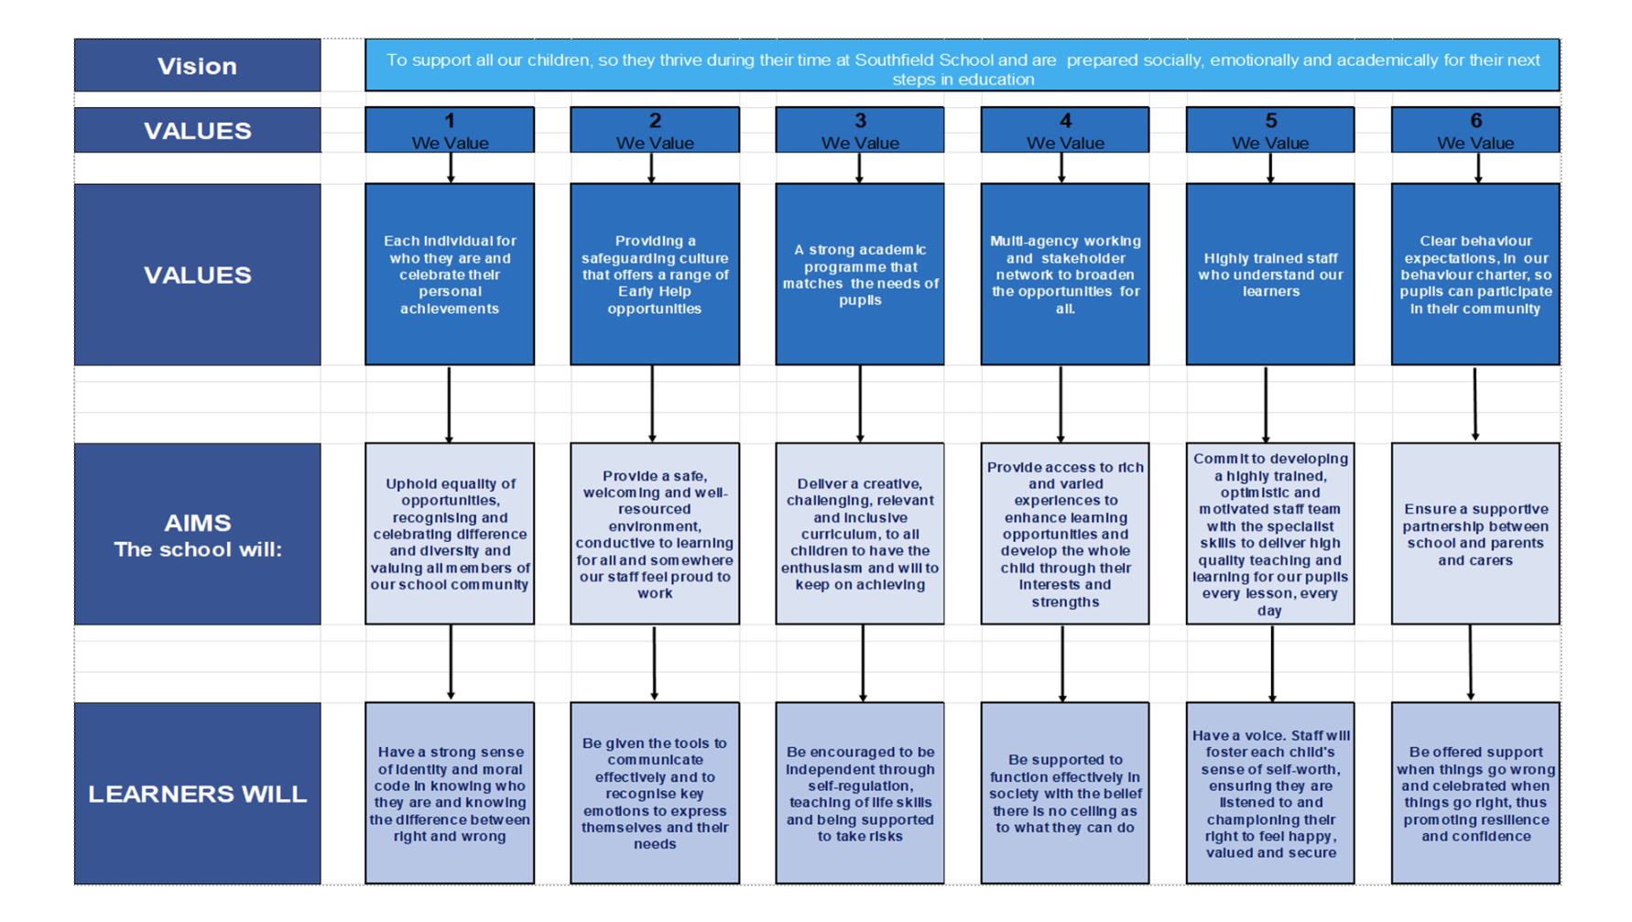
A Bright Future for ALL

