

TEACHING ASSISTANT LEVEL 2

Central MAT Office
The Diocese of Coventry Multi Academy Trust St James’ C of E Academy
Candidate Information

Barbridge Road
Bulkington Bedworth CV2 9PF
Together, pursuing life in all its fullness
Teaching Assistant Level 2
Fixed Term 2 Years

Our Trust
Thank you for your interest in joining The Diocese of Coventry Multi Academy Trust, we are delighted to provide you with an application pack. It is hoped that the information provided will be of interest and will help you to begin your journey with us.


The Diocese of Coventry Multi Academy Trust was incorporated in 2013 and is one of over 2,500 Multi Academy Trusts in England. The trust is now home to twenty-two academies spread across the Diocese of Coventry. This scale makes us one of the 100 largest Multi Academy Trusts in the country.

Our vision, “together, pursuing life in all its fullness”, is based on John 10:10 and reflects the Church of England’s vision for education. You will see this come to life in all of our academies every day. We offer a vision of human flourishing for all, one that embraces excellence and academic rigour, but sets them in a wider framework. We offer opportunities for children to realise their God given potential and flourish.

Our strategic plan focuses on five key stakeholder groups and recognises
that these groups will flourish together, far better than they will flourish alone. We aim to:
- Support colleagues to flourish
- Support children to flourish
- Support those involved with governance to flourish
- Support families to flourish
- Support the wider church school family to flourish

To work with us, you must aspire to be an outstanding colleague, be prepared to go the extra mile and be comfortable with high levels of accountability for the progress of over 5,000 children. You must be willing to share and learn. Above all else, you must like young people and aspire to make them outstanding citizens.

In return, we offer excellent working conditions, first class professional development, genuine career development and opportunities for growth. All of our teachers are offered membership of the Teachers Pensions Scheme and all support staff are offered membership of the Local Government Pension Scheme.
In short, we believe our Trust has a bright future and are looking for bright people to help us get there.

Thank you once more for your interest in The Diocese of Coventry Multi Academy Trust and in the position available. I hope that this introductory letter has given you a clear sense of our vision and I hope that this pack gives you a feel for what we need. We look forward to hearing from you and exploring your future with us through our selection process.

Michael Cowland, Chief Executive Officer

What our employees say about us…

In our 2024 staff survey, the Trust scored above national benchmarks in almost every area. Support from colleagues is a particular strength of working for us: our staff value the respect and support they receive from their colleagues. Leadership is also an area of significant strength and staff rate their leaders highly. Finally, job satisfaction and employee communication are rated highly and above national benchmarks.

Staff support and relationships

How comfortable are you with asking your colleagues for help when you need it? | 93%
How respected by your colleagues do you feel? | 89%

Leadership

Leadership dynamics | 15% higher than national benchmark
Professional support from line manager | 4% higher than national benchmark

Job satisfaction and communication

Effective and regular communication with employees | 18% higher than national benchmark
Job satisfaction | 20% higher than national benchmark

Our Diocese
Diocese of Coventry
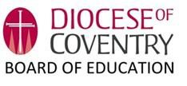
The Diocesan Board of Education seeks to serve and equip the church school family in a variety of ways. The Diocesan Director of Education, Reverend April Gold, is supported by a team of highly qualified, experienced and well-regarded professionals who aim to:

- ‘be there’ for our church school family and act as a central reference point supporting pastorally and professionally;
- facilitate creative and flexible networking between schools;
- promote excellence and distinctiveness within the family of church schools/academies and beyond;
- share best practice collectively;
- provide professional development: for staff at all stages of their careers and for governors;
- facilitate collaborative school improvement partnerships through the growth of our six CofE majority MATs;
- support the process of academy conversion;
- promote the establishment of new church schools;
- represent church schools to the wider church, to diocesan groups, in the press, and in public and community debate;
- champion inclusion and equality including advising on admissions policies and managing appeals;
- protect the status of church schools
- and promote the importance and the continuance of the voluntary sector.

‘Our schools are a hugely significant part of the Church family of the Diocese. Seeking to build communities of care and understanding, they witness to God’s love for each and every person, and reflect God’s desire for the world to be a better place for us all to live in. I believe they are at the heart of the Church’s mission to the nation and play a very important role in the life of their own parishes and communities.
As a Diocese, our 76 Church of England schools serve 18,500 children, and their families. The 2000 members of staff and all the volunteers who support, as governors, directors, and other contributors, are seeking to offer both an excellent education and ensure that all our young people have the opportunity to live life to the full. We aim to do this by living, telling and sharing the values of Jesus Christ. Thank you for being willing to share in this journey with us!’

Bishop of Coventry

Teaching Assistant – Level 2

About the Role

The Trust is looking to appoint an inspirational and highly effective Teaching Assistant Level 2 who is committed to supporting Harris CofE Academy to educational excellence and further developing the distinctive Christian character of educational provision and the school community.

In return we can offer:

- A support network of professional colleagues
- A strong culture of professional development
- The opportunity to be part of an aspirational organization and contribute to its development and growth plans
- The position is Monday – Friday from 9.00am – 3.00pm, 27.5 hours/week, 39 weeks.
- We are offering a salary of Grade F, SCP7 £17,103 (Actual), £26,403 (FTE)
- Eligibility to join the Pension Scheme

Applications

Thank you for your interest in this post. Interested candidates are welcome to speak to us for more information about this fantastic opportunity. Please contact recruitment directly on recruitment@harris.covmat.org for an informal discussion about the post.
Please note the closing date for applications is midnight, Sunday, 05th July 2026. Please apply through My New Term’s online application process.

We welcome all applications regardless of age, disability, gender reassignment, marriage and civil partnership, pregnancy and maternity, race religion and belief, sex and sexual orientation.

Interviews TBC
Job Description

KEY PURPOSE

To support the teacher with their responsibility for the development and education process by providing care and supervision skills to students, including those who have special educational, physical and emotional needs, by utilising a good standard of practical knowledge and skills. To work with students to help support them in and out of lessons, to integrate in the Academy.

ACCOUNTABILITIES

The appointee will be line managed by the Mrs Blackburn

PRINCIPAL RESPONSIBILITIES

Outline of responsibilities and tasks
Under the direction and control of the classroom teacher or designated supervisor:

- Monitoring individual students’ problems, progress, achievements and condition and report these to the designated supervisor as appropriate.
- Actively engaging in educational activities and work programmes and to assist in personal and individual development of individuals or groups of students.
- Supervising the activities of individuals or groups of students to ensure their safety and facilitate their physical and emotional development.
- Undertaking those activities necessary to meet the physical and emotional needs of individuals and groups of students, including those with educational, physical or emotional special needs

Job responsibilities and tasks may include the following under the direction and control of the teacher:

- Assisting the teacher with learning activities generally in the classroom.
- Contributing to the planning of work to meet the needs of the National Curriculum and individual needs of students.
- Contributing to the formulation of Individual Learning Plans including attendance at SEN reviews and other meetings relevant to students’ needs.
- Carrying out appropriate activities as planned within the classroom or with groups of students including administration of baseline tests.
- Displaying and presenting students’ work.
- Supporting revision and small group work
- Responsibility for visual aids.
- Preparing and organising teaching resources including the checking and maintaining of classroom equipment and materials including control of stock within the classroom.
- Preparing resources for lessons and activities.
- Assisting with the physical manipulation of objects and equipment.
- Supervising, counselling and disciplining of students, within the procedures of the school.
- Assisting the teacher in liaising with parents/carers and professionals such as speech therapists.
- Assisting at an appropriate level with the provision of general care and welfare of students including:
  - Assisting with the identification and monitoring of students' general health
and welfare.
  - Helping the teacher with tasks.
  - Hearing students read.
  - Supporting students to be independent by helping them with tasks.
  - Answering questions from students.
  - Giving spelling exercises if appropriate to the needs of the students.
  - Assisting with supervision of students within the school.
  - Assisting students to access the normal routines of the classroom.
  - Preparation or modification of the work for the student under the direction of the teacher, and supporting the student in carrying out this work.
  - Assisting in the implementation of programmes designed by other professionals such as educational psychologists or speech and language therapists.
  - Contributing to meetings to discuss specific students’ progress.
  - Assisting with the provision of general care and welfare to students and to be mindful of the need to maintain a safe environment at all times.
  - Adhering to and maintaining school routine and codes of conduct.
  - Supporting the ethos of the school.
  - Assisting with the support of group activities within and away from the classroom, for example, educational visits.
  - Ensuring that students are able to safely use equipment and materials provided and be aware of the range of resources available
  - Promoting student independence in learning, and reinforcing students’ self-esteem through praise, encouragement and rewards in line with whole school policy.
  - Assisting with the promotion of independence activities and mobility skills.
  - Maintaining personal and professional development to meet the changing demands of the job, participate in appropriate training activities and encourage and support staff in their development and training.

SUPPORTING THE WORK OF THE MULTI ACADEMY TRUST

As part of the Diocese of Coventry Multi Academy Trust, the Deputy CEO - Education will be expected to develop and maintain strong, positive relationships with colleagues in the Multi Academy Trust, within the family of Multi Academy Trust academies and the Diocesan family of schools.

STRENGTHENING THE COMMUNITY

Academies exist in a distinctive social context, which has a direct impact on what happens inside the school. Academy leadership should commit to engaging with the internal and external school community to secure equity and entitlement. All staff should collaborate with other schools in order to share expertise and bring positive benefits to their own and other academies. They should work collaboratively at both strategic and operational levels with parents and carers and across multiple agencies for the well-being of all children.

This will include:

- Building a school culture and curriculum which takes account of the Church Foundation and the richness and diversity of the school’s communities.
- Creating and promoting positive strategies for challenging harassment of any kind.

- Ensuring learning experiences for pupils are linked into and integrated with the wider community, the local church and diocesan communities.

- Ensuring a range of community-based learning experiences, including building links with local churches and Coventry Diocese.

- Collaborating with other agencies in providing for the academic, spiritual, moral, social, emotional and cultural well-being of pupils and their families

- Creating and maintaining an effective partnership with parents and carers, (including those who may be described as ‘hard to reach’, those with learning disabilities and those for whom English is an additional language), to support and improve pupils’ achievement and personal development.

- Building bridges with the school’s diverse communities, seeking opportunities to invite the whole range of parents and carers, community figures (including clergy and church representatives), businesses or other organisations into the school to enhance and enrich the school and its value to the wider community.

- Contributing to the development of the education system by, for example, sharing effective practice, working in partnership with other schools and promoting innovative initiatives.

- Co-operating and working with relevant agencies to protect children.

SAFEGUARDING CHILDREN AND SAFER RECRUITMENT

Our Trust is committed to safeguarding and promoting the welfare of children and young people and expects all staff and volunteers to share this commitment. The successful candidate will be required to undertake an enhanced criminal record check via the DBS. Further information about the Disclosure and Barring Service is available from the DBS website at: Disclosure and Barring Service - GOV.UK (www.gov.uk)

The Trust will ensure that:

- The policies and procedures relating to safeguarding and safer recruitment are fully implemented and followed by all staff.
- Sufficient resources and time are allocated to enable the designated person and other staff to discharge their responsibilities in relation to safeguarding, including taking part in strategy discussions and other inter-agency meetings and contributing to the assessment of children.
- All staff and volunteers feel able to raise concerns about poor or unsafe practice in regard to children, and that such concerns are addressed sensitively and effectively in a timely manner in accordance with agreed whistle blowing practices.

DATA PROTECTION

The post holder must meet the requirements of the General Data Protection Regulation Act 2018 at all times, especially concerning conﬁdentiality, treatment of personal information and records management.

ADDITIONAL DETAILS

Whilst every effort has been made to explain the main duties and responsibilities or the post, each individual task undertaken may not be identified. Staff will be expected to comply with all Trust policies and procedures and any reasonable request from a manager to undertake work of a similar level that is not specified in this job description. This job description will be reviewed annually and the Chief Executive reserves the right to alter the content of this job description, after consultation with the post-holder, to reflect changes to the job or services provided, without altering the general character or level of responsibility.

PERSON SPECIFICATION
Personal Qualities,  Qualifications and Experience |  | Measured By
 |  | Essential | Desirable | Application | Interview Process | References
Qualifications and Training
1 | Relevant school qualifications showing a good standard of literacy
2 | Good IT, numeracy and literacy skills
3 | Willingness to undertake further professional development
4 | Appropriate knowledge of first aid
5 | NVQ level 2 or above qualification appropriate to the post
6 | Recognised first aid certificate
7 | Level 2 in English and maths
Professional Experience and Knowledge
1 | Previous experience of working in a classroom environment with students
2 | Experience of procedures relating to child protection and safeguarding
3 | Previous experience of working in a classroom environment with students who are disabled or have special educational needs
Skills and Abilities
1 | Suitability to work with young children
2 | Able to form and maintain appropriate relationships and personal boundaries with children and young people
3 | Positive attitude to the use of authority and maintaining discipline
4 | Ability to maintain strictest confidentiality and integrity at all times
5 | Ability to encourage high standards of student behaviour at all times
6 | Ability to recognise behaviour giving cause for concern
7 | Ability to supervise and assist students to ensure they make progress
8 | Ability to liaise with other members of staff in a professional manner
9 | Ability to manage own time effectively and demonstrate initiative including establishing priorities within own workload
10 | Ability to work constructively as part of a team or individually, understanding school roles and responsibilities and own position within these
11 | Ability to adhere to working procedures and policies within the school environment
12 | Ability to work under pressure
13 | Ability to relate to students and staff
14 | Ability to deal with problems in a positive and systematic manner
15 | Ability to communicate effectively at all levels
16 | Fluent in at least one additional language.
17 | Knowledge of the national curriculum
Personal Qualities
1 | A willingness to work with young people and adults.
2 | Ability to use judgement and common sense
3 | Approachable
4 | Ability to prioritise
5 | Ability to work on own initiative
6 | Commitment
7 | Reliable and trustworthy
8 | Flexible approach to work
9 | Honest
10 | Ability to be sensitive to the needs of others
11 | Ability to be supportive
12 | Professional
13 | A sense of humour, warmth, energy, stamina and resilience
14 | Ability to take responsibility for dealing with incidents as soon as they occur
15 | Willingness to reflect upon his/her experiences in a critical and constructive manner

I (name) hereby confirm that I have received a copy of the Job Description for the post of Teaching Assistant Level 2

Signed ………………………………………………… Date …………………………..
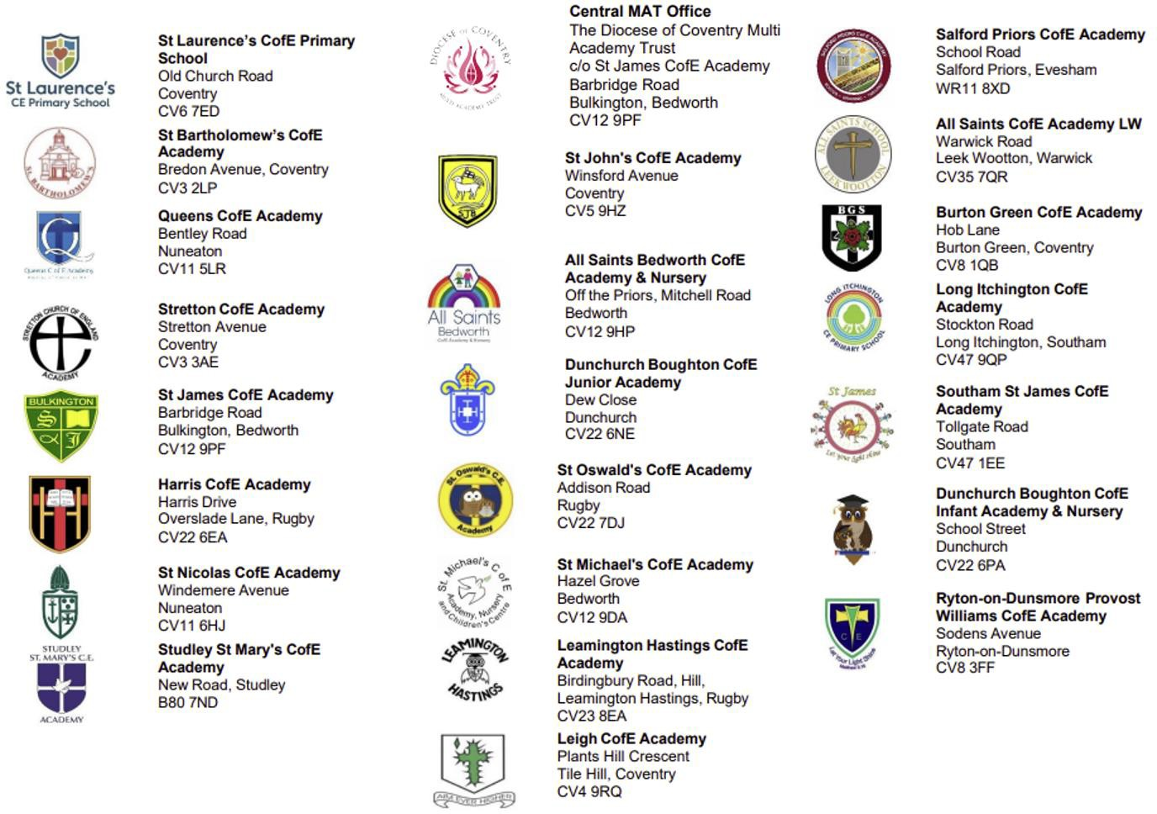
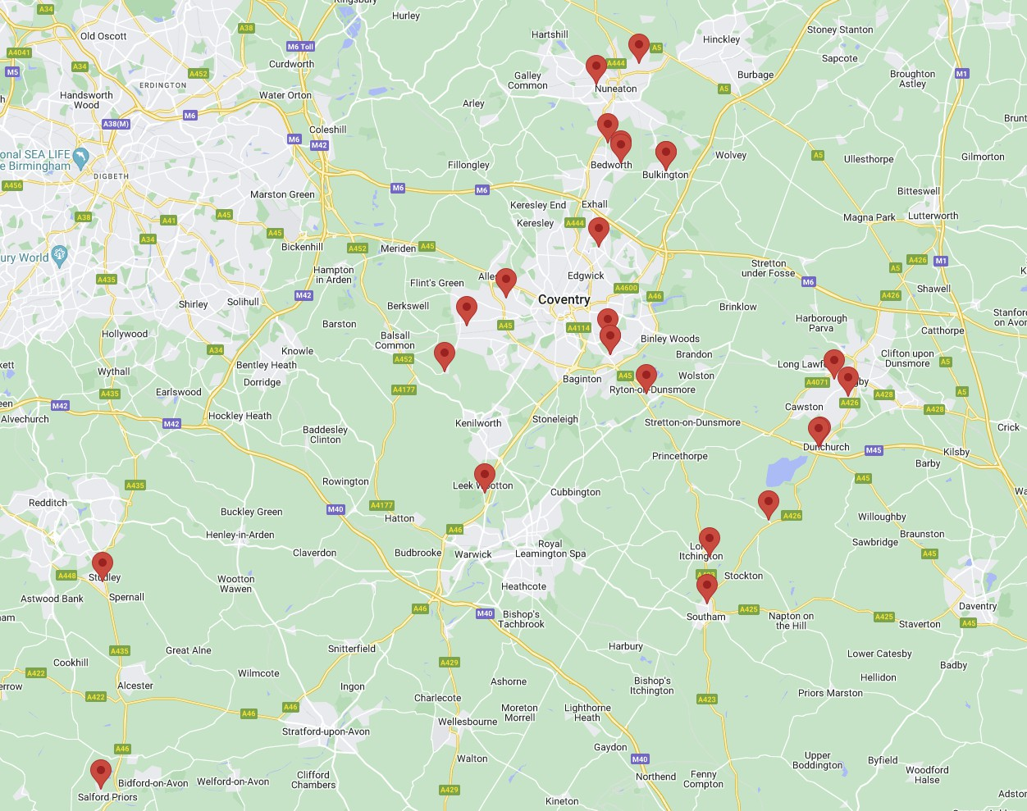
Our Academies

