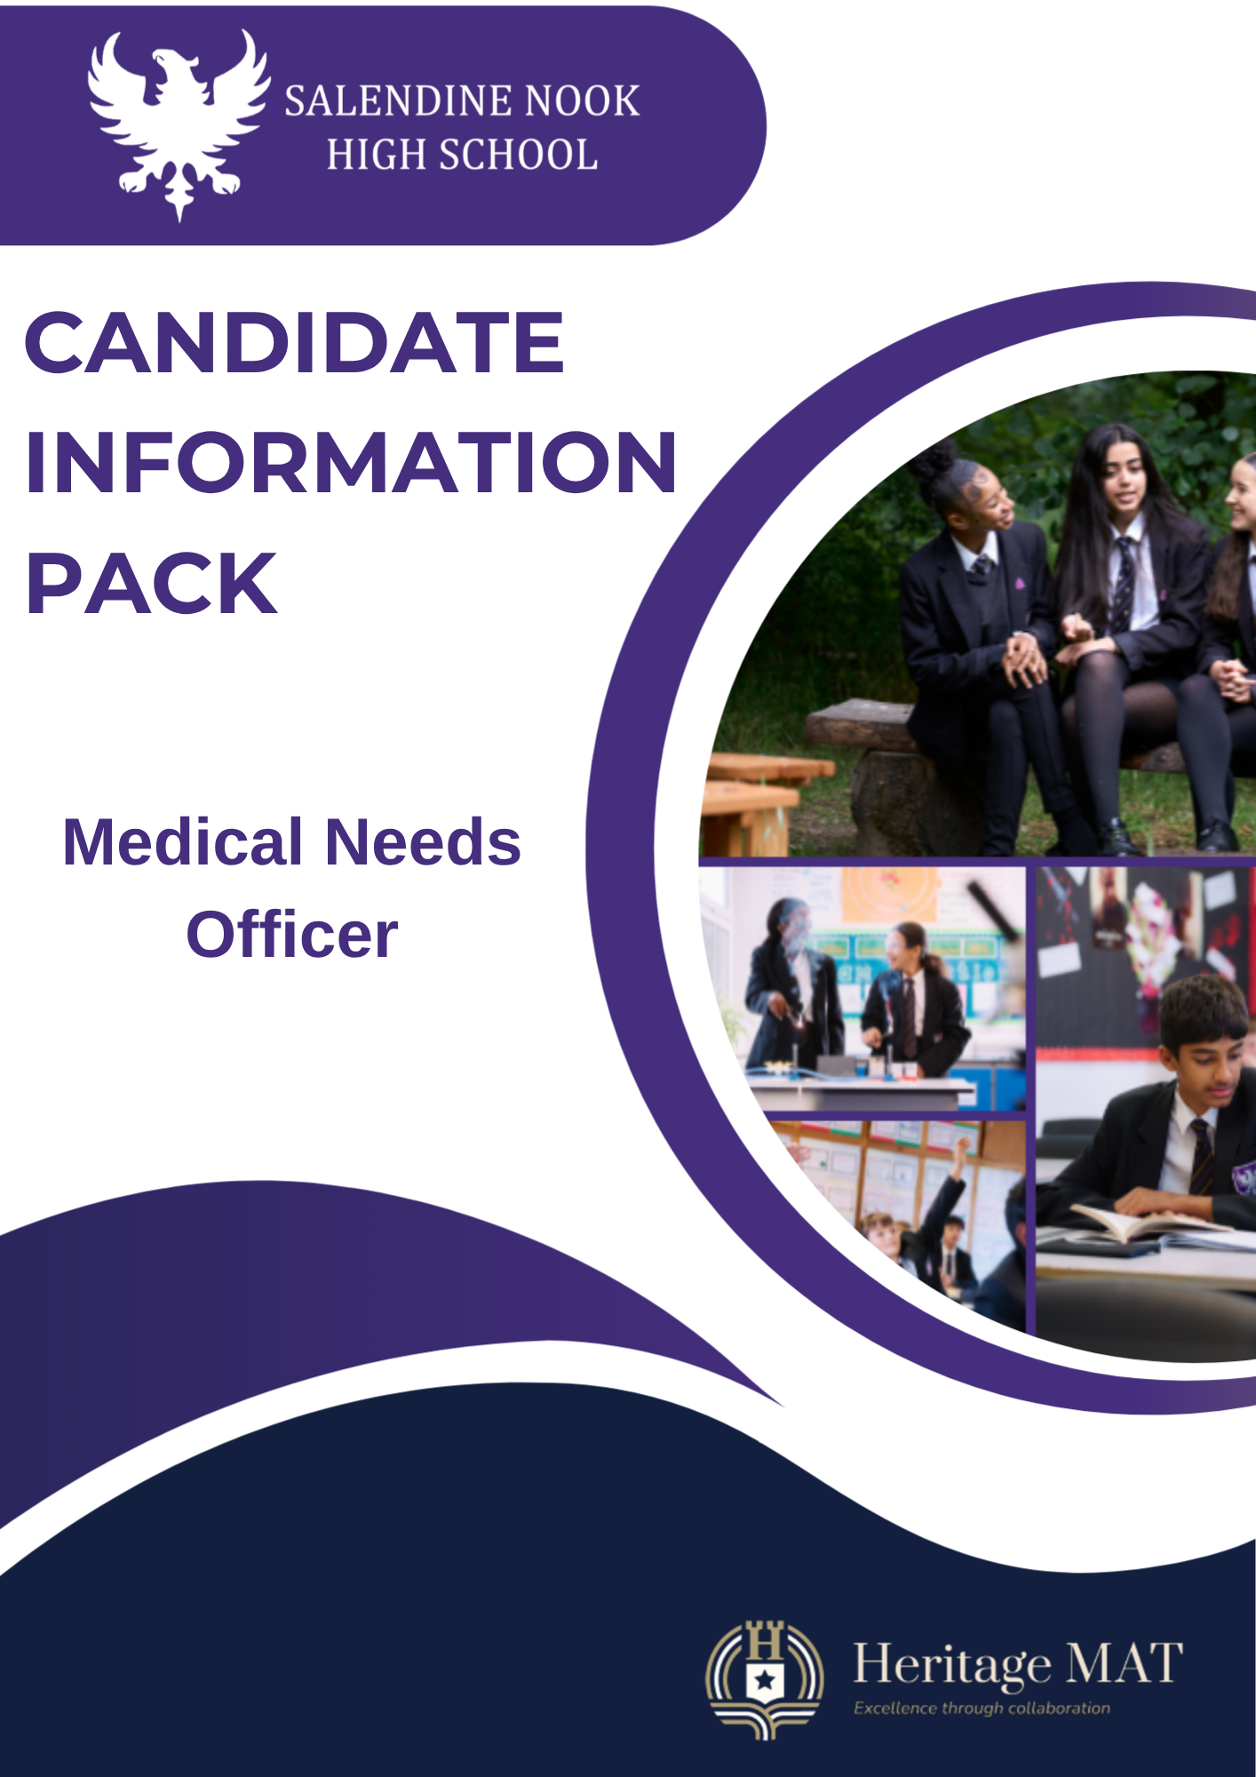
Medical Needs Officer

JOB DESCRIPTION

Trust School: Salendine Nook High School
Grade: 6 / 7 NJC point 7-17 (depending on qualifications/experience)
Hours: 32.5 per week- term time only
Contract type: Permanent
Reporting to: Assistant Principal Behaviour
Responsible for: None
Job Purpose: The Medical Needs Officer leads the medical provision at Salendine Nook High School, providing daily care to students, staff and visitors and responding confidently to medical issues and emergencies.
Key Responsibilities
Medical Needs:
- First Aid trained to provide first aid and emergency care to all members of the school community where necessary. If a student needs to go to the hospital and a parent/carer cannot be contacted, at times you may be needed to accompany students in the ambulance.
- Care for students who are injured or who become unwell during the school day. Notify parents/carers and arrange for the students to go home if necessary.
- Provide emotional support to vulnerable students and signpost to the appropriate support within the school.
- Ensure individual healthcare plans (IHCPs) and treatment protocols are developed and written for those students requiring them, in consultation with the parents/carers and SENDCO as required.
- Supporting and assisting students with IHCPs (e.g. diabetes) and actioning accordingly.
- Provide training and support to relevant staff regarding the care of the students with identified medical or health needs.

Ensure the smooth and efficient running of the medical room, ensuring processes are in place that can be followed by members of the First Aid team.

Maintain medical room stock, hygiene and tidiness.

Lead the First Aid team, this can be done through meetings and email correspondence

Maintain First Aiders’ training, ensuring all are updated promptly and organising whole staff training events, e.g. anaphylaxis training.

Ensure all first aid boxes located around the school are up to date and within expiry time limits, ordering replenishment stocks as required. Checks of departmental boxes will form part of a half-term routine.

Responsible for the dispensing and recording of medication.

Responsible for the coordination and release of medication for students involved in external activities/trips.

Follow stringent procedures for the recommended safe storage, usage and disposal of medical supplies and drugs. All stored drugs and medical supplies should be documented for school records.

Recording of all medical forms and consent registers. This includes medical care plans being recorded on SIMS for individual students.

Arranging with external health agencies (predominantly Locala) the programme of student immunisation and coordinating the arrangements on the day of vaccinations.

Assessing a student’s mobility on return to school following an injury, liaising with other members of staff on room changes and completing any risk assessments as necessary.

Monthly checks and logging of school’s defibrillation and EpiPen kits, this is then liased with the British Heart Foundation Circuit.

Liaising as appropriate with the pastoral team, parents and school catering staff concerning students with medical needs, e.g. food allergies.

Administration:

To log all first aid and medical incidents.

To maintain health records, ensuring confidentiality and appropriate legal storage in line with data protection requirements.

To review and update school policies appropriate to the role (First Aid Procedures, Accident/Incident Reporting & Investigating Procedures and Managing Medication Policy) in conjunction with senior colleagues.
- To maintain records of student health concerns and source training for staff as appropriate (e.g. use of epi–pen, procedures for asthma attacks, etc.)
- To liaise with school, parents and professionals to complete and review Medical Care Plans

To undertake general administration duties as required by the line manager.

- To support staff in school creating any medical risk assessments as appropriate

- Attend the weekly pastoral meeting on Thursday morning at 8am

Health and Wellbeing:

Action legal requirements, national policies and guidance on the safeguarding and promotion of the well-being of children and young people.

Have a sufficient depth of knowledge to be able to advise students on the importance of maintaining a healthy lifestyle – for example, eating, drinking, exercise and nonsmoking/vaping.

Identify and support students whose progress, development or well-being is affected by changes or difficulties in their personal circumstances and refer them to colleagues for specialist support.

To ensure one's own continued professional development is maintained and built upon, by attending relevant training courses, seminars and conferences relating to health matters.

Additional Information
- This post is subject to an enhanced DBS check as it is a regulated position.
- The job description may be amended at the discretion of the Headteacher to meet the changing needs of the school.
- Reasonable adjustments will be made to support disabled applicants or employees.

