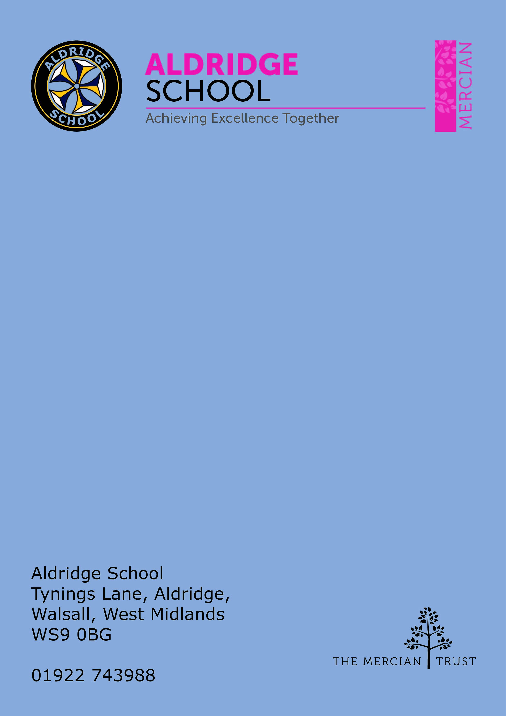

Application Pack

Teacher of Mathematics
(Fixed Term 1year – Maternity cover)



About Aldridge School – a Founder Academy of the Mercian Trust

About The Mercian Trust

Person Specification
How to Apply

Job Description


About Aldridge School

Thank you for taking the time to find out more about Aldridge School. This pack is intended to give you information about this role and our school's broader vision and ethos. Further background information is available in our Prospectus and Sixth Form Prospectus on our website.

We are a comprehensive school of over 1500 students situated near the centre of Aldridge village. We believe that it is our responsibility to work to meet the needs of every individual student, challenging them to achieve their best, supporting them to become responsible young adults and preparing them for their next steps into the world of work or further education.

Aldridge School is a good school (Ofsted 2022). It is a school which is proud of its traditions and successes which have been achieved through hard work and high expectations.

Aldridge School has a dedicated, talented and conscientious team of staff who work together to provide a high standard of teaching, excellent pastoral care and professional support services. Our broad curriculum is designed to meet national expectations, be relevant and interesting, support our students in achieving the best possible standards in external examinations and to equip them with the skills they need to be successful in adult life.

At Aldridge School we have a popular and thriving Sixth Form. We are very proud of our students' success with over 80% securing places at some of the top Universities and on Higher Apprenticeships last year. We offer a very broad range of both academic and vocational courses at level 3, ensuring that Aldridge School Sixth Form is an option for a wide range of students.

We also enjoy strong links with surrounding primary schools, working with students in Years 5 and 6 including work in Science, Maths, English, Performing Arts and Enterprise. We are proud of our community, and we work hard to promote this pride in all our partnerships, so that we can make sure that future students from these schools enjoy an easy, enjoyable transition to Aldridge School.

Students at Aldridge School are friendly, polite and respectful. Strong relationships between staff and students contribute significantly to ensuring that students are happy and feel safe.

If you would like to find out more, please contact us to arrange a visit to see our school at work. We look forward to meeting you.

Benefits of Working at Aldridge School

- All staff are provided with a laptop
- All classrooms are equipped with BENQ interactive panels
- High expectations of pupil behaviour and a clear rewards and behaviour policy
- Visible senior leadership team
- Excellent pastoral support
- Professional development tailored specifically to the goals of individuals
- Countless opportunities to get involved with the wider life of the school - Duke of Edinburgh, school performances, sports teams, music
- Access to a range of personal and professional development opportunities and Staff Wellbeing initiatives to support you along the way
- High quality curriculum resources to support workload

About the Mathematics Faculty

Aldridge School’s Faculty of Mathematics is an experienced team of 13 subject
specialists, teaching across all age and ability ranges. We strive to incorporate opportunities for real life application and problem solving into our curriculum to ensure best outcomes for our students, both in terms of qualifications and for their future endeavours. As a department we aim to offer extra-curricular opportunities and out of the classroom learning experiences to broaden our students’ horizons.

The Mathematics Curriculum

Key Stage 3

At Key Stage 3, we follow a mastery approach to our curriculum which connects content, pedagogy, assessment and data to deliver a coherent and responsive learning experience. The curriculum develops knowledge, skills and understanding in line with the DfE Mathematics guidance for KS3 so that learning is well-sequenced and connected, building upon what has been learned at KS2 and preparing learners for the transition to KS4. The mastery approach is designed to:
- ensure learning is built on firm foundations
- enable learners to make connections between new ideas and previous learning
- promote depth of learning
- provide time and scaffolding for all learners to become fluent
- enable responsive teaching and learning based through integrated formative assessment

Key Stage 4

We follow the EdExcel GCSE specification with pupils taking the qualification at the end of year 11. Our curriculum aims to provide pupils with the next steps required to build on their prior learning at Key Stage 3 ensuring that their understanding is at a greater depth, and to build a platform to allow as many pupils as possible to move on to successfully study mathematics at Key Stage 5. Pupils who are not meeting age related expectations at the end of Key Stage 3 are able to establish strong foundations in mathematics by working towards the Entry Level Certificate from level 1 up to level 3. This provides pupils with a mathematics qualification whilst also building confidence and enabling them gain later success with the GCSE qualification later.

Key Stage 5

Our aim at KS5 is to provide all students with the opportunity to continue the study of Mathematics beyond GCSE. Our Key Stage 5 courses are well subscribed with our students being offered A Level Mathematics, A Level Further Mathematics and Level 3 Certificate in Mathematical Studies (Core Maths). We want our most able mathematicians to develop deep mathematical skills and the resilience to use these functionally in a real-life context.



The Mercian Trust

Aldridge School is an academy in The Mercian Trust.

The Mercian Trust brings together twelve very different and individual schools together as a single Multi-Academy Trust or MAT.

The twelve schools are unique in their identity and united by their ambition to offer the best possible future for their students.

The twelve schools are:
- Aldridge School
- Queen Mary’s Grammar School
- Queen Mary’s High School
- Shire Oak Academy
- The Ladder School
- Walsall Studio School
- Q3 Academy Great Barr
- Q3 Academy Langley
- Q3 Academy Tipton
- New Leaf
- Rushall Primary School
- Oakwood School

Each school has its own distinct ethos and approach, but we have this over-arching aim in common: we prepare all our students to enjoy life to the full by inspiring them to:
- Realise their potential as learners
- Thrive in the world of work
- Make a positive contribution to the local, national and international community

The Mercian Trust respects the autonomy of its member schools but, through collaboration, fosters strengths that are greater than the sum of its parts. Working together as a Multi-Academy Trust provides a framework for sharing expertise and enthusiasm, resources and ideas.

A sector-leading CPD offer

- We offer a truly comprehensive training programme featuring exclusive Mercian Trust content from the world’s leading education professionals.
- You can be assured of getting the very best mentoring and support for all external professional qualifications and programmes such as ECT and NPQs.
- We are proud of our package of goals-focussed training for non-student facing associate staff.
- Our Digital Champions support all staff to maximise the benefits of our multi-million pound digital infrastructure and to transform the way we teach, we learn, we lead and we operate.
- We hold an annual staff development conference for all staff that is packed with content, valuable resources, and networking opportunities.
- Staff can join our wide range of Professional Learning Communities, led by Trust Lead Professionals to develop collaborative practice across our schools and wider sector.
- All staff are invited to have articles published in our half-termly education journal, The Education Exchange, and to be supported to write and speak for external audiences via our excellent links with leading publications and training organisations.


Job Description

Post: Teacher of Mathematics (Maternity Cover)
Responsible to: TLR Holder in mathematics faculty
Salary: MPS/UPS

The post-holder will be expected to undertake duties in-line with the professional
teacher standards for qualified teachers.

1 Set high expectations which inspire, motive and challenge pupils
- Establish a safe and stimulating environment for pupils, rooted in mutual respect
- Set goals that stretch and challenge pupils of all backgrounds, abilities and dispositions
- Demonstrate consistently the positive attitudes, values and behaviour which are expected of pupils

2 Promote good progress and outcomes by pupils
- Be accountable for pupils’ attainment, progress and outcomes
- Be aware of pupils’ capabilities and their prior knowledge, and plan teaching to build on these
- Guide pupils to reflect on the progress they have made and their emerging needs
- Demonstrate knowledge and understanding of how pupils learn and how this impacts on teaching
- Encourage pupils to take a responsible and conscientious attitude to their own work and study

3 Demonstrate good subject and curriculum knowledge
- Have a secure knowledge of the relevant subject(s) and curriculum areas, foster and maintain pupils’ interest in the subject, and address misunderstandings
- Demonstrate a critical understanding of developments in the subject and curriculum areas, and promote the value of scholarship
- Demonstrate an understanding of and take responsibility for promoting high standards of literacy, articulacy and the correct use of standard English, whatever the teacher’s specialist subject

4 Plan and teach well-structured lessons
- Impart knowledge and develop understanding through effective use of lesson time
- Promote a love of learning and children’s intellectual curiosity
- Set homework and plan other out-of-class activities to consolidate and extend the knowledge and understanding pupils have acquired
- Reflect systematically on the effectiveness of lessons and approaches to teaching
- Contribute to the design and provision of an engaging curriculum within the relevant subject area(s)

5 Adapt teaching to respond to the strengths and needs of all pupils
- Know when and how to differentiate appropriately, using approaches which enable pupils to be taught effectively
- Have a secure understanding of how a range of factors can inhibit pupils’ ability to learn, and how best to overcome these
- Demonstrate an awareness of the physical, social and intellectual development of children, and know how to adapt teaching to support pupils’ education at different stages of development
- Have a clear understanding of the needs of all pupils, including those with special educational needs; those of high ability; those with English as an additional language; those with disabilities; and be able to use and evaluate distinctive teaching approaches to engage and support them
6 Make accurate and productive use of assessment
- Know and understand how to assess the relevant subject and curriculum areas, including statutory assessment requirements
- Make use of formative and summative assessment to secure pupils’ progress
- Use relevant data to monitor progress, set targets, and plan subsequent lessons
- Give pupils regular feedback, both orally and through accurate marking, and encourage pupils to respond to the feedback

7 Manage behaviour effectively to ensure a good and safe learning environment
- Have clear rules and routines for behaviour in classrooms, and take responsibility for promoting good and courteous behaviour both in classrooms and around the school, in accordance with the school’s behaviour policy
- Have high expectations of behaviour, and establish a framework for discipline with a range of strategies, using praise, sanctions and rewards consistently and fairly
- Manage classes effectively, using approaches which are appropriate to pupils’ needs in order to involve and motivate them
- Maintain good relationships with pupils, exercise appropriate authority, and act decisively when necessary

8 Fulfil wider professional responsibilities
- Make a positive contribution to the wider life and ethos of the school
- Develop effective professional relationships with colleagues, knowing how and when to draw on advice and specialist support
- Deploy support staff effectively
- Take responsibility for improving teaching through appropriate professional development, responding to advice and feedback from colleagues
- Communicate effectively with parents with regard to pupils’ achievements and wellbeing

Personal and Professional Conduct
A teacher is expected to demonstrate consistently high standards of personal and professional conduct. The following statements define the behaviour and attitudes which set the required standard for conduct throughout a teacher’s career.
Teachers uphold public trust in the profession and maintain high standards of ethics and behaviour, within and outside school by:
- Treating pupils with dignity, building relationships rooted in mutual respect, and at all times observing proper boundaries appropriate to a teacher’s professional position
- Having regard for the need to safeguard pupils’ wellbeing, in accordance with statutory provisions
- Showing tolerance of and respect for the rights of others
- Not undermining fundamental British values, including democracy, the rule of law, individual liberty and mutual respect, and tolerance of those with different faiths and beliefs
- Ensuring that personal beliefs are not expressed in ways which exploit pupils’ vulnerability or might lead them to break the law
- Teachers must have proper and professional regard for the ethos, policies and practices of the school in which they teach, and maintain high standards in their own attendance and punctuality
- Teachers must have an understanding of, and always act within, the statutory frameworks which set out their professional duties and responsibilities.


Person Specification

Qualification Criteria

- Qualified to degree level or above
- Possesses QTS status or equivalent

Experience

- Successful teaching experience or placement in a secondary school
- Fulfilling a Form Tutor role in a secondary school
- Leading or supporting extra-curricular activities

Knowledge

- National curriculum at key stages 3 and 4
- Research-informed teaching techniques that support pupils to make good progress
- Subject-specific pedagogy
- Current legal requirements, national and school policies and guidance on the safeguarding and promotion of the well-being of children and young people

Skills

- Effective and adaptable ICT skills
- Excellent communication and interpersonal skills
- Energy, enthusiasm, resilience and perseverance
- Commitment to continual reflection and improvement of teaching practice
- Able to adapt learning to support the needs of individual students
- Effective use of data to identify student underperformance and plan appropriate intervention
- Excellent planning and organisational skills
- The ability to produce correspondence/documents, appropriate for a specific audience and in well-written English, ensuring the tone is appropriate to the purpose


How to Apply

Salary
MPS/UPS (fixed term 1 year)

Closing Date
Friday 15th May 2026

Start Date
September 2026

Visits to School
For further information, please contact the school either by email info@ald.merciantrust.org.uk or by telephoning Mrs Knight on 01922 743988 ex 2224

Applying
Apply via My New Term.

