
Giles Junior School

Achieving Excellence through Leadership

Positive Relationships Policy
(Previously named Pupil Behaviour and Discipline Policy)

Document Details
Approving Body | FGB
Author | Giles Junior School
Committee Responsibility | Curriculum and Standards
Scheduled Review | Annually
Date of Policy | July 2025
Next Review | July 2026

Positive Relationships Policy
Purpose
At Giles Junior School, we recognise that positive and safe relationships between staff and pupils are the foundation for effective learning and positive behaviour. Research from the Education Endowment Foundation (EEF) highlights that a secure, respectful, and nurturing classroom environment supports both academic progress and emotional development. When children feel safe and valued, they are more likely to engage in learning, demonstrate resilience, and show respect for others.
The principles of attachment theory (Bowlby, 1969) emphasise the significance of consistent, responsive relationships in supporting children's ability to regulate emotions and develop socially and academically. For many pupils—particularly those with additional needs or adverse experiences—school may be their most reliable source of structure and emotional safety. These relationships foster trust and allow pupils to take academic risks, manage their behaviour, and thrive.
Our behaviour approach is therefore rooted in the belief that strong, positive relationships are not only beneficial but essential in enabling all children to flourish.
Aims

- To promote an environment where we help our pupils’ learn to self regulate to and enable them to learn that they are responsible for making proactive choices
- To create a calm and ordered learning environment with consistent and reliable routines embedded.
- To encourage consideration for others in the community.
- To support the development of self-esteem and self-respect by distinguishing between a pupil and that pupil’s behaviour.
- To ensure that pro-social behaviour is encouraged, recognised and expected through clear instructions and repetition from staff to embed routines
- To develop pupils’ pride in the school, in learning and in effort, as well as achievement.

Legal Guidance and Responsibilities

The Department of Education guidance, ‘Behaviour and Discipline in Schools; Advice for headteachers and school staff (February 2024 )’ has been read and used to guide the school on the legal obligations, powers and responsibilities in terms of discipline and managing behaviour within the school.

Responsibilities of our school community

Pupils are expected to:
- know the school expectations, routines and engage in discussions about them; sign class contract
- adhere to the school expectations, including during off-site visits, and when travelling to and from school;
- support other members of the school community in promoting the expectations of good behaviour

Parents and carers are expected to:
- support the ‘Home School Agreement’ as expected when choosing this school for your child ;
- know the Behaviour Policy and actively support it through discussions with their child as appropriate to support the expectations of the school;

Members of Staff in school must:
- set high standards of professional behaviour, politeness, self-discipline and respect to all;
- Be aware of “school routines” following supporting pupils to have consistent routines implemented in all classes (see link)
- listen to pupils, making it clear through their response that pupils’ comments are taken seriously and are of importance;
- actively support the Behaviour Policy through implementation and discussion with pupils;
- seek advice from senior leaders and report any concerns regarding the implementation of the behaviour policy
- resist interrupting another member of staff who is speaking to a child (be this for positive or negative affirmation)
- avoid recounting behavioural incidents to other members of staff in front of any children
- follow measures and framework (so it doesn’t sound robotic)in Individual Risk Management Plans

Governors are expected to:
- refer all matters regarding discipline to the Headteacher who, in consultation with relevant parties, will investigate;
- know, support and promote the school’s Positive Relationships Policy;
- evaluate the effectiveness of the Positive Relationships Policy and hold senior leaders to account for its implementation.

Giles’ values are the principles that come from the 7 Habits

Within the 7 Habits, there are 27 principles which are similar to values. Instead of teaching a value each week or every month, these principles are modelled on a daily basis through direct and indirect teaching and modelling. See appendix 2.

Recognising Positive behaviour
At Giles Junior School, we believe that children will learn best if they have high self-esteem. We believe children will make positive choices if there is an expectation and a climate of positive behaviour.

Children who demonstrate the 7 Habits and behave appropriately will be recognised in the following ways:
- frequent positive praise (verbal)
- individual class rewards e.g. tokens, stickers or Dojo points
- sharing work with the class;
- Leader of the Week award (for showing elements of the 7 Habits)
- Emotional Bank account slips
- House Rewards
- Extra Play for achieving class specific rewards (Wildly Important Goals)
- Selection for sports events

See appendix 3 for a list of useful strategies to maintain positive behaviour.

Leader of the week
Each week, one child from each class will be chosen as the leader of the week for demonstrating a habit which reflects a principle from the 7 habits. In the leadership assembly, teachers will stand up and explain why the child has been showing leadership qualities. The child is given a certificate.

Emotional Bank Accounts
Each child has an Emotional Bank Account. Children make deposits at least once weekly. Each class has emotional bank account leaders who ensure that all pupils are getting approximately one deposit per week.

Termly Merits
Children are chosen to receive a merit award at the end of each term. Parents are invited to attend this assembly and are informed about the assembly.

Teaching Prosocial Behaviour Through Logical Consequences
At Giles Junior School, we believe that children learn to behave prosocially when they understand the link between their actions and the outcomes that follow. Our behaviour approach includes the use of logical, fair, and proportionate consequences that help pupils reflect on their choices and take responsibility for their behaviour.
Rather than punitive measures, we focus on restorative and educative consequences. For example, if a pupil chooses not to focus during a lesson and, as a result, is unable to complete their work, they may be expected to use part of their free time (such as break or lunchtime) to complete the task. This consequence is directly linked to the behaviour and helps the child understand that their actions have an impact on their learning.
By using consistent, meaningful consequences, we aim to promote accountability, build self-regulation, and reinforce the importance of respectful and responsible behaviour. These responses are always delivered calmly and proportionately, with the goal of supporting pupils in making better choices and contributing positively to the school community.
Children are still learning how to focus, communicate and what boundaries are acceptable in different environments. For most of our pupils quick reminders to prevent and reduce low level disruption are effective in changing behaviours long term. Applying consistent and relevant consequences which support the pupils in understanding expectations makes sure the learning environment is suitable for all pupils and gives them the skills needed to become a successful member of society.
The table below offers guidance to staff so they can apply consistent reminders to pupils to help them maintain focus and keep their classroom calm and productive.
It should be noted, that as an inclusive school, there are a number of reasonable adjustments, which will, made of pupils who have difficulties in class. These will be bespoke and will be in place to mitigate the requirement for intervention such as listed in the table below.

STAGE | CHARACTERISTICS | CONSEQUENCES | PARENTAL INVOLVEMENT
1.  Low level disruption/ inappropriate behaviour (in class) | - Calling out  - Interruption  - Ignoring  - Incomplete tasks  - Off task | - Recognise – one or two children who are doing the right thing  - Warning – the child is told why their behaviour is unacceptable and is redirected.  - Loss of minutes – from their next break/lunch time (Debrief - see below)  - Further loss of minutes – additional minutes issued  - Partner class – the pupil is sent to a partner class (as agreed between teachers) | Parents will be informed if necessary. Incomplete work to be completed in break and if not completed it will then be sent home when agreed by parents and teacher.
2.  High level disruption | - Taking things  - Offensive language  - Repeatedly ignoring adult instructions  - Hurting someone  - Threatening language | Reflection – days to be agreed according to the incident  The teacher will record the details of the incident on the reflection register  Review of extracurricular activities based upon safety protocol | The parent will be informed on the same day or the day before the reflection taking place unless there is a reason not to do so which will be recorded.
3.  High level incident | - Persistent bullying  - Repeated challenge to authority  - Repeated refusal to comply  - Racism  - Homophobia | - Sanctions and rewards chart as agreed with SLT  - Consider managed move to another class  - Home-School book  - Up to 5 day reflection (dependent on context, type of language and if they show remorse)  - Internal exclusion (a repeat of this behaviour following an internal exclusion may result in an external exclusion) | Parents to meet with SLT to agree on relevant sanctions
4.  Extreme and dangerous behaviour | - Leaving the school boundary or absconding on a trip  - Serious intentional harm to others  - Repeated aggression to pupils and/or staff  - Persistent damage to property | - Risk Calculator completed  - Risk Reduction plan put in place  - External behaviour support advice  - Reduced timetable  - External suspension  - Managed move to an alternative school  - Permanent exclusion | Parental involvement at all points

NB The list of sanctions and consequences is not exhaustive and does not directly correlate to the characteristics opposite. In all circumstances, our knowledge of the individual child and the context in which incidents and behaviours are exhibited will be factors brought into consideration by staff - this is especially so for pupils with complex Special Educational Needs & Disabilities

Debrief – this will take place during the child’s minutes at break or lunch time
The teacher will ask the child to think about the questions below:
- What did I do?
- What was I thinking when it happened?
- How do I feel?
- How can I fix it?

Reflection
Reflection is a session held during the child’s lunch time to allow them to consider their actions and learn from them, thinking about the impact their behaviour has had on other people. Before issuing a reflection, the situation will have been explored with one or two members of staff. This will include finding out where it took place where children involved will have been spoken with to ascertain an accurate picture of the incident.

A reflection will involve a conversation with a member of pastoral staff. They will explore the incident with the child and what they could have done differently. Depending on the incident, they will be given a toolkit of strategies or will repair a relationship with another pupil or they might refer to videos to support their understanding of a particular situation and reflect on what they could do differently if the same situation arises.

Repeat incidents might involve a different approach such as missing football - this will be a linked consequence.
Where another child has been hurt, the Restorative Justice Approach should be used to support both the victim and the aggressor. See restorative justice questions – Appendix 4
Lunchtime
At lunchtimes, positive learning behaviours are still maintained but the children follow the lunchtime procedures led by. Where possible, poor behaviour is dealt with immediately in the following way:
- Warning
- 5 minutes timeout (standing next to the supervising adult)
- 10 minutes timeout (standing next to the supervising adult) for a repeated incident
- Alternative sough - such as going inside for the remainder of lunch

If a high level, extreme or dangerous incident occurs, then the child is escorted inside as soon as possible.

Resolving concerns raised by pupils

At Giles we use habit 5 (Seek first to understand, then to be understood) to make sure we have all the necessary information to help find a suitable resolution where all parties can move on.
- Listen to the problem and find out who it involves (including anyone who may have been a witness but not directly involved)
- Find out when, where and what happened
- Speak to other individuals involved to see if all the information reflects a full and true picture
- If a child has been hurt their parents will be informed if the time of day allows for this to happen it will be same day but may be the following day– including the outcome/consequence agreed so they are aware of how the situation has been resolved
- A consequence which is relevant will be agreed by two members of staff e.g. reflection, missed break, time out of class

Pupils showing dangerous behaviour

If a child is repeating the same behaviours again (e.g. deliberately hurting other children), a member of SLT will call a review meeting. At this review meeting a decision will then be made about risk reduction plans which are required for pupils who are not responding to the school behaviour policy.
- The child’s class teacher will be part of the writing process alongside a member of SLT, and, if appropriate, the child
- A range of tools will be used in order to consider triggers for those individual pupils and support a comprehensive plan e.g. early prognosis, risk calculator, anxiety mapping, subconscious/conscious checklist
- The headteacher/deputy headteacher/assistant headteacher will make a decision about accessing external advice, suspensions or exclusion as they will have the full picture about home issues, previous support, mental health issues or other professionals who are involved with the child, and other influencing factors.
- Pupils with individual Risk Reduction Plans will have their plans shared with all staff so this can be applied consistently.
- All staff have a duty to follow the measures in the plan to ensure anxieties and trigger points are reduced.
- If staff are unsure how to approach a child they don't know well they should seek advice from another member of staff before managing challenging behaviour.

Suspension
We recognise that some children will be reactive and be unable to regulate their emotions for a range of reasons and this sometimes results in extreme anti-social behaviour. The head teacher can use a period of internal exclusion where a child or children may not go back to class for a fixed period of time. They will either carry out their learning activities in the den or another classroom. In extreme situations the head teacher may decide that a suspension is appropriate. Any decision made of this nature is never taken lightly. As part of a suspension, parent/carers will receive a letter (with official wording). The child and parent/carer will be invited to attend a reintegration meeting, which will take place upon their return to school. This discussion and agreed actions will be documented.

We work hard to use strategies other than suspension or exclusion; however, in some cases, where behaviour is extreme, persistent, reoccurring or violent, permanent exclusion may be necessary. In this situation, Local Authority and DfE guidelines are followed and the head teacher and parents/carers are involved.

Physical intervention- Positive Handling
Members of staff should physically intervene only to prevent a child causing harm to themselves or others, or causing damage to school property. Physical intervention is very rare and is in line with Herts Steps guidance and positive handling training. The adult should always seek assistance from another adult through our radio system. A member of the Senior Leadership Team should be informed as soon as possible. The incident should be recorded and a parent/carer should be informed.

The school recognises that there are occasions when physical contact (other than reasonable force) with a pupil is proper and necessary, such as:

- to give first aid;
- a child holding the adult’s hand (adult to keep hand in an open mitten shape);
- when comforting a distressed pupil (side hug);
- when a pupil is being congratulated or praised (side hug);
- to demonstrate how to use equipment;
- to demonstrate techniques.

Absconding from school site
We have a secure site with door access control. We have clear routines and procedures in place, but the site is only as secure as the people who use it and the whole school community has a responsibility to help us maintain security. In the unlikely event of a child leaving the school premises without permission, staff should follow the following procedure:

- Missing child with initials relayed on on radio
- Staff member to follow pupil taking a phone/radio - if distressed keep distance and encourage to stay safe
- take radio and radio for support from another member of staff
- Staff member who has radioed goes to the office and reports child’s name to allow contact with parents and police to be called
- Member of office staff to call parent immediately to state their child has absconded from site
- Member of staff following pupils to call the police and give current location

Staff training
Staff are given a copy of this policy as part of their induction to the school.

As part of on-going professional development all staff are regularly reminded of the importance of following this policy. We draw upon training from Herts Steps and Positive regard in our approach to reducing challenging behaviour. At least one senior member of staff is trained as a Herts Steps trainer and can deliver training to Giles staff. Staff receive whole school behaviour training annually this does not always take the form of the full Steps Programme and is relevant to the cohort and needs of staff and pupils each year.

In addition, staff access specific training according to their role and the needs of the child/children with whom they interact. For more specialist training, we adopt a cascade approach. This means only a couple of staff may have attended specific, in-depth training, and they then disseminate this information as appropriate. Staff training records are regularly reviewed as part of the appraisal process and school improvement planning. Where gaps in knowledge and understanding are identified, or where a member of staff wishes to further enhance their skills, training will be accessed when it is available.

Procedures for review and evaluation
This policy is a ‘living policy’. Monitoring, review and evaluation is built into the annual school self-review cycle. Monitoring takes place in a number of ways:
- The completion of short questionnaires by pupils, staff and parents/carers;
- Involvement of pupils in environment walks and interviews;
- Classroom observation.
- Staff input when policy is due for review to check it is relevant and echoes what is happening in school

Staff are kept informed of changes via staff communication systems.

Parent/carers are kept informed of changes via the newsletter and the school website. Paper copies are available from the school office

Complaints
The school’s procedures for dealing with complaints about behaviour are a part of the school’s procedures for handling all complaints.

Related Policies:
- Anti-Bullying Policy
- Child Protection Policy
- Complaints Procedure
- Equality and Diversity Policy
- Restrictive Physical Intervention Policy

Date for review: - July 2026
Distribution:-
A copy of this policy will be available to:-
a) all school governors
b) all school staff
c) all Parents.
Please note this policy is signed digitally on Governor Hub.

Appendix 1 – Positive Phrasing Examples

Negative Phrasing | Positive Phrasing
Stop running. | Walking please. Thank you.
Stop talking. | Show me you’re listening. Thank you.
No fiddling, put your pen away. | Hands in laps. Thank you.
Stop tipping on your chair. | Chair on four legs.
Stop handing the books out | Thank you for being helpful but we don’t need the books right now.

Appendix 2
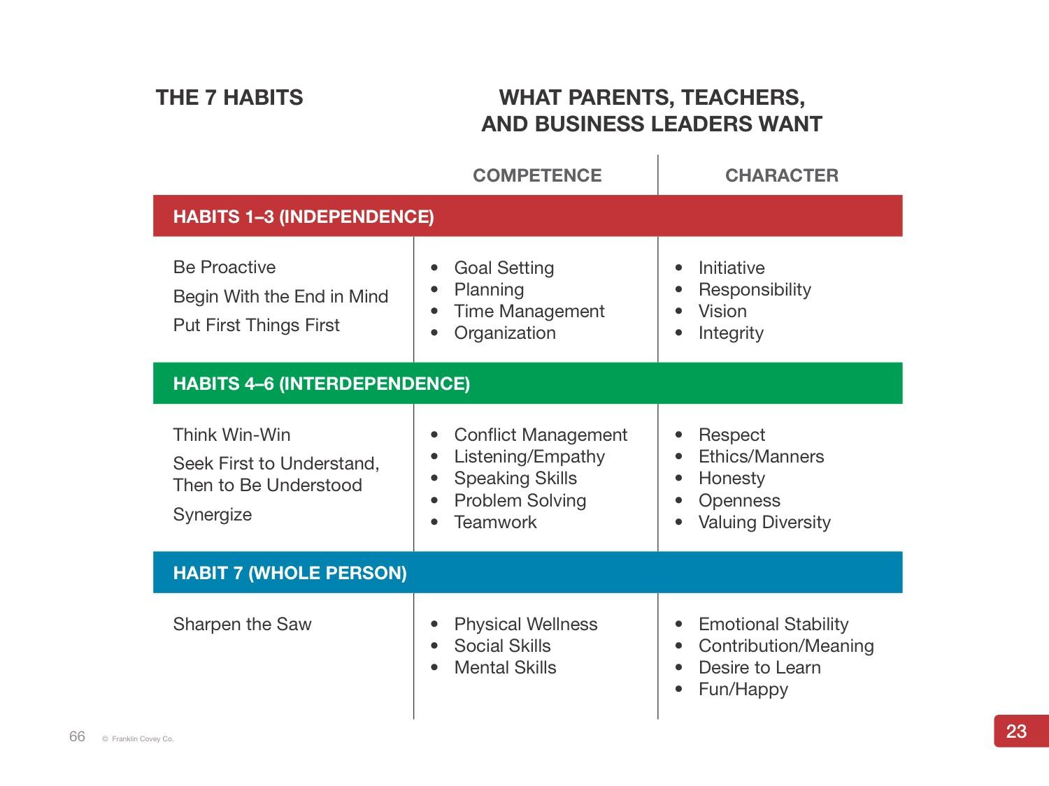
Appendix 3 – Useful behaviour management strategies
Public praise and private criticism
Public acknowledgement of good behaviour can be very powerful. Usually, criticism should be as private as possible; lowering a child’s self-esteem is likely to increase misbehaviour. Avoid standing on one side of the classroom and telling someone off on the other side. The audience provided by the rest of the class can prove rewarding for the child as well as making the rest of the class feel told off too. Some children find direct praise hard to handle, so praise should be as descriptive as possible and you should be sensitive to the impact. Perhaps allow the child to hear you telling someone else how well he or she has done. Praise can also be non-verbal (a smile, a thumbs-up or a sticker). Expand your vocabulary for praise.

Acknowledging feelings
Children often misbehave because they feel upset. One reason for this can be to attract adult attention to their bad feelings in the hope that they will get some help with them. Being aware of the child’s feelings can pre-empt them resorting to other ways to get your attention. Remember some behaviour is a language and the child is only trying to communicate his/her feelings.

Give them a choice
Give children a choice as often as possible. This can be as simple as deciding which piece of work they want to do first. Being given choices increases a child’s sense of independence, which in turn contributes to the development of their self-esteem.

Develop systems
Very clear systems help to minimise disruption. Consider how children line up, where they sit, who gives out and collects in equipment, how children move around the school, how they change for PE, what happens at home time, how they use the cloakroom/toilets etc.

Being consistent
Children have a need for the world to be as reliable as possible. When staff act consistently and reliably, they make the child feel safer and therefore less anxious.

Model desired behaviour
It is important for adults within the school to model the kinds of behaviour that they expect from children in terms of respect, concern, fairness, how to apologise, how to resolve difficulties fairly and amicably. Dealing with difficult behaviour can trigger feelings of anger, irritation, disappointment or even despair. It is better to avoid communicating these feelings. Responses should be low key and matter of fact.

Scan the classroom
Teachers who seem to know what is going on even before it has started and seem to have eyes in the back of their head impress children. Put yourself in a position where you can see what is going on and scan for children who are off-task. Re-direct children before behaviour has become disruptive. Listen for changes in patterns of conversation, which might indicate off-task behaviour. Make your presence felt by a look or by repositioning yourself.

Listen to children
Listen to children and make them feel significant. It is important to make children feel aware that you recognise their feelings... “You seem cross, did something happen?” Follow up concerns raised and complaints made, even if you need to say that you will deal with it later. Children need to feel able to share things with us and for issues not to be driven ‘underground’.

Pre-empt disruptive behaviour
If a child is off-task, the important tactic is to return their attention to the task before they actually become disruptive.

Be aware of yourself
When dealing with disruptive incidents, consider the following:
- your position in the class;
- your proximity to disruptive children;
- your facial expression and the use of eye contact;
- your posture;
- your tone of voice and choice of words.

Catch them being good
This can be hard with some children but it is usually more important for them than for many others. Noticing and acknowledging anything that is in the direction the adult wants the child to take will encourage and reinforce that movement.

Use positive language
Instead of saying, “Will you stop talking” say, “I’d like everyone listening, please”. Instead of “John, stop turning around and distracting Mike” say, “John, I’d like you facing this way and getting on with your work… thanks.” Instead of “Stop running!” “Stephen, walk through the hall…thank you.”

Choice, direction and ‘when…then’
- “Jamie, you can either work quietly by yourself or you can come and sit with me”.
- “Josh, when you have shown me level 5 learning behaviour, then you can go out to play.”
- “When you have finished tidying up your area, then you can sit wherever you want….”

Pause Direction
Children are in a bubble of their own a lot of the time. Just because you start talking, doesn’t mean they hear you. Make a deliberate pause between gaining a child’s attention and a direction, to ensure they have had sufficient ‘take up’ time, e.g. “Michael (pause) …David (pause) …could you face this way and listen, thanks”. Gain their attention, with eye contact.

Take-up Time
Simply, “Michael… (pause to gain attention) come here a sec.” Then look away and talk to someone else. Michael will come. It also works in the corridor. “John, come over here for a sec”, then walk away to a private area. John will follow. You can then have a quiet word about the behaviour.

Mindfulness
Techniques such as ‘feet on floor, bums on seat’ (FOFBOS) may help to refocus pupils during periods of sustained work or to settle pupils after transitions.

Co-regulation]
Support children with their regulation so they are not dealing with distress alone.

Appendix 4

Restorative questions include (suggested order):
- What happened?
- What were the people involved thinking and feeling at the time?
- Who has been affected? And how?
- How can we put right the harm? How can we mend this situation?
- What have we learned so as to make a different choice next time? Next time I’m… I will…
- What would you like to happen next?
- How can we make things better for…(you)?
- If everything was going to be alright what would need to happen?
- How can you help put this right?
- How can we make it okay for you to go back to lessons/activities?
- What do you think… might need?

