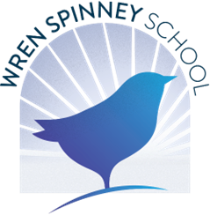
“Educating for the future, Step by Step”

Headteacher







Mike Tebbutt
Part of Creating Tomorrow Trust
Wren Spinney School, Westover Road, Kettering, NN15 7LB
office
@
wrens
pinne
y
.co.uk

head
@
wrens
pinne
y
.co.uk

www.wrenspinney.co.uk

Telephone: 01536 481939

LUNCHTIME SUPERVISOR
20 hours per week 38 weeks per year
£12.65 per hour

To assist in the feeding, supervision and lunchtime routines (including personal care) of pupils with severe, profound and multiple learning difficulties in this secondary age special school
The successful applicant will need to be:

- A team player, flexible when necessary and have a pleasant disposition.
- Able to demonstrate an interest in working with and interacting with children with special needs.
- Experience of working with children in an educational setting preferable.
- An awareness and ability to identify issues that children with special needs may experience and how they can be resolved.
- Good communication and listening skills.
- An awareness of Safeguarding (although training will be given).
- Ability to problem solve and communicate issues of concern about staff and children to the appropriate person.
- Committed to equal opportunities.
- Manual handling skills.
- An excellent attendance and punctuality record is essential.
- Previous experience desirable but not essential.

Closing date: 13th April 2026 @ Midday
Interviews to be held 22nd April 2026

Please note candidates will be interviewed at a mutual time with the Headteacher.

