

Learning Support Assistant and MDSA
Recruitment Pack

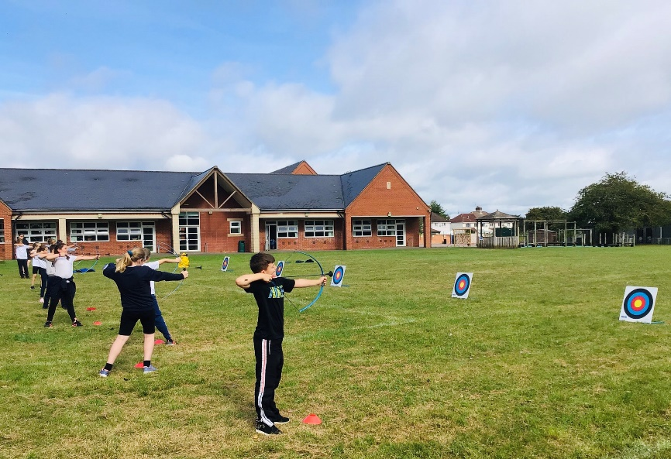

Advert Opens: 14.07.26 Advert Closes: 17.07.26



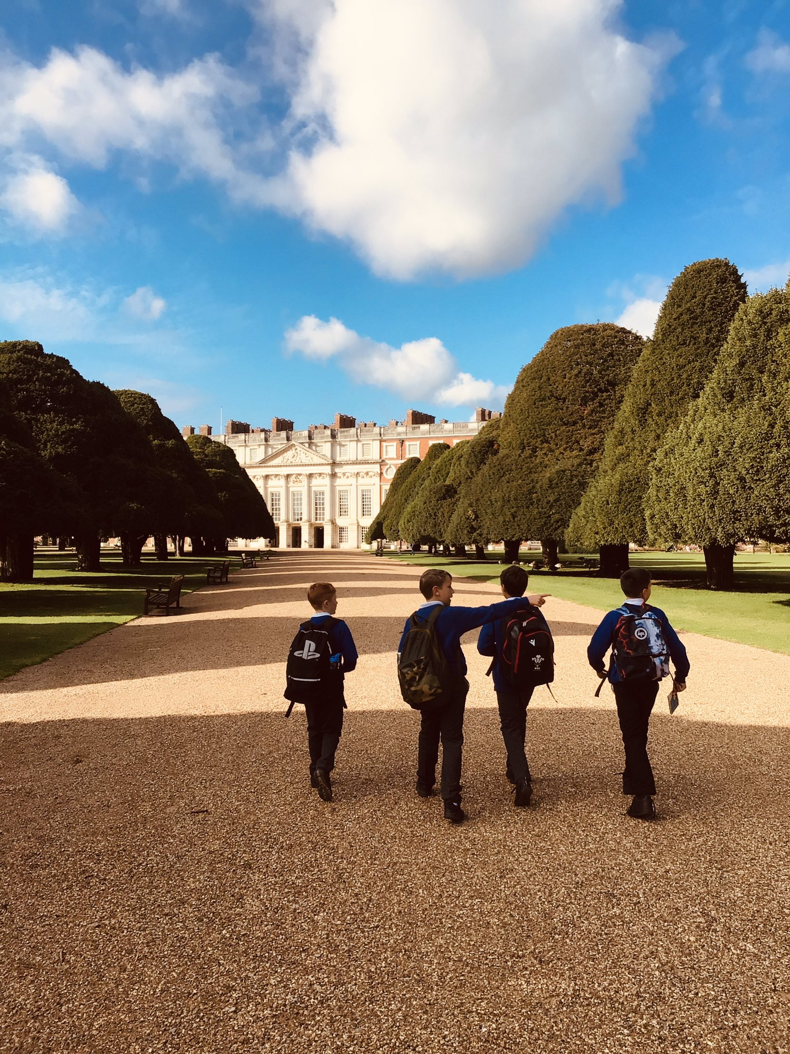
Contents

Grove Learning Trust (GLT) Vision 2
A snapshot of Southfield Junior School 3
Our school values 3
Welcome 4
Person Specification 6
Recruitment Process 7
Safeguarding, Equal Opportunities and Data Protection 8

Grove Learning Trust (GLT) Vision
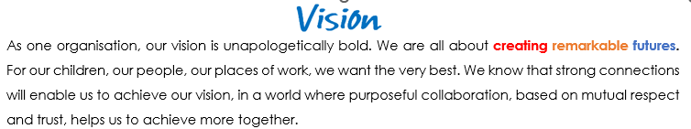
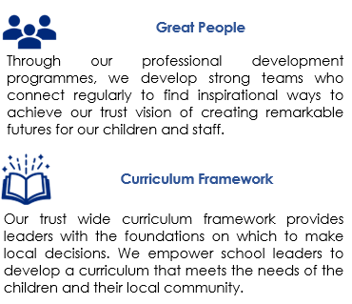
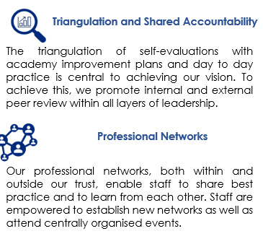

A snapshot of Southfield Junior School



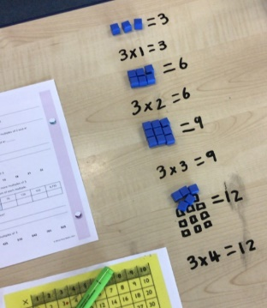

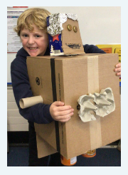
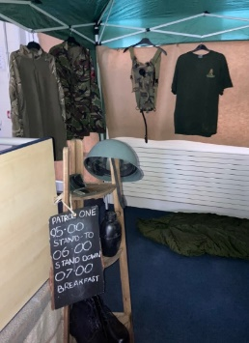


See more at: https://www.southfieldjuniorsch.co.uk/ or on our Instagram page https://www.instagram.com/southfieldjunior/ - we are sure you’ll be impressed!

Our school values

Our School Council worked collaboratively to decide on our six school values.



The children, with our School Council leader and pupil voice governor, also worked with the designers from our website design company, Greenhouse Schools Online, to design the characters below.






Welcome

Thank you for your interest in our vacancy: Southfield is a great school to work in! We are a school brimming with excitement. We believe strongly that learning has no limits and do our best to make sure that each day is great for every child as an individual and as part of our wider school community.

Our school is an academy situated in Highworth, just north of Swindon and we 175 wonderful pupils. We work with our local area and staff and children can often be found using the local church for religious education lessons; litter picking in the community; or sometimes in the Highstreet to study our local history.
Southfield is recognised as a good school by Ofsted (March 2025). We strive to progress and enhance children’s education. At Southfield, we are reflective practitioners and make improvements based on the needs of our children and community.
We are proud of the learning environment we’ve created and strongly believe that prospective candidates will see that Southfield is a very welcoming and inclusive school which benefits from a supportive staff team, families and governors. We encourage learning in a variety of ways and we are proud to have the facilities to run outdoor sessions; we also run nurture sessions weekly and mental health and well-being sessions! We immerse the children in their topics and plan ‘hook’ days, trips, events and experiences to aid their learning. Our whole school use the ‘zones of regulation’ to aid the children’s personal development and we have weekly circle time sessions.
We feel privileged to work with a team of open-minded and dedicated professionals who are focused on the children’s learning, wellbeing and development. We welcome creative thinkers, inspirational team players, flexible leaders and people who are committed to making sure that the children who attend Southfield Junior School get the very best, all-round experience which enables them to grow into talented young people.
If we sound like a good match for your way of working, please get in touch to arrange a visit… come and see all that our school has to offer you.
If we, or any other member of the academy team here at Southfield, can be of any help, please do not hesitate to get in touch at your earliest convenience.
With best wishes and good luck,

Kimberley O’Sullivan - Head of School Julie Warburton - Executive Head
Job Description
Post: LSA and MDSA. Part-time (8:30 – 3:00)
3 days per week

Start date: September 1st 2027

Reports to: Head of School

Grade: K scale (depending on experience)

KEY PURPOSE OF THE JOB
Under the direction of the Head of School, teacher, Special Education Needs Co-ordinator (SENCo) and / or Deputy SENDCo, work as part of a team to promote the emotional, physical, social and educational development of all pupils.

PRINCIPAL ACCOUNTABILITIES

Supporting pupils | Supporting staff | Enhancing the curriculum
Participate in activities designed to meet the emotional, physical and learning needs of individual children and groups of children, including those with special needs.  Prepare activities that support the development of identified children or groups of children.  Provide personal, social, hygiene, welfare and behaviour support to pupils.  Be responsible for promoting and safeguarding the welfare of children and young people within the school.  To promote resilience and perseverance when faced with challenges and maintain high-standards of behaviour to act as a role-model to all children.  Maintain a conscientious attitude to policies to ensure children’s behaviour is in-line with school expectations.  Help pupils to develop self- confidence in a range of areas including decision making, problem solving and general life skills, and manage emotions in a positive way. | Assist with the organisation, preparation and development of the learning environment and ensure adequate supplies of learning materials.  Implement a variety of methods to support, challenge and observe pupils. Work with the class teacher/s to identify areas of support for individual children and plan to address these areas.  Provide feedback to staff regarding a child’s development.  Utilise the school’s systems to record academic, behavioural, emotional strengths and concerns. | Assist in the delivery and evaluation of learning activities for individuals, groups or the whole class, working with the teacher or Inclusion team.  Assist in the organisation and delivery of learning activities.  To promote a love of learning by modelling, recognising and rewarding good learning behaviour, in line with the school’s behaviour policy.  Where appropriate, work with staff members to adapt the curriculum to ensure all learners can access and make progress.  To accompany teaching staff on off-site visits to enhance the children’s learning experiences (as required).

Other duties
- In accordance with the provisions of the Health & Safety at Work Act 1974, take reasonable care for the health and safety of yourself, colleagues and pupils who may be affected by your omissions at work, and to co-operate with the school so far as is necessary to enable the school to perform or comply with their duties under statutory health and safety provisions.
- Undertake any other duties that can be accommodated within the grading level and nature of this post.
- To attend relevant meetings and participate in training opportunities and professional development as appropriate.
- Communicate professionally, where necessary, with parents.
- Support pupils in developing effective relationships with peers, younger pupils and adults,
challenging anti-social behaviour e.g. racism.

Additional duties and responsibilities
- The post holder may be required to perform duties other than those given in the job description for the post. The particular duties and responsibilities attached to posts may vary from time to time without changing the general character of the duties or the level of responsibility entailed. Such variations are a common occurrence and would not of themselves justify the re-evaluation of a post. In cases, however, where a permanent and substantial change in the duties and responsibilities of a post occurs, consistent with a higher level of responsibility, then the post would be eligible for re-evaluation.
- In fulfilling the requirements set out in this job description, the post holder will apply Grove Learning Trust’s commitment to equality by treating all employees fairly and without discrimination on the grounds of colour, race, ethnic or national origins, sexual orientation, age, marital status, disability, trade union association or religious beliefs.
- In addition, the job holder will respect the need for confidentiality at all times whilst performing the duties of the role.

Person Specification
 | Essential | Desirable
Qualifications | - Good general level of education to include Maths and English GCSE grade C (5) or above  - Further relevant experience in the absence of formal qualifications | - First aid  - Safeguarding Level 1
Experience | - Previous experience of working in a school  - Experience of working in a classroom environment  - Understanding planning for, monitoring and evaluating children’s progress with support and guidance from teacher  - Supporting children with their behaviour / choices | - Supporting children with SEND needs  - Delivering intervention groups including tracking progress  - Communicating with parents effectively  - Supporting children with low self-esteem  - Flexibility to adapt to situations where further teaching support is required  - Proven ability as an excellent Teaching Assistant
Knowledge & Understanding | - Confidence to work with and support children through ages 7 - 11  - Understanding of an effective learning environment  - A sound understanding of child development and children’s individual needs  - Ability to facilitate children’s learning  - Know and be able to use a range of behaviour strategies  - Be able to encourage good social skills | - Knowledge of the Primary National curriculum  - Understanding of how children may learn in different ways and suit different styles of teaching  - Understanding of a range of additional needs and how best to support learning  - Understanding of the importance to hear the child’s voice and recognise behaviour is a form of communication
Skills & Personal Attributes | - A positive attitude  - Reliable  - Adaptable and flexible  - Can show resilience  - Have a basic understanding of ICT  - Able to work as part of a team  - Shows initiative  - Patient  - Enthusiastic  - Positive role model | - Ability to communicate effectively with all stakeholders  - Committed to own professional development
School Specific Needs | - Fully committed to the vision and values of Southfield Junior School as an inclusive school  - Work flexibly to provide support to staff and children | - Committed to developing the school at the heart of the community; strengthening links within the local area.  - Aid promotion of the school at school based and community based events.

Recruitment Process

Applications and Visits

We’d really like to meet you, show you around and introduce you to the children and staff. Visits can be arranged by contacting our school office team on 01793 762210 or by e-mailing admin@southfield-jun.swindon.sch.uk

Download an application pack for this position by:

- Accessing My New Term and searching Swindon vacancies for Southfield Junior School
- Speaking to a member of our school office team

School Website

https://www.southfieldjuniorsch.co.uk/

Key Dates:

Advert opens : 14.07.26
Advert closes:17.07.26
Shortlisting: 17.07.26
Interviews: 20.07.26

** We reserve the right to close the advert early and interview prior to the closing date.

Candidates who are successful at the shortlisting stage will be notified shortly after the closing date. Candidates who have not heard from us by this point should presume that their applications have not been successful on this occasion.

We will seek references for all shortlisted candidates prior to interview and, in line with guidance in ‘Keeping Children Safe in Education’, online checks will also be made of shortlisted candidates.



Safeguarding, Equal Opportunities and Data Protection

Safeguarding

We are committed to safeguarding and promoting the welfare of all children. We expect all candidates to share this commitment. The successful candidate will be expected to undertake an enhanced Disclosure & Barring Service (DBS) and relevant identity, qualification and disqualification by association checks before a formal offer is made, contracting is undertaken and induction commences within our school.

For further details about safeguarding, please visit our school website.

Equal Opportunities

We are an equal opportunities employer and welcome applications from all suitably qualified persons regardless of their race, sex, disability, religion/belief, sexual orientation or age.

Data Protection Privacy Notice

As part of the recruitment process, we collect and process personal data relating to job applicants. We are committed to being transparent about how we collect and use that data and to meeting data protection obligations. For further information on how we collect and process data, please refer to the Data Protection Policy & Privacy Notice found on www.grovelearningtrust.co.uk

