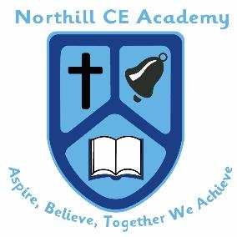
Northill CE Academy
Bedford Road, Northill, Bedfordshire SG18 9AH
Tel: 01767 627215
Email: office@northillacademy.org.uk
Mrs Siobhan Wright, Headteacher

“Shine…like stars”
(Philippians 2:15)

Tuesday 16th December 2025

Dear Prospective Applicant,

We are seeking to employ a Class Teacher to join our team of hard working and dedicated colleagues. Northill CE Academy is a small village school with wonderful children and a very supportive parent body.

We are looking to appoint a full time teacher, however would consider part time applicants. This post is due to start on 13th April 2025, this is a permanent contract on the Main Pay Range. (MPR) This role would be suitable for someone whom is starting out their Teaching Career as an ECT, who is relatively new to teaching.

At Northill CE Academy, we believe that high levels of well-being and confidence are essential in children making good progress with their learning. Happy children enjoy school, are involved in their learning and show curiosity and interest in their environment.

We warmly welcome visits to our school to see us in action; visits can be booked through our School Office by contacting Mrs Jane Hewlett on 01767 627215 or emailing: office@northillacademy.org.uk.

If you have any further questions, please do get in touch.

Kind regards,



Mrs Siobhan Wright
Head teacher

